Dear شالح الحربي

Thanks very much for your reply and wish you a good day!

1. Specification of 10 tons cube ice machine
As for 10 tons cube ice machine, it is our model CV10000.
It can produce 139 kg cube ice per shift (20 mins), 417 kg per hour, 10,000 kg per 24 hours.

The dimension of the machine is 5.83(L)*1.98(W)*2.32(H) m.
It is better to position the machine on a 50 cm high platform so that you can control ice packing easily. In that case, you would need at least 2.5 m high indoor place to arrange the machine.

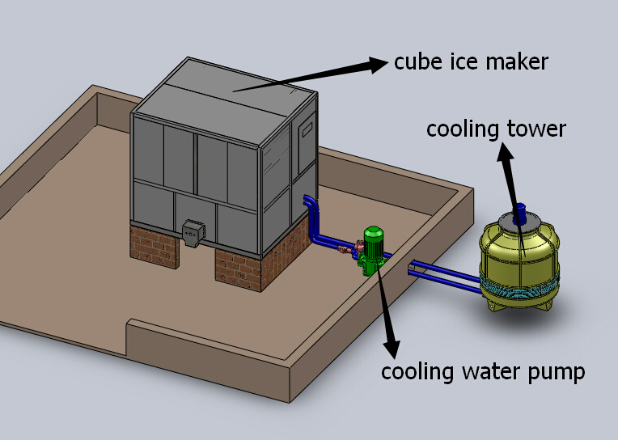

2. Price
Our FOB price of 10 tons cube ice machine CV10000 is $ 52,300 USD for a complete set of machine.

I definitely could apply for discount for you but could you please kindly tell me whether this machine will be installed in Saudi Arabia or other countries? I need to confirm the power supply form of the machine you need.

And when are you planning to buy the machine?

3. Youtube video and quotation sheet
Here we share a Youtube video of cube ice machine installation and operation: https://www.youtube.com/watch?v=aH-bLsxmX_s

Besides, we enclosed a detail quotation sheet which includes more pictures, drawing sheet, project case etc… Please download attachment to check.

Waiting for your reply
Thank you

Best Regards,
Jamko Ye (Sales Manager)

