Quotation
Our Ref No. |  | ICT-FR-20150827-01 | Date: August 27th, 2015
To: |  | BAMA | ICESTA Ice Systems
Attn: |  | Ms. Linda | From: Ms. Sharon
Email: |  | bama.linda@yahoo.fr | Email : sharon@icesta.com
Tel:+86- 0755-29914211
Fax: +86-0755-29914210
Subject: | Quotation for 3ton block ice machine
This program includes the following:
1) Quotation for the equipments
2) Technical parameter and components list
3) CE Certificate
4) Control system
5) Principles for Guarantee and technical support
6) Photos gallery for block ice machines
7) Working partners
1).Quotation for 3Ton block ice machines
Item No. | Model | Capacity(T/24h) | Unit price (USD)
Block ice machine | IB3T-R2W | 3t/24h | 20,000.00
Total Value in amount FOB Shenzhen |  |  | 20,000.00
IB3T-R2W: including refrigerating unit, cooling tower, water pump, connecting PVC pipes,connecting power line,pouring into brine to the scale mark after clean the brine tank, pouring into clean water to the scale mark after clean the ice rind (water pipes and wires not included, match one-time use solid salt)
COMMERCIAL ITEMS
Remarks
Trade terms | FOB Shenzhen Port
Payment terms | Telegraphic Transfer. 30% deposit after PO confirmed. Balance paid before delivery.
Delivery | 25~30 days after deposit, depends on model and quantity
Package | Standard Wooden package
Validity | 30days
Warranty period | 1 year after B/L date. Any failure occurred within the period due to our responsibility, we'll supply you the spare parts for free, and permanent technical support & consultation all life long for the machines.
Note | CE approved certificate

- . Block Ice Machine Technical Parameter

Block Ice Machine Technical Parameters IB3T-R2W

Model  Parameters | IB3T-R2W
Compressor Model | 4JE-15
Design capacity | 3000kg/24h
Refrigeration capacity | 27.4kW
Evaporating temp. | -15℃
Condensing temp. | 40℃
Total input | 15.27 kW
Power of compressor | 11.9kW
Water pump of cooling tower | 1.5kW
Power of cooling fan | 0.37 kW
Water pump input | 1.1kW
Power of electric hoist | 0.4kW
Power supply | 380V/3P/50Hz
Water feeding pressure | 0.1Mpa－0.5Mpa
Refrigerant | R22
Design ambient temp. | 30℃
Design water inlet temp. | 20℃
Ice temp. | -10℃
Each weight of the block ice | 25kg
Dimension of ice (MM) | 390*120*600
Each freezing time (H) | 11h
Each doff ice time (H) | 0.4h
Ice Machine Diameter (MM) | 1800*1000*1350
Dimension of cooling tower (MM) | φ1165*1645
Unit weight | 6t
Unit Operating Weight | 10t

Spec. Sheet of Block ice Machine IB3T-R2W

Item  Specification |  |  | ICB3T-R2W
Name | Brand | Origin | QTY
Compressor | Bitzer | Germany | 1
Anti-vibration Pipes | Hanlisi | Korea | 1
Oil Separator | ALCO | USA | 1
Condenser | Lianhe | China | 1
Cooling Tower | Lingdian | China | 1
Cooling Water Pump | Yuanli | China | 1
Circulating Water Pump | South Pump | China | 1
Filter Drier | Fasike | China | 1
Solenoid Valve | Danfoss | Denmark | 1
Expansion Valve | Danfoss | Denmark | 1
Gas-Liquid Separator | Fasike | China | 1
Pressure Controller | Danfoss | Denmark | 2
Pressure Meter | Xianchuang | Taiwan | 3
Hoisting Equipment | Icesta | China | 1
Ice-pouring Equipment | Icesta | China | 1
Water-supply Equipment | Icesta | China | 1
PLC Controller | LS | Korea | 1
Air Switch | Schneider | France | 1
Contactor | Schneider | France | 7
Thermal relay | Schneider | France | 7
Touch Screen | Weinview | Taiwan | 1

3) ICESTA ICE SYSTEMS CERTIFICATION
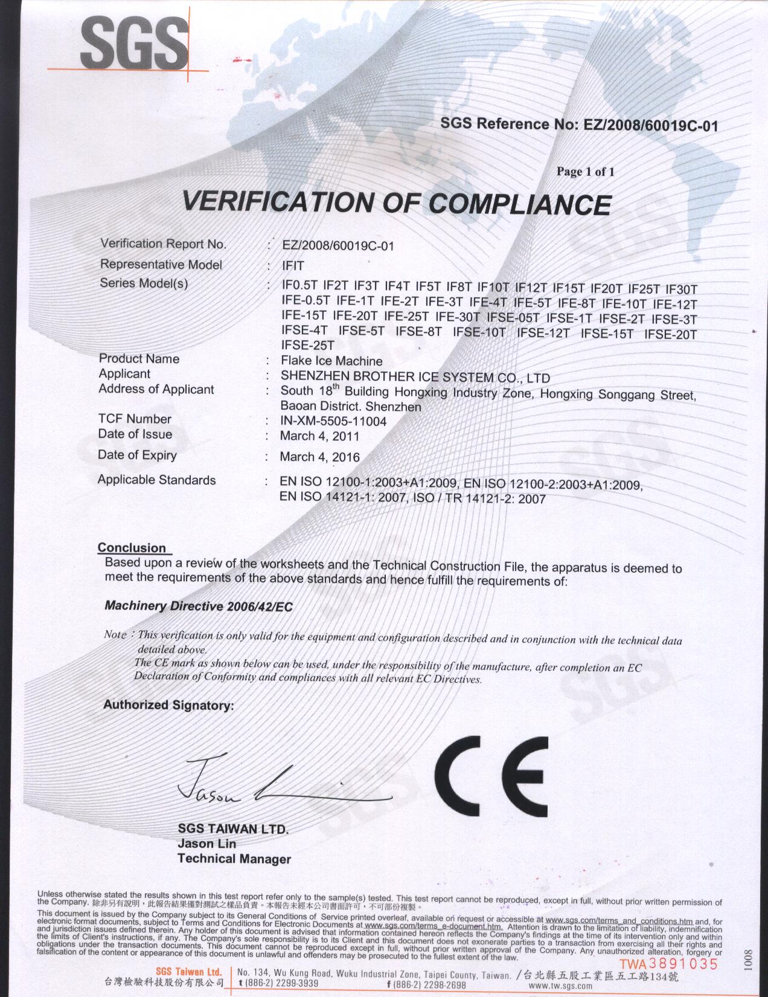

4) ICESTA CONTROL SYSTEM (PATENT) UNIQUE INNOVATION
* Running status played live in touch-screen
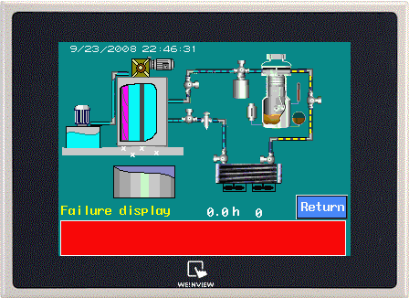
* All failure record and relevant solution programmed in touch-screen for most convenience.
* Stop-time setting at will

ICESTA Control system
1). Picture one is the displaying screen of operation.
Characteristics：1. User-friendly display。
2. System failure will be indicated on screen。

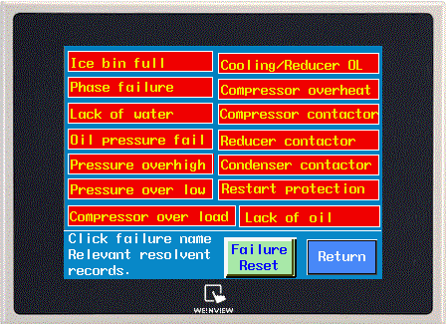
2). Picture 2: Failure Display
Characteristics： The possible failures are all programmed
Into computer，operator could settle down the break-down
following systems instructions very easily.

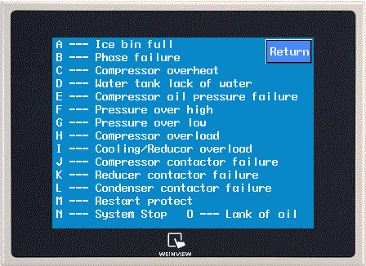
3). Failure history record
Characteristics: The computer will record all history failure in
Its system, which will give greatly convenience to the services
man, for system checking and maintenance.

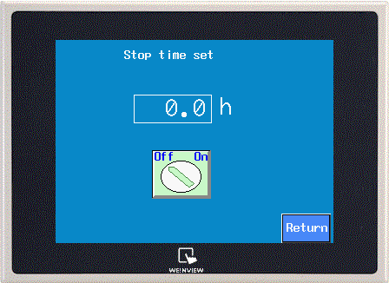
4). Picture 4: Operation hours setting
Characteristics：
A. User-friendly design，operator could set working hours,
system will stop automatically at setted time.
B. User could decide the working hours by himself, to avoid
Energy waste and save cost
5). Guarantee, technical support and failure claim procedures
- All Icesta ice systems delivered to customers are carefully examined and tested, with 72 hours trouble-free trial operation.
- All ICESTA ice systems delivered are plug-in ready and well piped.
- All ICESTA ice systems enjoy 1 year guarantee ever since B/L date.

Technical support
- ICESTA provide full technical support and training courses after equipment installation and commissioning.
- 7*24 hours phone assistance on technical support.

Failure Claim procedures
- Detailed written failure description is required by fax or by mail, indicating the relevant equipment information and detailed description of failure.
- Relevant pictures are required for failure confirmation.
- ICESTA engineering and after-sales service team will check and form a diagnosis report.
- Further trouble-shooting solutions will be offered to customers within 24 hours after receiving the written description and pictures.

6) Photos gallery
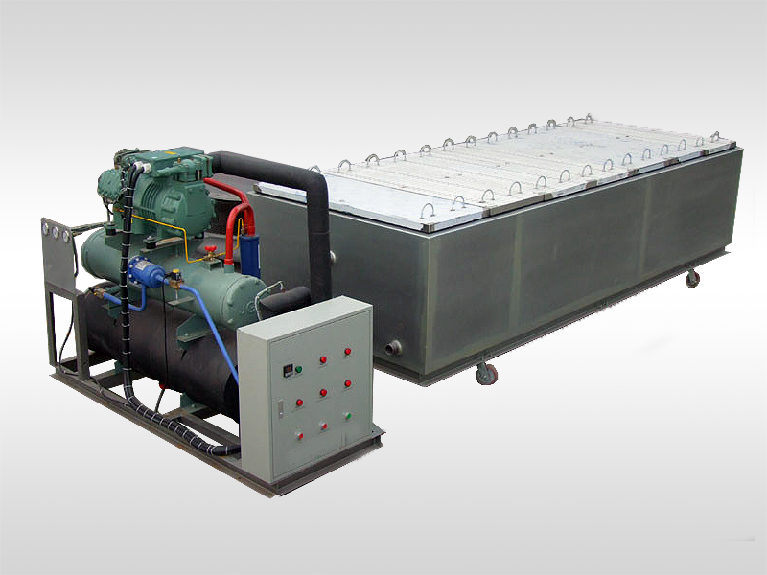

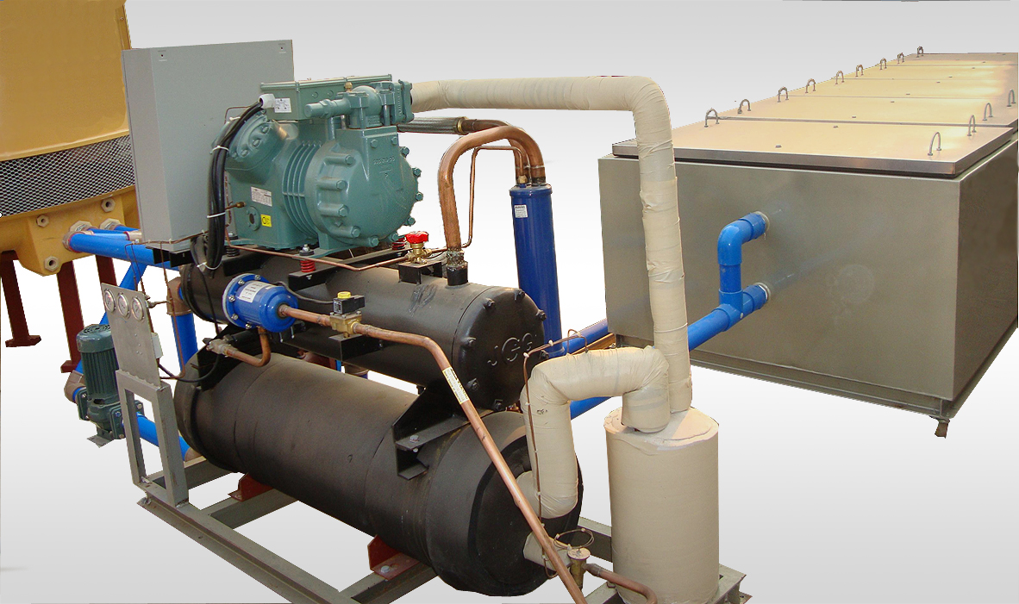

7). Working partners worldwide in variety industries
Seafood Industry




Construction and concrete cooling industry


Meat processing Industry



Poultry Slaughtering


Super market and Chain stores







