Dear شالح الحربي

Wish you to have a nice day!

Did you receive our quotation of 10 tons cube ice machine yesterday?

I am sorry I made a little mistake about machine dimension in the quotation sheet. The correct dimension of the machine is 5.83(L)*1.98(W)*2.32(H) m. Please notice that!

Because you might be the first time to engage in ice business.
In following, I will specify what other things you might need to establish 10 ton cube ice production line:

1. Cube ice machine
Above all, you have to select a right capacity cube ice machine for yourself, from 1~20 tons.
Our FOB price of 10 tons cube ice machine CV10000 is $ 52,300 USD for a complete set of machine.
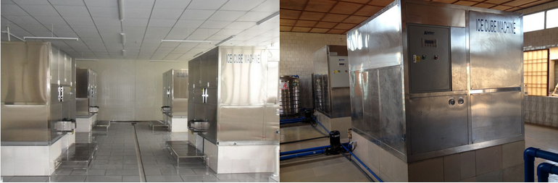
porject case
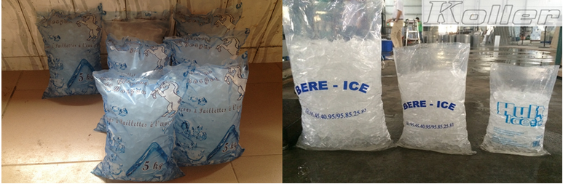
bags of cube ice

2. Ice water treatment
The pure water quality is important as much as the food-grade standard of our icemachine.
We recommend to equip with a RO450 water filteration equipment to dispose wate. It can produce 450 L pure water per hour.
Pure water would be storaged in a stainless steel water tank before making ice.

Our EXW price for RO450 water treatment equipment with double filter membrane is $ 3,900 USD for a complete set.
Our EXW price for 1 tons storage capacity stainless steel pure water tank is $ 177 USD for a complete set. (can be bought in Saudi Arabic)
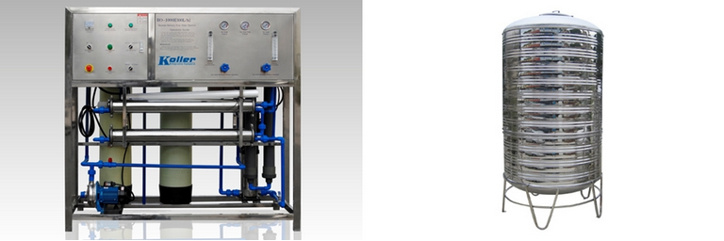
water treatment equipment pure water tank
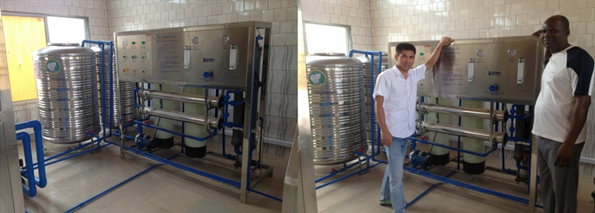
complete set of water treatment equipment

3. Bags of ice weighting and sealing
Our EXW price for ice weighing and bags sealing machine is $ 120 USD.
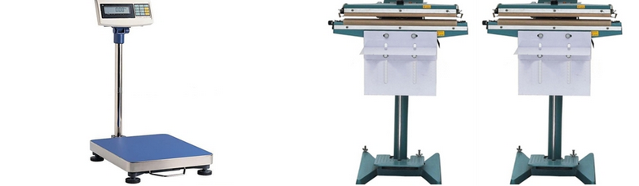
scale sealing machine
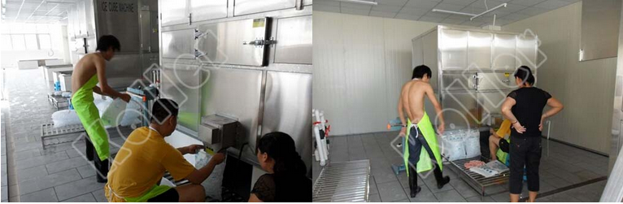

4. Cold room
Besides ice machine, you will aslo need a cold room for storage after finishing. That way, ice will has lower temperature and become harder and not easy to melt.
It's good for ice long distance transfer and schedulable ice production plan. You don't have to make ice everyday because you can have ice in stock!
Our FOB price for 10 m³ cold room is $ 3,924 USD, which can storage 2.5 ~ 3 tons ice.
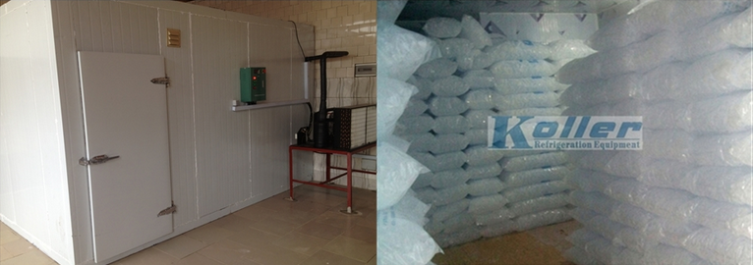

شالح الحربي, as you can see, to invest a complete 10 tons cube ice production line, the facilities investment would cost around $ 60,421USD.

*What do you think? If you think 10 tons capacity is good for you, I shall apply for an discount for you in my next email.
If you think it is over budget, you could have a smaller capacity and let me quote you.

Looking forward to your reply
Thanks

Best Regards,
Jamko Ye (Sales Manager)

