Dear Francis Díaz

We used to quote you our block ice machine, how is going now?

1. Our latest FOB price for 1 tons block ice machine with 5 kg block ice cans is 6,770 USD.

This price is base on:
(1)440V, 60 Hz, 3 phases supply power in Peru
(2)Germany Bitzer compressor
(3)Stainless steel 304 material for brine water tank and ice cans (prevent against brine water corrosion)
(4)Famous refrigeration components from Denmark Danfoss and electrical components from Korea LG

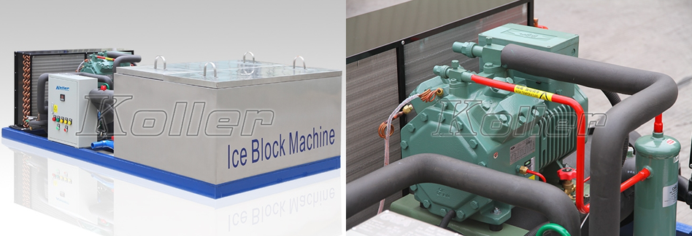
MB10 block ice machine 4 H Bitzer compressor

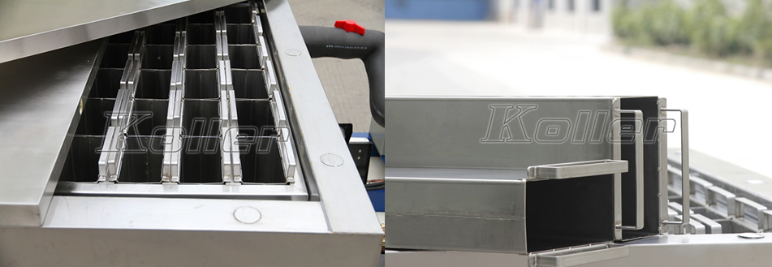
Complete stainless steel 304 material portable ice moulds

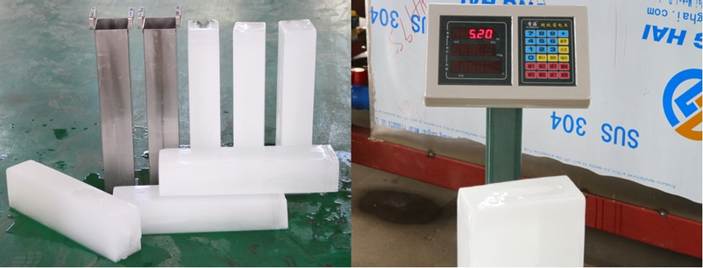
hard and solid block ice - capacity is 100% guaranteed

Francis, which power supply form do you prefer to run the machine with in Peru, 220V or 440V?

Waiting for your most kindness reply
Thanks

