Dear Nelson

Wish you good day!

1. Our latest FOB discount price of 3 tons block ice machine MB30 with 5 kg block ice cans is $ 13,200 USD. (former price $ 13,900 USD)

MB30 has 120 pieces ice cans, which can produce 120 pieces 5 kg block ice per 4.8 hours; 600 pieces 5 kg block ice per 24 hours.

2. Nelson, how is your market investigation going? Did you inspect the seafood market or fishery port?

Now one of our plant is testing 2 sets 5 tons block ice machine for one of our Zambia customer. I really wish someday we could test your ordered machine there.
Here we share a 5 tons block ice machine installation and operation video with you : https://www.youtube.com/watch?v=x9U3F3iW8eQ

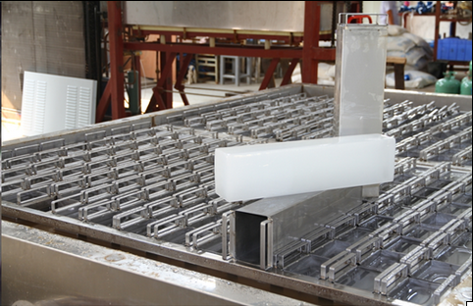
block ice with portable ice moulds

Looking forward to your reply
Thanks

Best Regards,
Jamko Ye (Sales Manager)

