Dear Rossard

I really appreciate your latest news and the effort you made!
But still I hope you could promote the deal and establish your business soon.

Here is a little case of our machine for you:
Now one of our plant is manufacturing a 20 tons tube ice machine for one of our customer from Australia.

He used to buy 1 sets 20 tons tube ice machine in 2014 and have his relatives running the ice factory in Laos.

He ordered another set of 20 tons machine recently because he found a prospective market in Lagos, especially in festival and holiday.
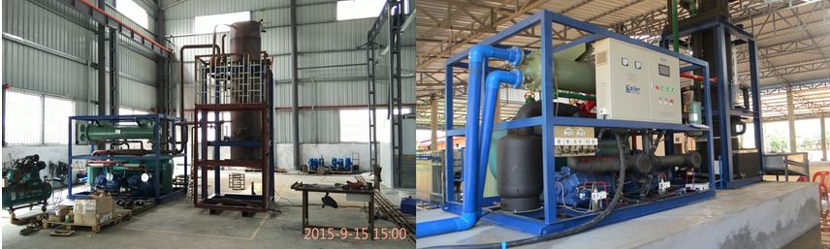
manufacturing tube ice machine installed tube ice machine

As an ice wholesale, he told us that the endless retailers ask for 2 ~ 3 tons ice per time, so his capacity is only able to cooperate with several retailer and reject the others.

And he also wants his factory to sell diverse ice in future for different area, drinks shops, restaurants, fishery harbor, vegetable and fruit market, chemical factory and so on.
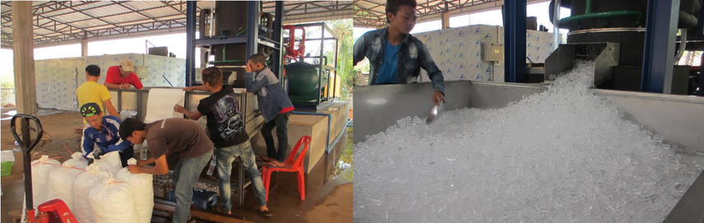
Packing and selling by some of local teenages

PS: In future, this factory can offer 30 job opportunity for teenages from thier neighborhood. This means 30 family could make a living by this factory temporarily because of local poor condition.
Looking forward to your kind news
Thank you

Best Regards,
Jamko Ye (Sales Manager)

