Dear Mr. Constantino Torres

This is Jamko from Koller cube ice machine manufacturer. Thanks for your inquiry of our 3 tons cube ice machine!
Actually we manufacture 1 ~ 30 tons capacity cube ice machine for business man selling ice, bars, restaurant, hotel, drinks shop...:

1.Specification and quotation
As for 3 tons cube ice machine you inquired, it is our model CV3000.

Our model CV3000 can produce 3,000 kg cube ice per 24 hours; 125 kg per hour; 42 kg per 20 mins (shift).
Our FOB price for CV3000 is $ 16,850 USD for a complete set of machine.

Machine installation and operation: https://www.youtube.com/watch?v=D5IBWC-ZHOg

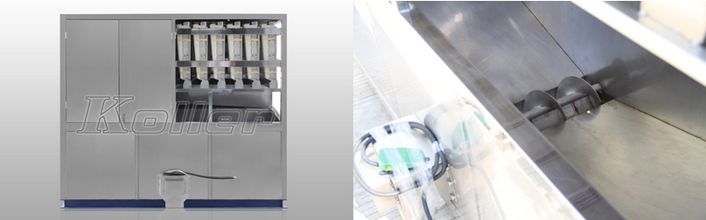
CV3000 3tons cubeice machine ice collecting bin
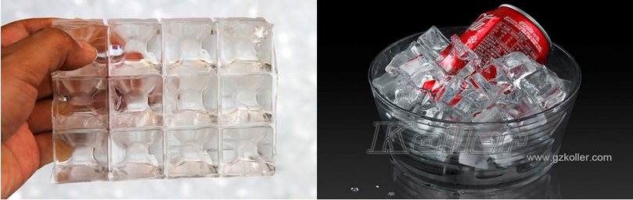
ice in collecting bin ice after dispensing

*Constantino, which country are you going to install the machine in? We need to confirm the power supply there.

Looking forward to your reply
Thanks

Best Regards,
Jamko Ye (Sales Manager)

