Dear Patricia Mouliom

This is Jamko writing from Koller cold room manufacturer company. Thanks for your inquiry of our cold room product.

As for 1,000 kg chicken storage, we recommend our 10 m³ cold room with optimized -18 ~ -20 ℃, here are the specification for your reference:

1. Cold room specification
Model | VCR10
Dimension (L*W*H) | 2.5 x 2.0 x 2.2 m (10 m³)
Suggested storage capacity | Around 2,000 ~ 2,500 kg
Rated temperature | -18 ~ -20 ℃ for meat storage
Supply power | 380V, 50 Hz, 3 phases
Compressor | Germany Bitzer compressor
Door size | 1 pcs swing door (1.8 x 0.8 m)
Panel material | Double-sides colorbond painted steel sandwiched with polyurethane
Insulated room panel thickness | 150 mm
Panel density | 42 kg / m³

2. Cold room quotation
Our FOB price of 10 m³ cold room with -18 ~ -20 ℃ is $ 4,940 USD for a complete set. This price base on a complete set of cold room with all necessary accessories.

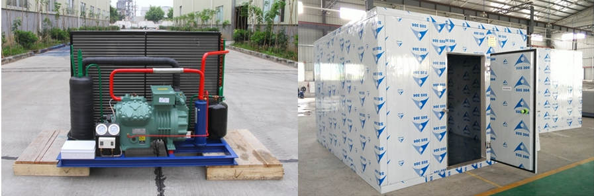
Germany Bitzer compressor unit insulated room
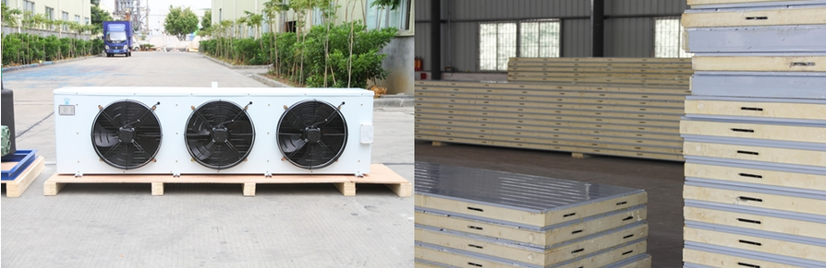
Air cooler insulated panels

3. Freight charge

By less than container load:
The packing volum of 10 m³cold room is 9 m³, the latest shipping cost from Guangzhou Port to Douala Port is 300 USD / m³.

So the total shipping cost for this cold room is $ 2,700 USD, it takes around 65 days to arrive at your port.

By full container load:
If you need the cold room urgently or have commodities bought from other suppliers, then we would suggest 20 feet container for you.

The shipping cost for 20 feet container from Guangzhou Port to Douala Port is $ 2,970 USD, it takes around 37 days to arrive at your port.

4. Delivery time: 20 days from receipt the deposit of advanced payment.

5. Payment terms: By T/T. 50% of total value as advanced payment, the 50% balance should be paid off before shipping.

* Patricia, could you tell us whether our 10 m³ cold room with -18 ~ -20 ℃ cold room meet your demand or not?

Looking forward to your reply
Thanks

Best Regards,
Jamko Ye (Sales Manager)

