Dear Adolfo Leal Silva

How are you!

This is Jamko writing from Koller refrigeration. Thanks for your inquiry of our ice machine equipment.

1.We will provide our oversea bank account to you, you can make the transaction by T/T (Telegraphic Transfer).
After we receive 50 % of total value as advanced payment, we would start to manufacture your order.
After 20 days, when the machine finished, we would inform you to pay for the 50% balance, then we would prepare to delivery your machine by ship or air transportation.
All the payment should be paid off byUS dollars before delivery.

2. We wonder whether you need an ice crusher machine or ice machine?

(1)If you need an ice crusher machine, what kind of ice you want to crush block ice, tube ice or cube ice?

If you want to crush block ice, what is your block ice dimension and weight? We need to confirm the feeder inlet of the machine.
Do you want to crush the ice into powder size or granular size?

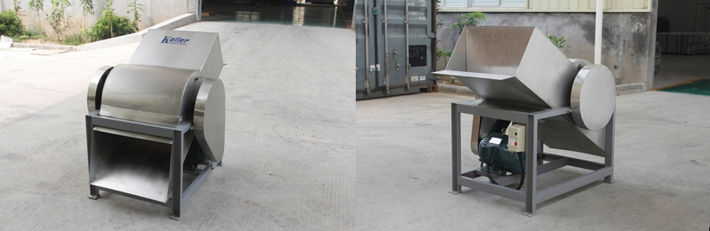
VIB 10 for 5~10 kg block ice crushing

(2)We also manufacture different kinds of ice machine, if you need ice mahcine, could you tell us which kind of ice machine you need?
Looking forward to your reply
Thanks

Best Regards,
Jamko Ye (Sales Manager)

