文字修改：

页面链接地址：http://www.kf-shelters.com/3-2-mobile-kitchen/179509

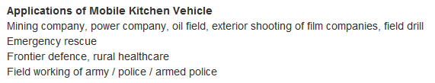

将Applications of Mobile Kitchen Vehicle下面文字改成：

They can be moved and used in:
-Rural areas
- Remodeling of hospital services
- Disaster
-Natural disasters
- mining camps
- oil camps
- Military Bases

