Dear Mr. Thiago Ribeiro Da Silva

How are you!

This is Jam from Koller ice machine manufacturer and exporter in China. Thanks for your inquiry of our tube ice machine.

2. Specification
We manufacture tube ice machine with daily capacity from 1~20 tons for human consumption drinks shop, restaurant, nightclub, hotel.
As for 5 tons tube ice machine you consulted, it is our model TV50, it can produce 70 kg tube ice per shift (20 mins), 210 kg per hour, 5 tons per 24 hours.

2. Price
And according to our experience, the 3 phase supply power in Brazil is 220 V, 60 Hz.
So if for Brazilian market, our FOB price of complete set of 5 tons tube ice machine TV50 is $ $27,450 USD.

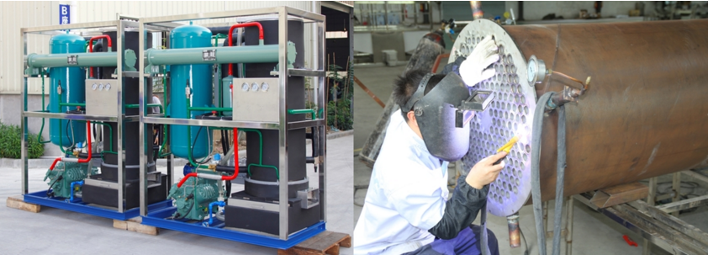

3. Componets and quality
* The machine will adopt with Germany Bitzer compressor to guarantee the excellent performance.

* Control by Germany Siemens PLC, the ice making is fully automatic.

* To guarantee the ice quality and sanitary, the ice evaporator is made of food grade seamless steel tube. Besides, framework is made of stainless steel 304.

* To meet the Brazilian criterion of environmental protection, the machine will adopt environmental R404a refrigerant.

* For your better understand, we share a youtube video of our water cooling tube ice machine installation and operation with

you: https://www.youtube.com/watch?v=yG1CCZK3izo

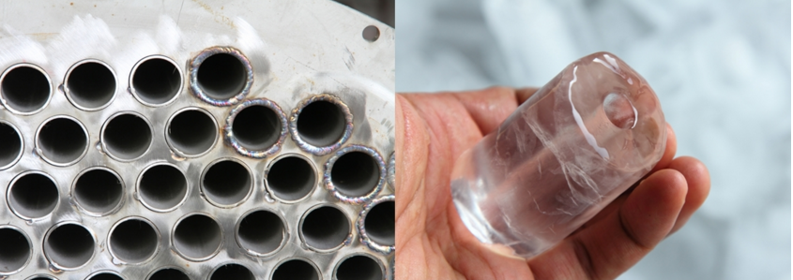

*Mr.Thiago, could you tell us your idea about the machine? Do you want to establish a tube ice production line in Brazil to sell ice?

Looking forward to your reply.
Thanks

Best Regards,
Jamko Ye (Sales Manager)

