Dear Frank Veliz

Happy new year!
This is Jamko from Koller refrigeration, an ice machine manufacturer with 8 years Alibaba gold supplier experience (http://www.gzkoller.com).
We learn from Alibaba you are interested in 1,000 kg cube ice machine and wonder if we could help to establish your own ice plant.
1. Accordingto your requirement, here we recommend our 1 tons cube ice machine CV1000 for you.
Our model CV1000 can produce 1,000 kg cube ice per 24 hours; 42 kg per hour; 14 kg per 20 mins (per shift).

Our FOB price of 1 tons cube ice machine CV1000 is $ 11,000 USD for a complete set of machine.
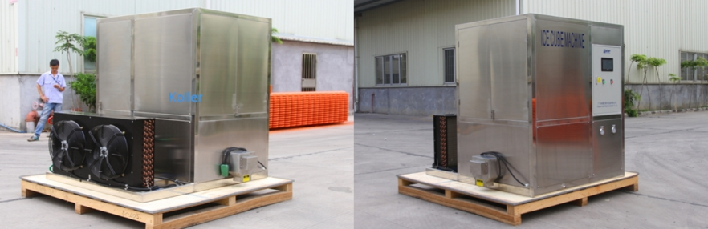
1 tons cube ice machine with air cooling system
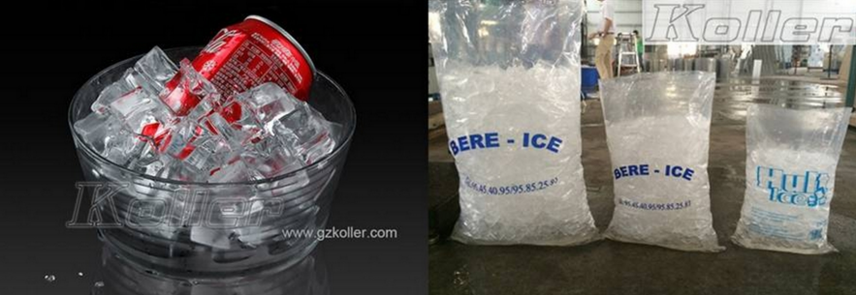
cube ice with bags packing

2. Please notice that the above price is base on machine with following standards:

(1)220V, 60 Hz, 3 phases supply power in Peru
(2)stainless steel 304 guarantee food grade ice standard
(3)Germany Bitzer compressor ensure excellent performance
(4)Germany Siemens PLC system control ice making and water supplying
(5)durable electrical components from Korea LG and Denmark Danfoss refrigeration components
(6)environmental R404a refrigerant (CFC free)
(7)spare parts and all necessary accessories are included for a complete set of machine

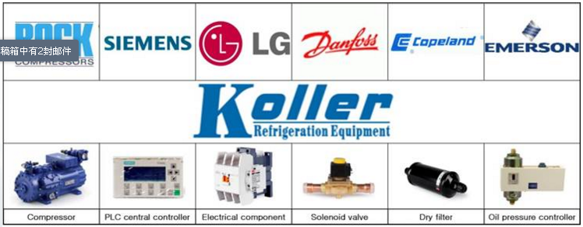

3. Here we also share a Youtube video of the machine installation and operation, hope you enjoy it: https://www.youtube.com/watch?v=iYhqtgbHv68
*Mr Frank, do you have any idea or question about the machine?
Looking forward to your reply
Thanks
Best Regards,
Jamko Ye (Sales Manager)

