Dear Walter Lozano
How are you!
This is Jamko from Koller refrigeration, an ice machine manufacturer with 8 years Alibaba gold supplier experience (http://www.gzkoller.com).

We learn that you are interested in 1~ 10 tons block ice machine and wonder if we could help to establish your ice plant.
To quote you our best price, here you can get more reference by answering the following questions:

(1)How much kilograms of each block ice piece do you want, 5 kg, 10 kg, 15 kg or ...?
The following table shows the connection between ice weight and freezing time.
As we can see from the table, the bigger and thicker block ice we made, the longer ice making time is required.
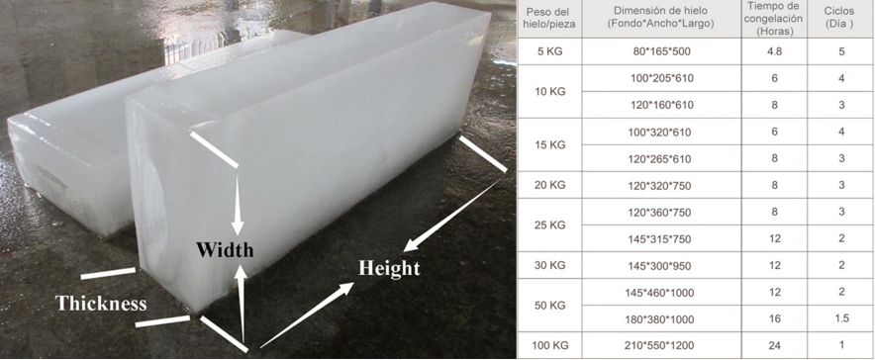

eg: To make 10 kg block ice, it require at least 6 hours to freeze. But for 5 kg ice, it only need 4.8 hours.
(2)How many pieces of block ice do you want per day?
Quantity of pieces block ice = daily capacity / daily shift times / block ice weight
Daily shift time = 24 hours / ice making time
eg: Our daily capacity 1 ton block ice machine can produce 40 pieces 5 kg block ice every 4.8 hours, that means 200 pieces 5 kg block ice every 24 hours. (200 pcs * 5kg = 1,000 kg =1 ton )

Mr Walter, could you kindly let us konw your answer?
Waiting for your most kindness reply
Thanks

Best Regards,
Mr Jam ko (Sales Manager)

