Dear Luis Rodriguez

Good morning!

Here we compare the 2 different type block ice machine for you as follow:

(1)Brine water block ice machine
It adopts with brine water as cooling medium to freeze ice, so the ice is normally for fishery and agriculture cooling.
During the production, the block ice might mix with brine water chemical, so the ice is not suitable for human consumption.
But still, some people in Africa and Middle East eat the ice even though it doesn't meet with food-grade standard.

5 tons brine water type block ice machine MB50 on Youtube:
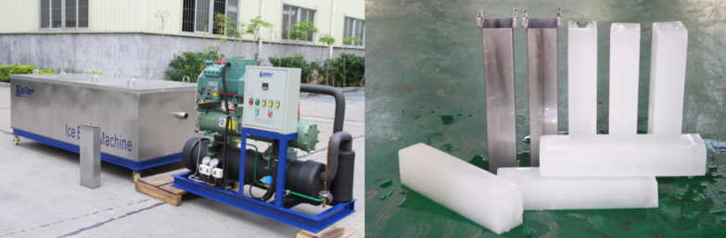

(2)Directly freezing block ice machine
This type of machine freeze ice directly without brine water. The ice is freezed in a food-grade aluminium ice cans so that completely meet food grade standard.
So this ice can be applied to both human consumption and fishery storage etc.

5 tons directly freezing type block ice machine DK50 on Youtube:
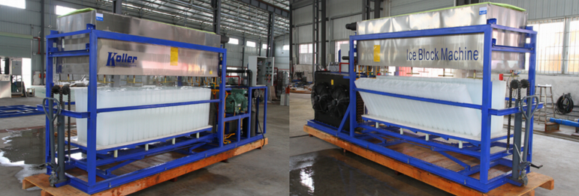

*Mr Luis, which type you would pick up?

Looking forward to your reply
Thanks
Best Regards,
Jamko Ye (Sales Manager)

