Dear Luis Rodríguez
Thanks for your reply!
1. The ice dimension of directly freezing type block ice machine is fixed standard, that means it can't be specially custom-mde like the brine water type machine.
Here are the specification of 5 tons directly freezing block ice machine with 25 kg block ice:

Model | Ice weight | Ice dimension | Ice making time | Capacity / shift | Capacity / 24hrs | Compressor | Cooling system
DK30 | 25 kg | 150*280*710 mm | 6 hours | 56 pcs | 224 pcs =  5 tons | 30 HP Germany  Bitzer compressor | Air cooling system

2. The containerized 5 tons directly freezing block ice machine is installed inside a 40 feet container, there are space available for a 20 m³ cold room installation as well. The machine will be installed well inside the container before delivery.

Item | Products’ Name | Quantity | Unit Price | Amount
1 | directly freezing block ice machine DK50 | 1 set | $ 36,770 | $ 36,770
2 | 40 feet HQ container | 1 set | $ 4,500 | $ 4,500
3 | create second door on container | 1 set | $ 300 | $ 300
Total FOB Guangzhou port price of containerized 5 tons block ice machine for human consumption $ 41,570 USD

3. Reference pictures
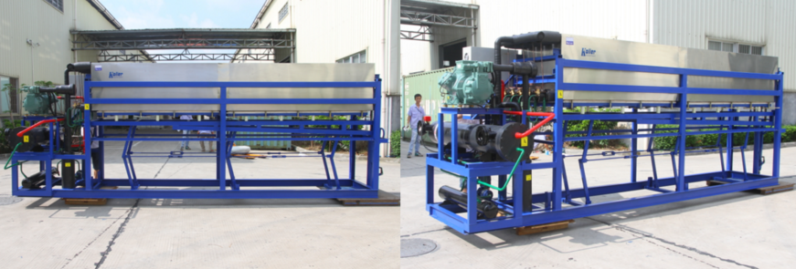
DK50 directly freezing block ice machine
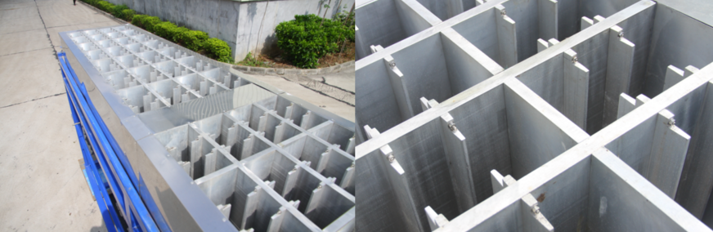
aluminum ice cans guarantee food-grade standard
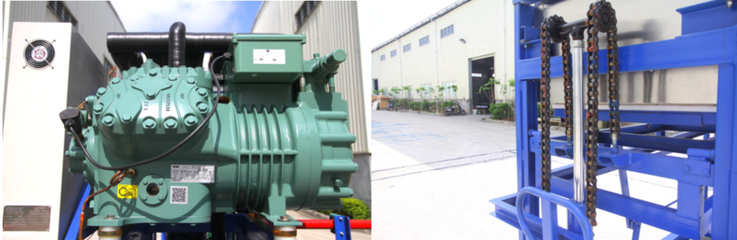
Germany compressor-efficient performance jack for ice discharging from cans-labor saving
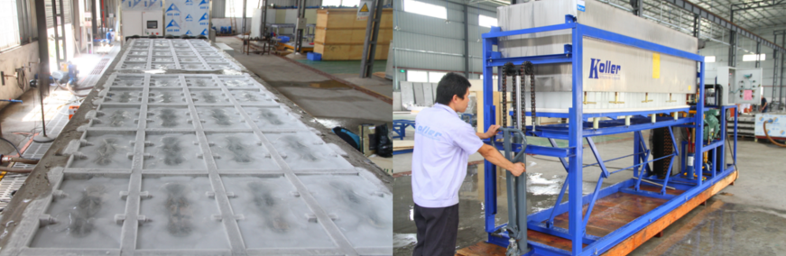
ice freezed in cans without brine water discharge all the ice by hands
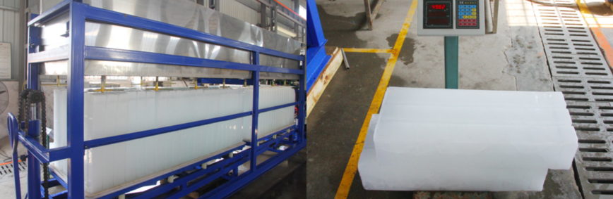
capacity 100 guaranteed

*Mr Luis, what do you think of the machine?

Looking forward to your reply
Thanks

Best Regards,
Jamko Ye (Sales Manager)

