Dear Romulo Furtado
How are you!

This is Jamko writing from Koller refrigeration. Thanks for your inquiry of our cube ice machine.
We manufacture 1~20 tons daily capacity cube / tube ice machine for human consumption in restaurant, hotel, drinks shop, night club etc…

1. Cube ice machine price
Our 10 tons cube ice machine CV10000 can produce 10 tons cube ice per 24 hours, 417 kg per hour, 139 kg per shift (20 minutes).
Our latest freezing low FOB price of complete set 10 tons cube ice machine CV10000 is $ 49,382 USD for Brazil market.
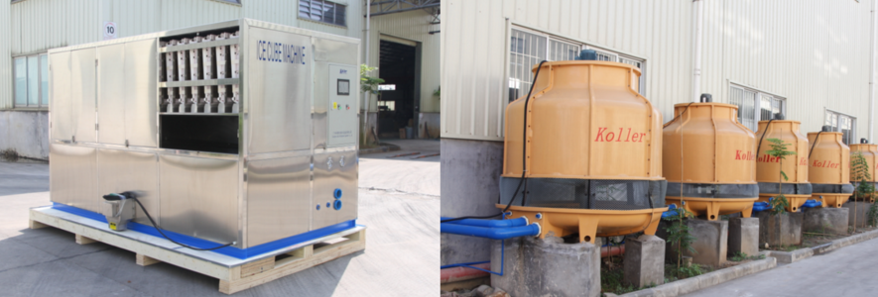
10 tons cube ice machine cooling tower

2. Cube ice machine installation
The complete set of machine consists of 1 cube ice machine unit and 1 cooling tower, these 2 parts will be connected by water pipes and water pump together.
Here is a Youtube video of our cube ice machine installation and operation for your reference: https://www.youtube.com/watch?v=aH-bLsxmX_s

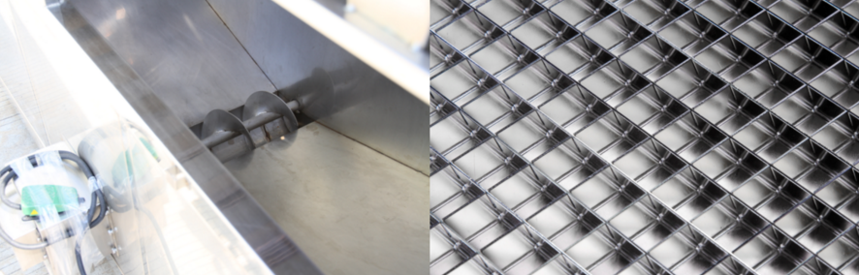
ice collecting bin with dispenser ice maker grids - brass plated with edible nickel
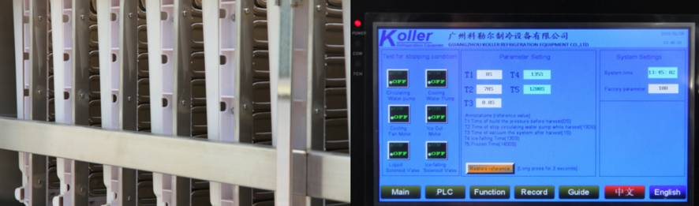cube ice evaporator touch screen with running condition and fault report

*Mr. Romulo, does our 10 tons cube ice machine meet your demand or not?
How many tons of cube ice do you need per day?

Looking forward to your reply
Thanks
Best Regards,
Jamko Ye (Sales Manager)

