Wuxi Zhouxiang Complete Set of Welding Equipment Co., Ltd

Add: Donghu Industry Garden, Donghutang Town, Wuxi City, Jiangsu, China

TEL: +86 (510) 8860 2338 FAX: +86 (510) 8879 1142

EMAIL: [alice@wxzhouxianghi.com](mailto:alice@wxzhouxianghi.com) ZIP: 214196

**Devis**

|  |  |  |  |  |
| --- | --- | --- | --- | --- |
| **Nom** | **Modèle** | **Qté** | **Prix unitaire/FOB Shanghai** | **Remarques** |
| Machine de découpe plasma à la flamme CNC | CNC/KDG-4000 | 1 set | 30,300 USD | Une torche de découpeplasma, une torche de découpe à la flamme, un système de contrôle CNC espagnol Fagor, Alimentation du plasma Hypertherm Powremax 105 d’Etats-Unis, Panasonic Servo, réducteur de vitesse Shimpo, logiciel d’imbrication automatique Fastcam |
| Potence de soudage mobile | LCH-3030 | 1 set | 11,480 USD | Manipulateur de soudage (colonne et palonnier), vireur, base, échelle, boîte de commande électrique.  **Course de lavage vertical: 3000mm**  **Course d’allongement horizontal: 3000mm**  **Diamètre approprié: 700-3000mm** |
| Poste à souder à l’arc DC | ZX5-1000 | 1 set | 3,800 USD |  |
| Machine de récupération de flux | YS-GHS100 | 1 set | 1,640 USD |  |
| Vireur de soudage auto-aligné | GLHZ-20 | 1 set | 5,160 USD | **Un vireur d'entrainement, un vireur mêné**  **Capacité de charge maximum: 20T**  **Gamme de pièce à usine: ф500-ф3500mm** |
| Total FOB Shanghai |  |  | 52,380 USD |  |

**N.B.:**

1. Ce prix est basé sur FOB Shanghai.
2. Validité de prix: 30 jours à partir de la date d’émission.

3. Termes de paiement: T/T, 30% comme l’acompte. Le solde doit être payé avant la livraison. (Nous acceptons aussi la L/C irrévocable à vue)

4. Garantie: 12 mois à compter de la date d’installation à l'atelier de l'acheteur, couvrant la qualité de fabrication (à l'exception des consommables).

5. Alimentation**: 3 phase, 380 V,50 Hz**( Si votre alimentation est différentes, s’il vous plaît contactez-nous. Nous pouvons fabriquer un moteur spécial pour vous.)

6. Délai de livraison: 40 jours après la reception de l’acompte.

Alice

2016-01-30

**CNC/KDG-4000 CNC Flame Plasma Cutting Machine**

**1.1 Structural principle**

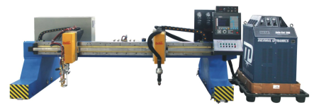

CNC cutting machine is a multifunctional thermal auto-cutting device combined microcomputer controlling, precise machinery and oxygen-acetylene gas cutting. Its CNC cutting torch can cut plates in arbitrary shape.

This kind of machine is composed of a gantry frame, [main](http://www.iciba.com/main/) and [secondary](http://www.iciba.com/secondary/) longitudinal guide rail, transverse torch (flame) and CNC system. Both driving end and cross beams adopt box-beam welding structure whose stress has been relieved, with compact structure and artistic appearance. The driving of the main longitudinal end beam adopts Japan PANASONIC AC servo driving system and driving epicyclical and Japan SHIMPO decelerator, through rack-and-pinion gearing. At the side of driving end beam fixes horizontal directive wheels which can be used to fasten by adjusting the eccentric shaft, therefore, the stability and accuracy during the whole moving can be assured. The longitudinal guide ways firmed by pressure plate backing board and connecting sleeve, all made by high intensity track, all the contact surface of track have precision machining and accurate grinding racks are installed outside the guide way. This installation method can guarantee the straightness and parallelism of guide way. The transverse cutting torch fixed on the transverse tool carriage. Its moving also realized by AC servo electric machine made in Japan PANASONIC to drive the epicyclical decelerator made in Japan SHIMPO, then use the way of rack-and-pinion driving.

The illustration of the transverse beam: it is made of box-beam and its wall is thin, it is assembled by sheets and the stress of the whole workpiece has been relieved. It featured by light weight, strong toughness, little deformation and artistic appearance. There has a high accuracy guide rail and pinion at the backward of the transverse beam. The transverse driving device uses a big speed radio reducer made by SHIMPO (Japan). It’ll drive the whole machine transversely when the [export](http://www.iciba.com/export/) axles rack match with the pinion.

The gantry frame illustration: the main gantry is assembled by sheets and the stress of the whole workpiece has been relieved. Both ends have horizontal wheel which can adjust the two sides that are clamped by longitudinal guide rail. It’ll play the guiding role when the whole machine moves back-and-forth, and its structure is compact and stable. The longitudinal driving device uses a big speed radio reducer made by Shimpo (Japan), with a tooth space take-up mechanism featured of precise guiding. It’ll drive the whole machine longitudinally when the [export](http://www.iciba.com/export/) axles rack match with the pinion of the longitudinal guide rail.

Longitudinal gauge: it is mainly made up of gauge and rack. The gauge made of 24kg steel which has been processed is installed at the beam along which the machine will move longitudinally.

Gas path illustration: longitudinal and transverse cable and gas pipe all adopt the [engineering](http://www.iciba.com/engineering/) [plastics](http://www.iciba.com/plastics/) chain produced in Korean Koduct.

**1.2 Technique parameter**

● Transverse gauge 4000mm

● Effective cutting width of strip torch 3200mm

● Track length 15000mm

● Effective cutting length 12500mm

● Cutting speed 50-1000mm/ min

● Free running speed ≤6000mm/min

● Cnc flame cutting torch 1 set

● Cnc plasma cutting torch 1 set

● Thickness of plate 6-70mm(single torch 100mm)

● Cutting gas oxygen, acetylene or propane

● The whole power 0.4KW

● Driving way Japan whole digital vector AC servo motor double driving

● Plasma power America Hypertherm PowerMax 105

● CNC control system Spain Fagor CNC

**1.3 Electrical control parts**

The electrical control parts of CNC cutting machine is composed of CNC, electrical and servo systems; the main parts of the control system in CNC cutting machine are famous brands at home and abroad. Modularization structure is adopted by the system; the advantage of this kind of structure is that wiring is simple, rational, proper and easy repair. The adoption of large scale of integrated circuit makes the machine smaller and stable. Man-machine dialogue can be realized easily in the system, featured by several input ways and easy operation. It also can program automatically with PC machine. For all these advantages, this machine provides more convenience for the users, and save much more time, also ensures the running reliability of the system.

**1.3.1 FAGOR CNC System**

FAGOR8037-CNC system is made by Spain FAGOR AUTOMATION Company which has excellent functions, reliable quality and flexible matching, can satisfy the requirement of CNC/flame cutting machine and have competitive price.

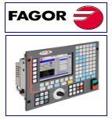

**Main Functions**

* High definition drawing process track display function
* Operation functions: auto, manual, single segment, theory, instruction, edit, input/output
* Real time moving drawing display, torch position and control programming display
* The system can supply precision 0.001mm
* The system adopted pellicle keys to control together, waterproof, dustproof and antipollution, suitable location and convenient operation
* Can do background programming and full screen edit
* Change between the metric system and the British system, coordinate shaft sign also can change
* Return to recut and adjust torches during process, and can stop cutting compulsion
* Can give dynamic compensation to cutting seam tools
* the system has functions of self diagnosis, data protection when power failure
* data input ways: manual keyboard input, computer communication directly
* CPU, moving card and I/O component all used face binding technology, reliable protection and excellent quality

**Technique data**

* 32 CPU (with inner PLC)
* 256KB RAM
* 8’’ color LCD
* RS232 communication (speed: 115,200port), DNC function
* Whole digital keyboard with soft definition function keys＋operation panel

**1.3.2 Japan Panasonic servo system**

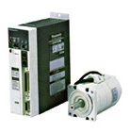

Panasonic whole digital vector AC servo system:

* AC servo motor has small volume, big output torque, quick response, adopted incremental pulse coder as the position feedback and speed feedback component, convenient installation and beautiful appearance.
* The driver adopted whole digital, power and control logical conformity modular structure. Wide range, simple wiring, stable performance and convenient operation
* Whole software parameter set, including increment, time constant, zero drift compensation, speed-up or down, torque limit, position feedback change and auto increment adjustment to guarantee the response, precision and stability of machine.
* It has protecting function of over current, over voltage, under voltage, over speed and limit.

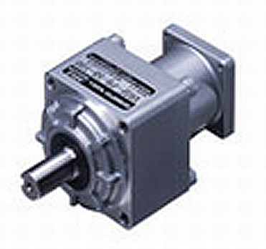

**1.3.3 Japan SHIMPO ABLE reducer**

Feature:

1.It is one of super-silence reduce .Because the tilt gear wheel instead of the line gear wheel and can decrease 10% .

2.This motor have precision position(less than 0.05o )and show high precision motor features , thus can fully exhibit high-precision servo motor’s capacity.

3. Lower-pulse rotating. The bevel gear can realize low pulse smooth rotation, and it is usually used in medical field and pump.

4.22mm (D period 750w) can make the machine light and convenient. Angle size is 98mm (while other companies are120mm). The small sized decision can work well with light and smaller servo motor.

5...Have good assembly circumstance that can improve the quality of products.

6. Freely installation. The long-life lubricate oil don’t need to exchange. And have closed structure to make installation work free.

6. Have functions of prevent oil leak. The cover has been dipped –treated, air-leaking treatment, this can fully oil-prevented.

7. Follow IP65 waterproofing requirement, have waterproof measure, so it can use in any circumstance

**1.3.4Auto-ignition device**

It is composed of lighting torch, ignition cable, gas soft tube and fixed frame. One end of ignition cable connect with lighting torch, another end connect with ignition controller; one end of gas soft tube connect with lighting torch, another end connect with gas source (center gas collecting pipeline), on and off of gas is controlled by electromagnetic valve, the fixed frame fix the lighting torch beside single cutting torch. The ignition procedure is controlled by ignition button on the operation table, when press the ignition button, the lighting torch light up and then firing cutting torch.

**1.3.5 Capacitive auto-height regulator**

Capacitive auto-height regulator system is suitable for flame cutting , when making the flame cutting ,the surface of the plate and the torch should keep the distance , with this system that will make sure the cutting quality .Because plate surface is not parallel with the horizontal ,and the surface of the plate is also not smooth , meanwhile , different plate have different distance between the plate surface and torch .So in order to make sure the cutting quality , it should match the auto-height regulator system .

**Shenzhen capacitive auto-height regulator CHC-200E**

🖝CHC-200E capacitive auto-height regulator is a closed loop control system, it is composed of signal control, signal treatment transfer, logistics control and motor driven, it is used in CNC cutting machine’s torches, such as flame cutting torch, plasma cutting torch and laser cutting torch and so on.

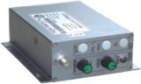

Height signal detecting device is adopting capacitive inverter sensor, sensor loop is insulated with the machine, which is fixed under cutting torch, connect with common metal sensor through coaxial line to detect the height between cutting nozzle and plate, send electrical signal through inner circuit in the middle of adjustor to logistics control circuit, then output signal is sent to motor driven circuit, driven motor rotator forwarder and back. The motor is driven by PWM.

The working power of height adjustor is AC24V, control signal is up- down, manual/automatic, remote height adjust, signal of public earth sensor.

Height adjusting motor is DC24V motor, speed ratio of reducer is 1：2.5-1：15，

* work power：AC24V±10%，50HZ/60HZ
* elevation motor：DC24Vmotor
* output current：1A-4A
* working temperature：height adjustor-10～600，HF coaxial linecable-10～2000C，sensor -10-3500C
* max output power：100W， reach 150W through changing current feedback resistance.
* （HF-cable）：500mm～15000m
* size：150mm×106mm×55mm

**1.3.6 Australia FastCAM auto-nesting software**

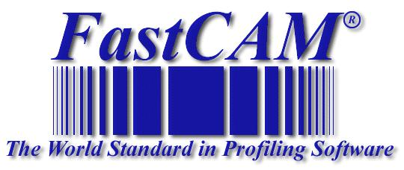

FastCAM have 30-years R&D history and famous brand in the world cutting industry. FastCAM shipbuilding version software is designed especially for shipyard for nesting and programming for Gas & Plasma bevel cutting machine. It is easy to convert Tribon and Hudong shipbuilding files into different NC cutting files with bevels.

Main functions of FastCAM shipbuilding software:

* CAD drawing: similar to AutoCAD, to draw all kinds of parts without AutoCAD experience
* CAD compatible and Optimizer: to read in and optimize DXF/DWG files by delete, compress, extract, explode
* Tribon convert: auto convert Tribon.GEN files into different NC cutting format.
* Hudong convert: auto convert Hudong Dongxin DAT files into different NC cutting format.
* Bevel programming: simply edit V, Y, X, Y bevel model to generate bevel NC cutting files.
* Cutting functions: Kerf compensation, plasma bridge, corners, CAD layers, word label
* Manual nesting: Up, down, left and right, turning.
* Automatic nesting in a row or in a matrix
* Fully automatic true shape nesting
* Interactive nesting combined auto and manual nesting by integrating human beings experience and wisdom.
* Remnant nesting for irregular remnant or parts
* Auto common-line nesting: common line nesting and edge cutting, reduce piercing, and increase productivity.
* Bridge cutting and continue cutting: realize continually cutting, reduce piercing and saving consumables.
* Bevel nesting: realize bevel parts auto nesting with normal no-bevel parts and continue cutting.
* Automatic & manual program: including cutting routine, marking, word printing, multi-layer cutting, bevel cutting
* Support multiple CNC control: ESSI & EIA G/M code, and overseas and local controllers
* Techniques: kerf comp., pre-pierce, stitch& tag cutting
* NC Verification: automatic & manual simulation, dimension and kerf compensation verification
* Costing: utilization, cut length, pierce & cutting cost
* Transfer NC files to CAM/DXF/DWG files, and convert NC files for different cutting machine.

FastCAM Support: Windows98/2000/NT/XP/Vista

FastCAM support multi-language: Chinese/ English/ German/

French/Spanish/Polish/Korea/Czech/Russian/Japanese etc.

**1.3.7 Plasma power**

## American Hypertherm POWERMAX 105

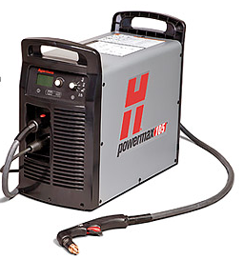

## Overview

The Powermax105 delivers superior cut capabilities on 1-1/4" (32 mm) thick metals. It has the duty cycle and industrial performance necessary for tough cutting and gouging jobs.

Seven Duramax torch styles provide versatility for hand cutting, portable automation, x-y table cutting, and robotic cutting and gouging.

Smart Sense technology automatically adjusts the gas pressure according to cutting mode and torch lead length. It also detects electrode end-of-life, automatically turning off power to the torch to prevent potential damage to other parts or to the workpiece.

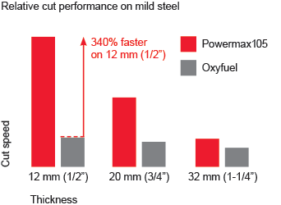

## Operating data

|  |  |  |
| --- | --- | --- |
| Capacity | Thickness | Cut speed |
|  | Cutting | |
| Recommended | 32 mm (1-1/4") | 500 mm/min (20 ipm) |
|  | 38 mm (1-1/2") | 250 mm/min (10 ipm) |
| Severance (hand cutting) | 50 mm (2") | 125 mm/min (5 ipm) |
| Pierce* | 22 mm (7/8") |  |
| * Pierce rating for handheld use or with automatic torch height control | | |
| Capacity | Metal removal rate | Groove profile |
|  | Gouging | |
| Typical gouge | 9,8 kg/hr  (21.7 lbs/hr) | 6,4 mm D x 7,4 mm W  (0.25" D x 0.29" W) |

**1.4 Goods supply range and component elements**

1. Framework assembly: including longitudinal cart, transverse trolley, track, pipeline, draglink.
2. Track assembly: including 15m×2 (24kg/ m) gauge, rack, pressure plate and adjusting seat pad
3. Torch assembly: including 1 set CNC flame torches, 1 set CNC plasma cutting torches, and cutting torch adjusting frame
4. Driving assembly: including servo electric machine, epicyclic reduction gearbox, moving gear and rack
5. Electric control system: including CNC system, CNC box, operation keyboard and high electric control box
6. Gas power assembly: including gas power glue tube, Voltage regulating valve, electromagnetism valve

**1.5 Parts made or prepared by users**

1. Cutting platform, hanging line support frame, track base frame (drawing supplied by provider)
2. Foundation (drawing supplied by provider)
3. Foundation bolt (or expansion bolt)

**1 Moving rotating type SAW welding column and boom**

**1.1 Structure principle**

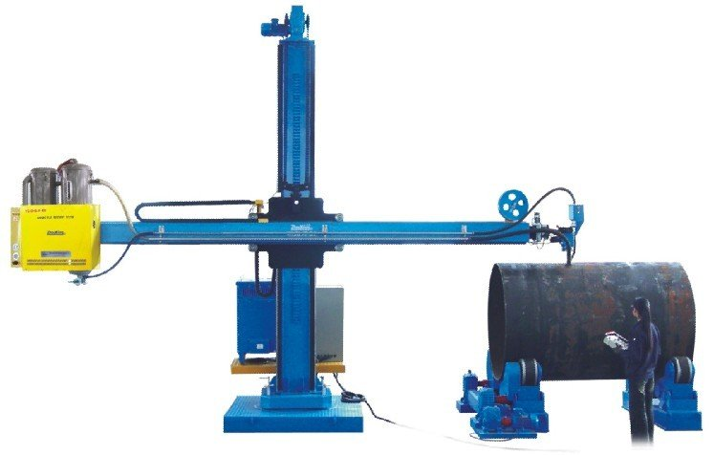

This type welding manipulator is composed of column, welding arm, rotating mechanism, elevating mechanism, expansion mechanism of the cross beam, electrical box, and bottom base and so on. It can meet multi-direction welding requirement. The elevating of welding arm adopted the way of worm gear transmission and chain drive elevating, its speed changed by converter which has stable transmission and slow and stable speed change.Slide carriage is used to adjust the deviation between wire and work-piece. The electrical control box is used to control power on/off, elevating and expansion of boom. In order to be more convenient, there’s also a remote control box which have boom speed adjust potentiometer, boom elevating and expansion switch and column rotating switch. And the control box of welder can install on electrical control box, on the panel have welding current meter, voltage meter, voltage potentiometer, current potentiometer, feeding, back, button, welding start and stop.

**1.2Technical parameter**

**LCH3030 welding manipulator**

* Vertical elevating stroke： 3000 mm
* Horizontal expansion stroke： 3000 mm
* Suitable diameter： 700-3000mm
* Boom elevating speed： 1 m/min
* Boom expansion speed： 0.12—1.2 m/min
* Rotating angle of the column： ±180°
* Forward and backward speed of trolley：3 m/min
* The center distance of the trolley track(mm)： 1500mm

**1.3 Supply range and component**

a. Frame assembly: column, welding arm, elevating mechanism, rotating mechanism, boom expansion mechanism, slide carriage, ladder and moving mechanism.

b. Electrical control system: electric control box, digital display device,

converter, manual control operation box and its accessories

c．Spare parts: three 2A melt cores and one piece of documentation

**1.4 Technical documents**

1. operation instruction (including electrical principle drawing)
2. certification, packing list, foundation drawing of the machine

**1.5 Parts prepared by user**

1. Foundation bolt (or expansion bolt)

**2 Zhouxiang ZX5-1000 SAW welder**

**2.1 Welder name**

ZX5-1000 DC Submerged Arc Welder

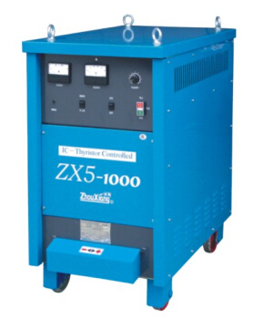

**2.2 Technical Parameters**

* Input voltage and frequency 3～380V 50Hz
* Input capacity 67kVA
* Current ouput range 150～1000A
* No-load voltage 72V
* Rated current 1000A
* Rated load cycle 100%
* Insulation grade F class
* Weight 520kg

**2.3 Welder Features**

* adopt American Lincoln technology,use thyristor to adjust and control.
* main components of control circuit adopts imported parts,has high reliability.
* product meets GB15579-2004 national mandatory safety standard and JB/T7835-95《arc welding rectifier》.
* reliable arcing,high successful arcing rate.
* stable welding performance,little spattor,good welding shapes.
* have the function of submerged arc welding,carbon arc gouging,also can be used as manual arc welder.
* suitable for carbon steel,low alloy steel,stainless steel,heat-resisting steel etc.
* widely used in shipbuilding,boiler,bridge,steel structure and other manufacturing industries.

**3 SAW Flux recovery machine**

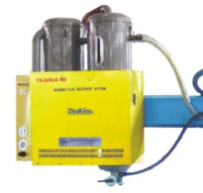

Flux recovery system is composed of flux recovery machine, flux cylinder, flux bucket, flux feeding pipe, flux recovery pipe and so on. They work together to realize automation of flux feeding and recovery process.

**4.Self-aligned Welding Rotator**

**4.1 Structure principle**

Self-aligned welding rotator including one power and one idle, after load on the work piece, the roll will auto suit the work piece, no need to adjust the center distance. The transmission mechanism: motor---multi-step speed adjust----roll, can adopt frequency speed adjust.

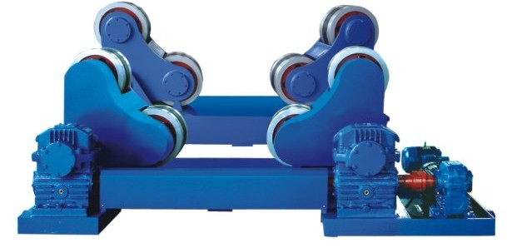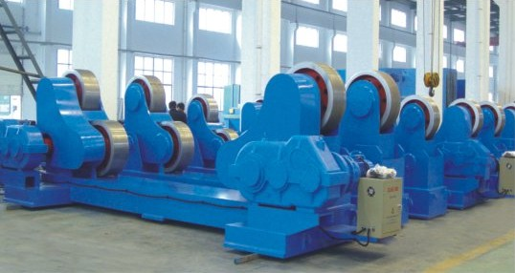

**4.2 Technical parameter**

GLHZ-20

Max load capacity: 20T

Suitable work piece range: ф500-ф3500mm

Roll linear speed: 6-60 m/h

Speed adjust mode: frequency stepless speed adjust

Motor power: 2.2KW

Power roller dimension:2250*930*950mm

Power roller weight:1412kg

Idle roller dimension:1920*490*950mm

Idle roller weight:850kg

**4.3 Products supply range and component elements**

1. frame assembly: one power and one idle rotator
2. Electrical control system: electrical control box, manual operation box and its accessory.
3. Spare parts: two 2A melt cores, two buttons and one piece of documentation

**4.4 Technical document**

1. operation instruction (including electrical principle drawing)
2. certification, packing list, foundation drawing of the machine

**4.5 Parts prepared by users**

1. Foundation bolt (or expansion bolt)