DCSWS-300 Automatic Triangle Tea Bag Packing Machine
Features:
- This triangle tea bag packing machine, can have inner bag with tag and thread with outer bag automatically.
- Packing process: cup doser fill rawmaterial into inner bag then it slip into outer bag.
- Inner tea bag packing machine use ultrasonic can get triangle tea bag and flat three side sealing tea bag.
- Whole packing line use PLC controller and touch screen operation, driving system simple and reliable.

Machine picture as below
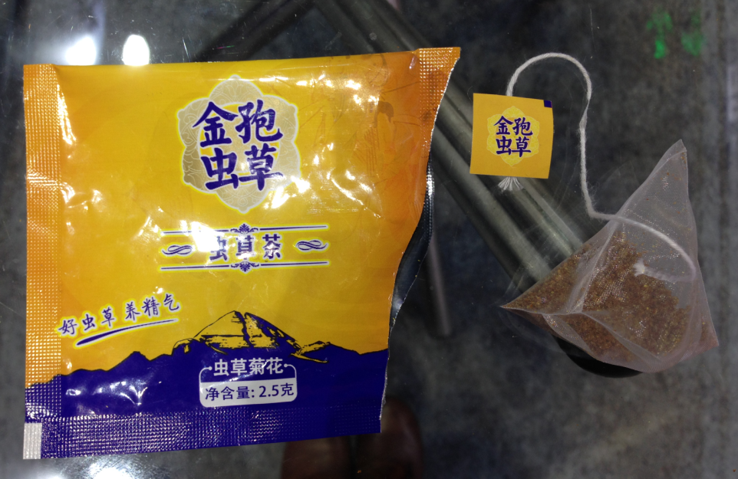
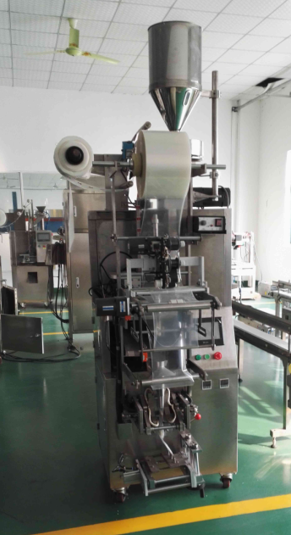
这台设备可以做内外袋，如提供的样袋，
价格是USD25,000

如果只需要做内袋，不需要外袋的话，设备的价格是USD16,600

Technical Specification
Item | Description of Item | Unit Price  in USD | Qty. | Total Price  in USD
01 | Nylon triangle tea sachet packing machine  Model:DCSWS-300  Range of Measurement: ≤3±0.5g Packing Speed:30 - 40bag/min （Depend on Products）  Request of rawmaterial: Tabular tea and length ≤15mm  Packing material: Nylon and printed with line and tag already  Sealing type: Ultrasonic sealing  Air requested: ≥0.6Mpa  Inner film width: 140mm  Outer film width: 180mm, outer bag size: W90*L100mm  Total Power: 380V/1.6KW  Machine Weight:950Kg  Mainframe Dimensions(L x W x H): (1300x1000x1980)mm | 25,000 | 01 | 25,000
Remark: All the price is FOB Port Shanghai.
Guarantee : One year from the date of shipment against any manufacturing defects
Shipment : Within 40-45 working days from receiving 30% deposit
Payment :T/T, 30% deposit in advance and full payment before delivery
Price of wrapping:
US$0.04/bag with thread and tag
6000bag/roll
6 roll/box
MOQ: 5 boxes (STD tag as below)
Delivery time: 10 working days
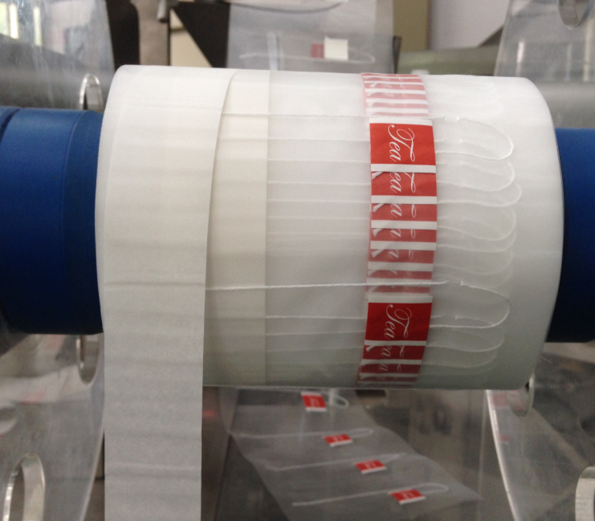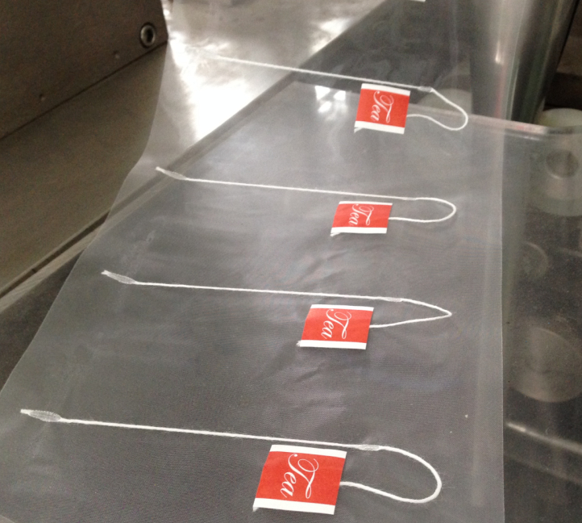
OEM tag: MOQ: 17 boxes and edit fee US$350/color
If your order reach 1000,000 bags, do not need pay for edit fee.
Delivery time: 80 working days.

About outer bag material like PET/AL/PE, US$7/kg, MOQ:500kg, edit fee: each color:US$160

