Dear Nelson Duarte

I am so glad to receive your inquiry again! As we known, the ice selling business is still very promising in Congo，

1. I had read your attached document of specification, most of the parameter is consistent with ours. As for galvanized steel indicated in the document for ice cans material, we would like to confirm whether it is what you want?

Because to protect the tank and ice cans from brine water corrosion, our standard design of brine water tank and ice cans are all made of stainless steel 304. We of course manufacture galvanized steel ice cans as well, it is less durable against brine water corrosion but more economical. What do you think, Nelson? Don’t you think stainless steel ice cans is much better for you?
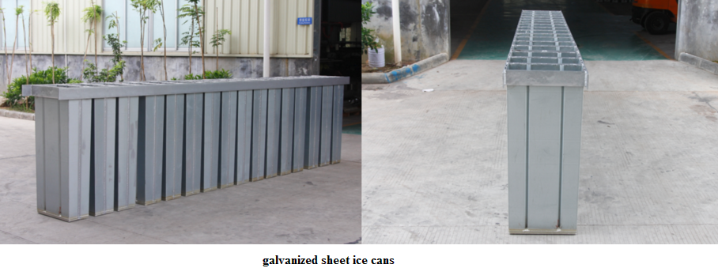

2. The containerized block ice machine is designed for those who doesn't have indoor place to accommodate the machine or want to move the ice production line very frequently. In other words, the containerized machine can be placed directly outside in the open air against sunshine and rain.

Limited by container space, some capacity model can be installed inside the container together with other facilities such as cold room or crane.
Cold room is for ice storage and crane is for ice lifting and ice pouring out of cans. So you have to think about whether it is really necessary for you to make them to be containerized?

Here is the catalog of containerized block ice machine for your reference:

Model | Block ice output  capacity in 24 hours | Ice weight | Cooling system | Available space for facilities
20 feet container block ice machine
JMB10 | 1 ton | 5kg/10kg | Air cooling | 10 m³ cold room
JMB20 | 2 tons | 10kg |  | 10 m³ cold room
JMB30 | 3 tons | 5kg/10kg |  | ×
40 feet container block ice machine
JMB40 | 4 tons | 10Kg | Water cooling | 30 m³ cold room or crane system
JMB50 | 5 tons | 10Kg |  | 30 m³ cold room or crane system
JMB100 | 10 tons | 20kg/25kg |  | Crane system

Looking forward to your reply
Thanks

Best Regards,
Jamko Ye (Sales Manager)

