Dear Nelson

Thanks for explaining your situation!

1. So glad to tell you that we can manufacture the 5 tons capacity block ice machine with air cooling system.

5 tons block ice machine MB50 | Components | price
Complete set 5 tons block ice machine MB50 | Compressor unit with air cooling system | $ 19,430 USD
Stainless steel 304 brine water tank with
126 pieces 10 kg block ice size cans
Complete set 5 tons block ice machine MB50 | Compressor unit with air cooling system | $ 21,810 USD
Stainless steel 304 brine water tank with
88 pieces 20 kg block ice size cans
Crane system of 5 tons block ice machine | supporting frame, hoist, tank for ice demoulding, rack for ice pouring, water refilling equipment | $ 5,030 USD

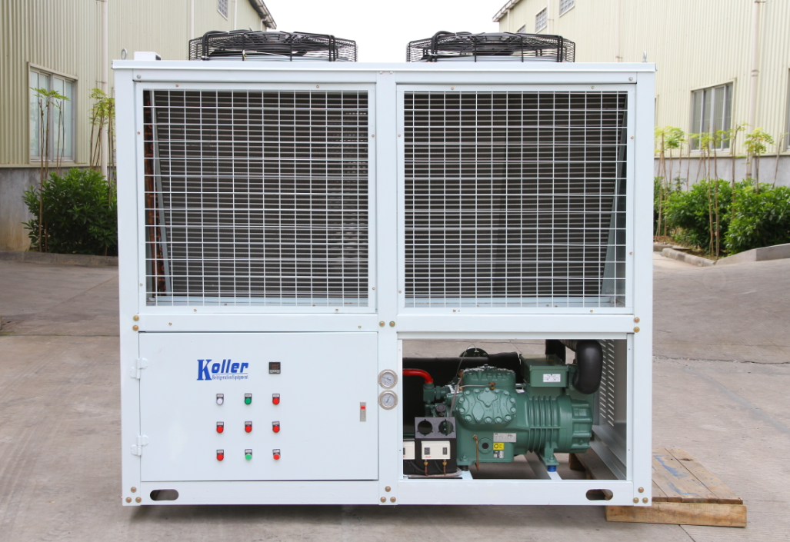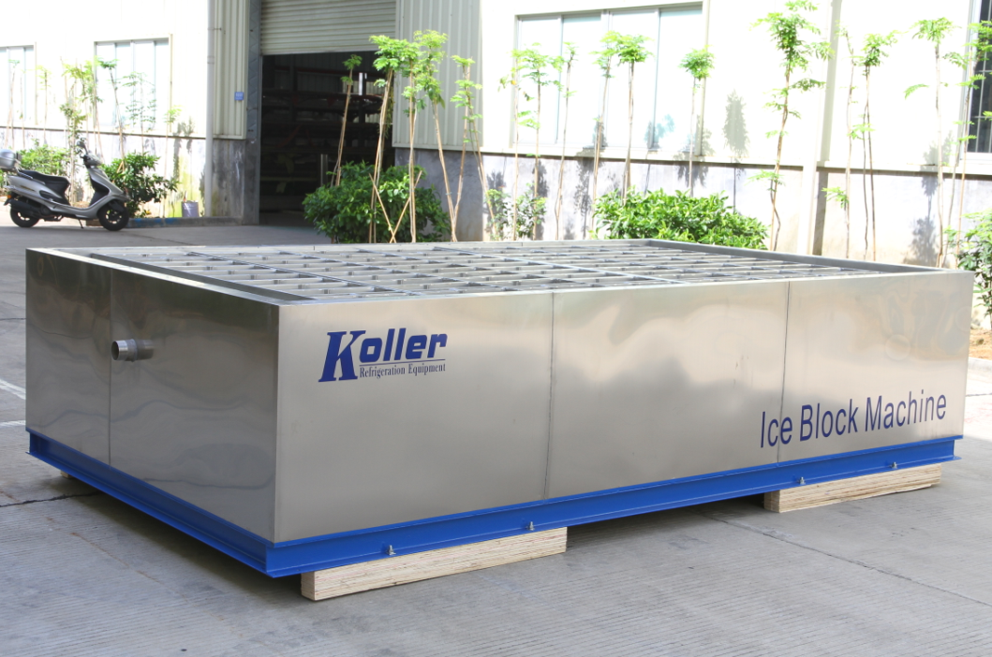
Compressor unit integrated with air cooling system brine water tank with ice cans

2. Layout
For your better reference, here is a video explain how the block ice machine work together with crane system: http://v.youku.com/v_show/id_XNDAxNjcyOTQ4.html?from=y1.2-1-103.3.5-1.1-1-1-4
Please refer to following drawing:
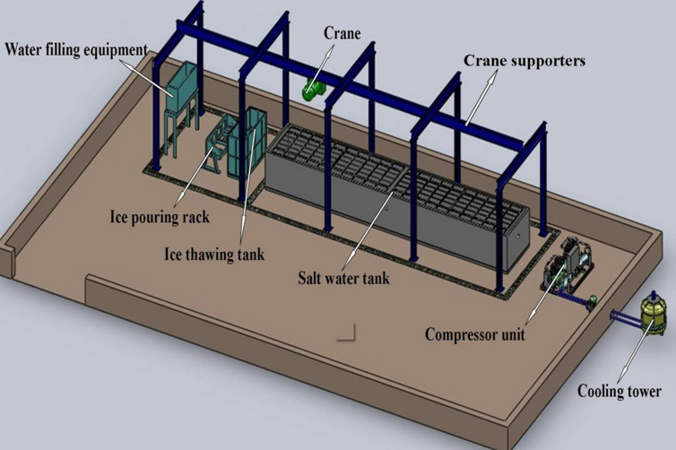

3. As for 10 tons capacity, we have forwarded your case to the technical department to redesign the refrigeration system and recalculate the price. Because like I told you before, our standard design of 10 tons machine equip with water cooling system.

*Mr. Nelson, what do you think of the 5 tons machine? Which ice size you prefer, 10 kg or 20 kg?

Waiting for your kindness reply
Thanks

Best Regards,
Jamko Ye (Sales Manager)

