Dear Emiliano

Good day!

Ice collecting bin with packing function
Do you know how to pack up the tube ice after finish? Well, if you want to sell the tube ice into market, the following facility might be helpful to you.
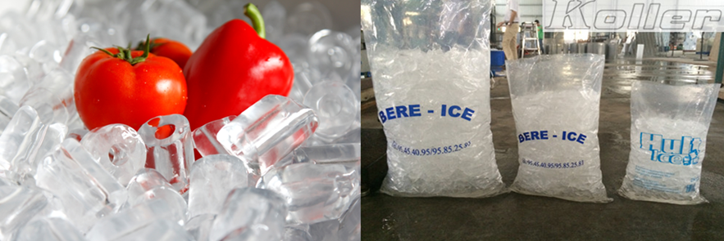
bags of tube ice
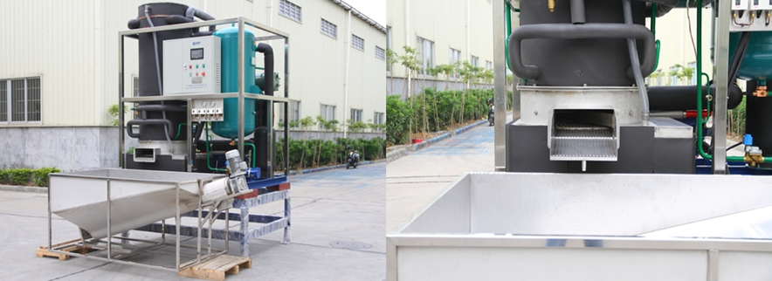
machine combines with ice collecting bin with dispenser

Considering ice packing is really labor intensive, so we develop ice collecting bin with dispenser for ice temporary storage and convenient ice packing.
There is a dispenser on the bottom of the bin, which can convey ice into plastic bag directly by controlling the pedal switch. Here is a Youtube video link that shows how it works: https://www.youtube.com/watch?v=jdgmo5EG3eE
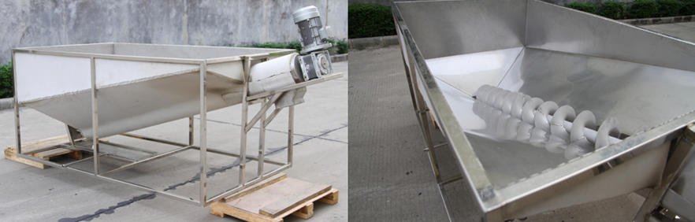
ice collecting bin with dispenser
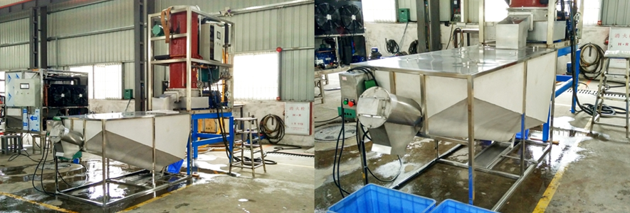
combines with ice collecting bin with dispenser
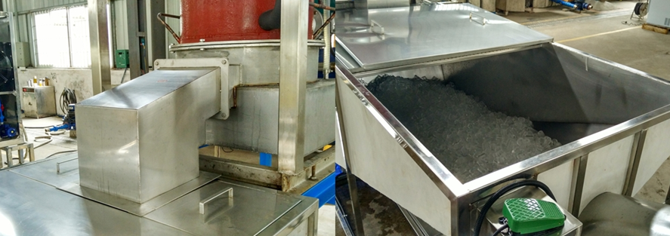
the connection joint tube ice in collecting bin
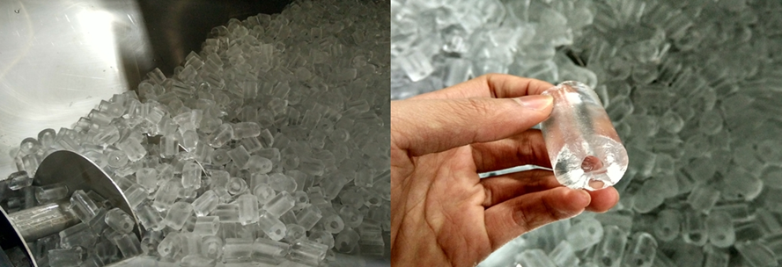
dispenser tube ice
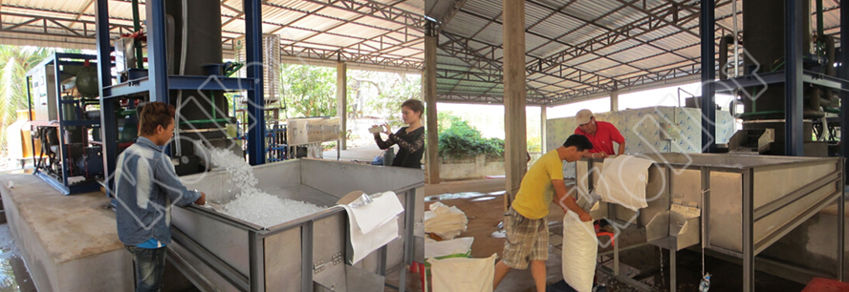
pack the ice into plastic bag directly (20 tons project case in Laos)

Mr Emiliano, are you interested in this machine? If you are, we will quote you price and send you more information.

Waiting for your reply
Thanks

Best Regards,
Jamko Ye (Sales Manager)

