Dear Emiliano

Thanks for your reply!

1. Our FOB price of tube ice collecting bin with packing function for 3 tons and 5 tons tube ice machine is $ 3,500 USD.
The body part and framework are made of stainless steel 304. The price includes 2 parts: the ice bin and supporting rack of the tube ice machine (strong channel steel).
The storage capacity of the bin is around 300 kg tube ice, it equips with a 1.1 KW motor, with dimension 2.0 * 1.0 * 1.5 m.
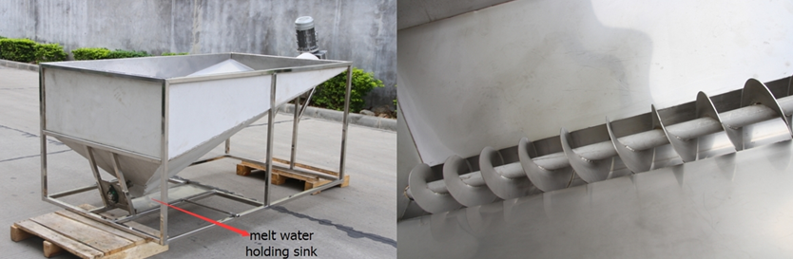
ice melt water holding in the sink dispenser
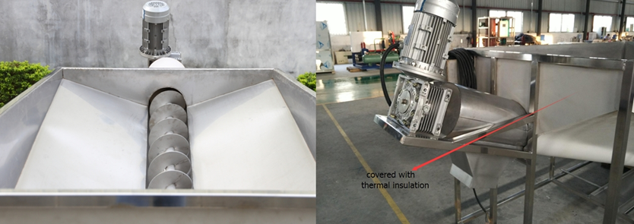
covered with thermal insulation
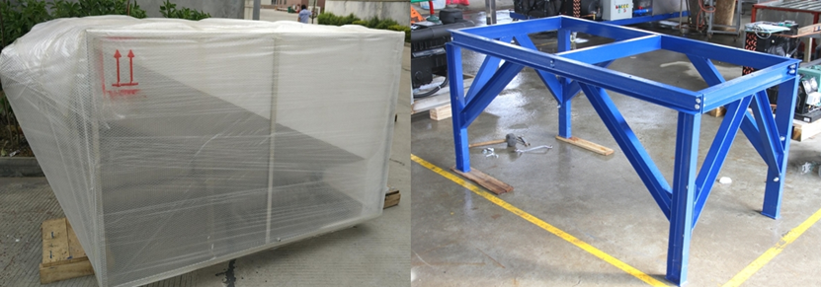
ready for loading tube ice machine supporting rack

2. As for 3 tns and 5 tons tube ice machine with air cooling system, we think we had quoted you price in our second email. Didn't you receive it?
Which capacity you would prefer? Do you prefer the machine equip with air cooling rather than water cooling system?
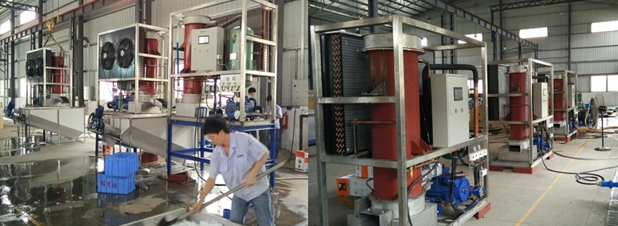
machine testing
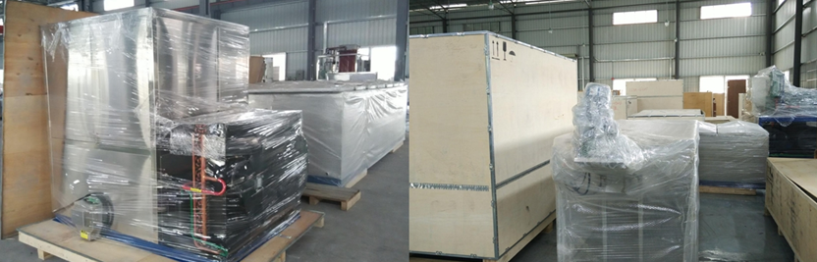
well packed for delivery

3. As for small capacity household cube ice machine (less than 1 ton), all these machine are design with 220V, 50 Hz, single phase supply power in China.
So we are afraid that these machine are not compatible with supply power in Costa Rica.

4. Besides, you will also need a cold room for ice storage. Because it makes the ice with lower temperature and not easy to melt away in short time.
It's good for ice transportation and making your production schedule. You don't have to make ice everyday because you can have ice in stock!
Our FOB price for 10 m³ cold room is $ 4,878 USD, which can storage 2 ~ 2.5 tons ice. Emiliano, are you interested in the cold room?
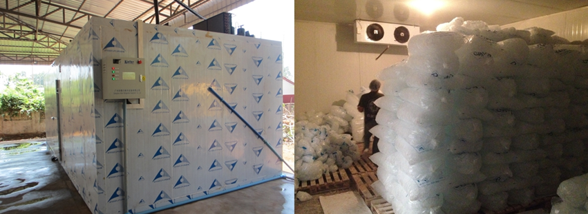
bags ice in cold room
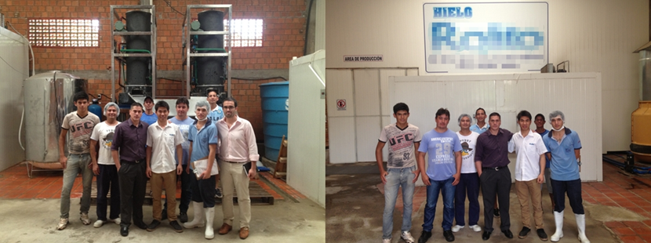technician installation service for free project case in Paraguay

*What do you think, Emiliano?

Waiting for your kindness reply
Thanks

Best Regards,
Jamko Ye (Sales Manager)

