Dear José María Luzón

Thanks for your reply!

1. According to your requirement, the cold room specifications and quotations are as follow:

Model | VCR30 | VCR30
Dimension (L*W*H) | 4.0 x 3.0 x 2.5 m
Volume | 30 m³
Suggested storage capacity | 7 tons
Temperature range | 0 ~ -5 ℃ for fruit & vegetable storage (adjustable) | -18 ~ -20 ℃ for meat & seafood storage (adjustable)
Supply power | 220V, 60 Hz, single phases | 220V, 60 Hz, 3 phases
Compressor | 2 * 1.5 horsepower  Italy Aspera compressor | 2 horsepower  Germany Bitzer compressor
Door size | 1 piece swing door (0.9 x 1.8 m)
Insulated panel material | Double-sides color plate steel sandwiched with polyurethane
Insulated room panel thickness | 100 mm | 150 mm
Insulated room panel density | 42 kg / m³
FOB price

2. The cold room mainly consist of 4 parts, prefabricated insulated room panel, compressor unit, air cooler and electric control box.
Here we share a Youtube video about how to assemble cold room when you receive it, hope you enjoy it: https://www.youtube.com/watch?v=zhmQqoq2eVU

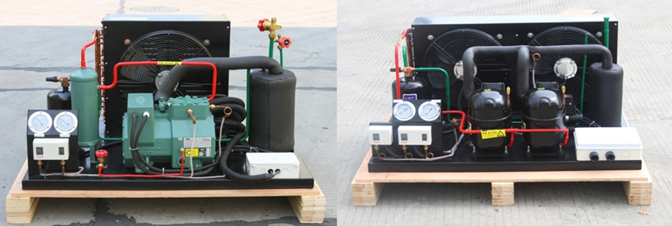
Germany Bitzer compressor unit Italy Aspera compressor
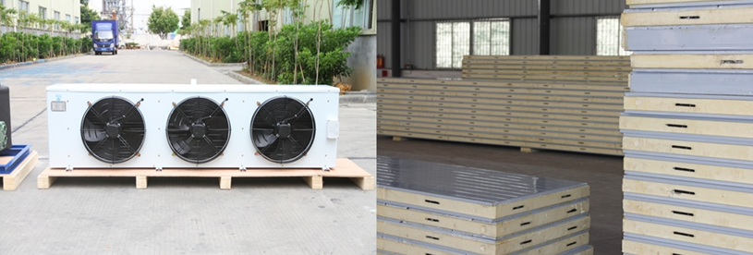
Air cooler insulated panels

*Mr. Luzón, does our cold room products meet your demand or not?

Looking forward to your reply
Thanks

Best Regards,
Jamko Ye (Sales Manager)

