Dear Mamadou Kone

Good morning!

This is Mr Jamko writing from sales department of Koller block ice machine manufacturer.
We learn from Alibaba that you might be interested in our products and wonder if we could help.

To start the ball rolling, here we quote you our minimum capacity 1 ton daily block ice machine for your preliminary reference:

Our FOB price of complete set of 1 ton block ice machine MB10 is $ 5,780 USD.(including all accessories and spare parts)
It has 40 pieces ice portable cans, which can produce 40 pieces 5 kg block ice every 4.8 hours, 200 pieces 5 kg block ice every 24 hours. (capacity 100% guaranteed)

The machine works under 380V, 50 Hz, 3 phases electric power in French or African countries.

Adopt with air cooling system, the installation and operation is very simple, which only involves with power and water supply connection.

Here is a video on how to install and operate our 1 ton block ice machine on Youtube: https://www.youtube.com/watch?v=Lg1PdiwwJR0
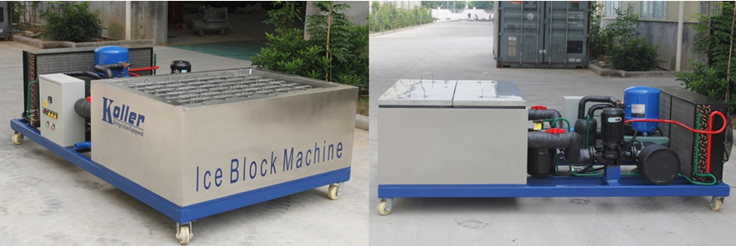
MB10 block ice machine - All the component are integrated to be an all-in-one unit with France brand Maneurop

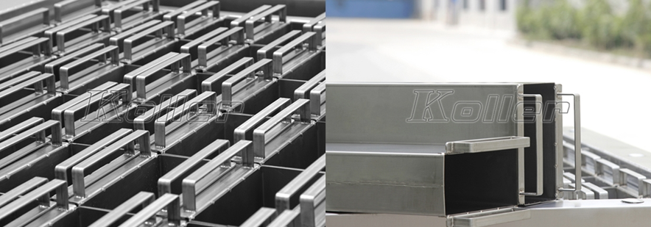
to protect from corrosion of salt water, the ice cans are made of complete stainless steel 304 materical
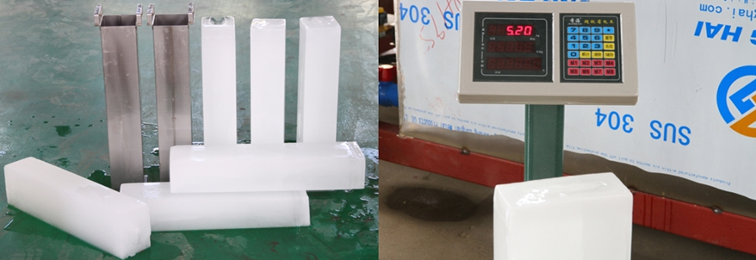
hard and solid block ice - capacity is 100% guaranteed

*Mr Kone, how many tons of ice would you need per day?
Which country will the machine be installed in?

Waiting for your kindness reply
Thanks

Best Regards,
Jamko Ye (Sales Manager)

