Dear Jean Paul Dupouy

Thank you for your reply and have a nice day!

1. Quotation
As for 1, 2, 3, 5 tons cube ice machine, here we quote you price as follow:

Model | Optional cube ice size | Ice making time / shift | Capacity / shift | Capacity / hour | Capacity / 24 hours | FOB price
CV1000 | 22*22*22 mm /  29*29*22 mm | 20 / 23 minutes | 14 Kg | 42 Kg | 1,000 Kg | $ 9,840
CV2000 |  |  | 28 Kg | 84 Kg | 2,000 Kg | $ 13,900
CV3000 |  |  | 42 Kg | 126 Kg | 3,000 Kg | $ 16,710
CV5000 |  |  | 70 Kg | 210 Kg | 5,000 Kg | $ 25,620
* The prices are based on machines work under 440V, 60 Hz, 3 phases electric power in Chile.

2. Reference pictures
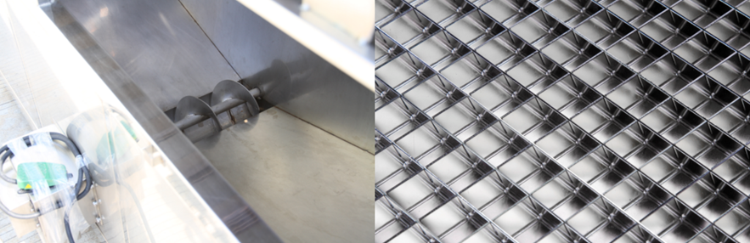
big ice collecting bin with dispenser for packing ice grids are made of brass plated with edible nickel
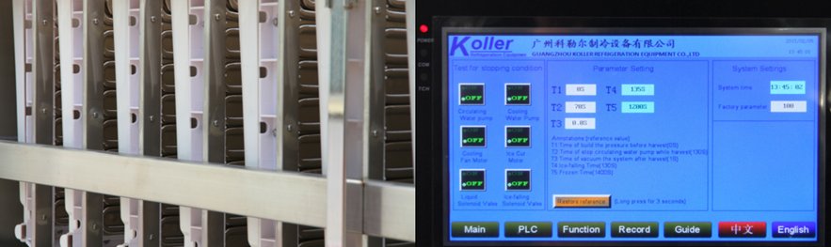
cube ice evaporators touch screen with running condition and fault report

3. Here we share a Youtube video link about how to install and operate the machine when you receive it, hope you would enjoy it: https://www.youtube.com/watch?v=E5__FBLpu-g

4. *Mr Dupouy, which daily output capacity do you prefer?

Waiting for your kindness reply
Thanks

Best Regards,
Jamko Ye (Sales Manager)

