Dear Wilian Gotardi

How are you!

This is Jamko writing from sales department of Koller ice machine manufacturer.
Thanks for your inquiry of our 3 tons cube ice machine from our website http://kollervideo.com.pt/Corporate-Outlook_2.

1. We manufacture and export 1 ~ 25 tons capacity cube / tube / block ice machine for human consumption in restaurant, hotel, drinks shop, night club etc...

As for our 3,000 Kg cube ice machine CV3000, it can produce 3,000 Kg cube ice per 24 hours, 125 Kg per hour, 42 Kg per shift (20 minutes).(capacity 100% guaranteed)
Our FOB price of 3 tons cube ice machine CV3000 is $ 17,100 USD. (including all accessories and spare parts)
This price is based on machine works under 220V, 60 Hz, 3 phases electric power in Brazil.

2. Reference pictures
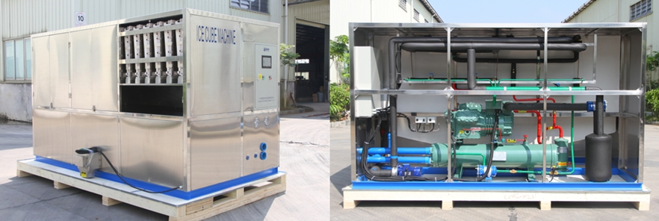
5 tons cube ice machine CV5000 (adopt with Germany brand compressor from Bitzer)
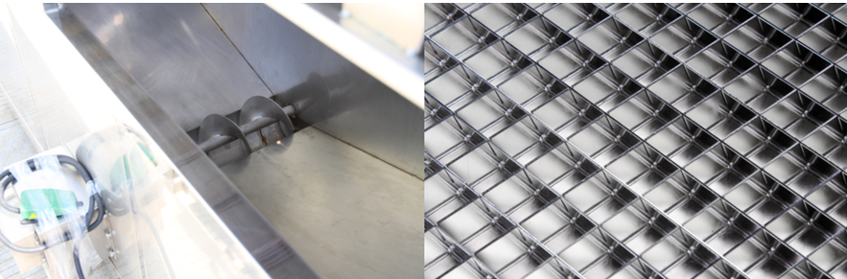
big ice collecting bin with dispenser for packing ice maker grids are made of brass plated with edible nickel
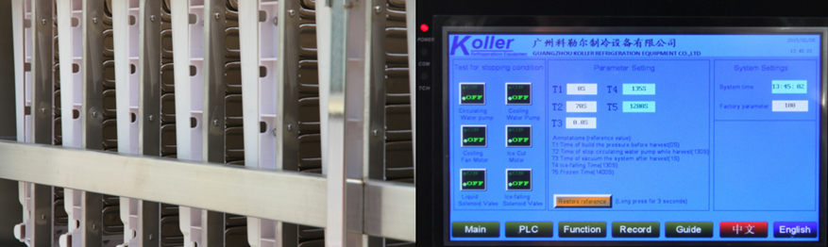
cube ice evaporators touch screen with running condition and fault report

3. Here we share a Youtube video link about how to install and operate the machine when you receive it, hope you would enjoy it: https://www.youtube.com/watch?v=aH-bLsxmX_s

4. Mr Gotardi, what is the industrial electric power form in your place? Is it 220V, 60 Hz, 3 phases or 440V, 60 Hz, 3 phases ?
Doese our 3 tons daily capacity cube ice machine meet your demand or not?

Waiting for your reply
Thanks

Best Regards,
Jamko Ye (Sales Manager)

