Dear Mr. Casenave Pedro

How are you!

This is Mr Jamko writing from sales department of Koller ice machine manufacturer. Thanks for your inquiry of our tube ice machine TV50.
We manufacture 1~20 tons daily capacity tube / cube / block ice machine for human consumption in restaurant, community, hotel, drinks shop, night club etc...

- Specification and quotation
As for 5 tons tube ice machine model TV50, it can produce 70 kg tube ice per shift (20 mins), 210 kg per hour, 5 tons per 24 hours. (100% capacity guaranteed)
Our FOB price of complete set of 5 tons tube ice machine TV50 is $ 23,950 USD. (including complete set of machine and spare parts)
The machine works under 380V, 50 Hz, 3 phases electric power in Argentina.
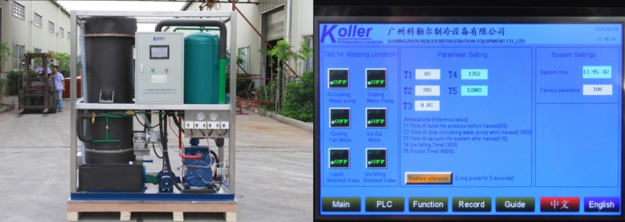
3 tons tube ice machine touch screen with running condition and fault report when it occur

2. The complete set of tube ice machine mainly consists of 1 tube ice machinery unit, 1 cooling tower and 1 cooling water pump.
Here we share Youtube video about how to install and operate the machine with you, hope you enjoy it: https://www.youtube.com/watch?v=yG1CCZK3izo

3. *Mr. Casenave Pedro, does our 5 tons tube ice machine meet your demand or not?
*Have you already owned a tube ice plant?

Waiting for your kindness reply
Thanks

Best Regards,
Jamko Ye (Sales Manager)

