Dear EDER CELI

Good day!

1. Quotation
Fresh water flake ice machine | Compressor | Cooling system | Refrigerant gas | Electric power | Unit price
1 ton | Germany Bitzer | Air cooling | Environmental R404a | 220V, 60 Hz, 3 phases | $ 7,200 USD
2 ton |  |  |  |  | $ 9,900 USD
3 ton |  |  |  |  | $ 11,700 USD
5 ton |  | Water cooling |  |  | $ 20,100 USD
10 ton |  | Water cooling |  |  | $ 31,300 USD

*We don’t manufacture 500 kg, 15000 kg flake ice machine which adopt with right electric power form in Peru.

2. Reference pictures:
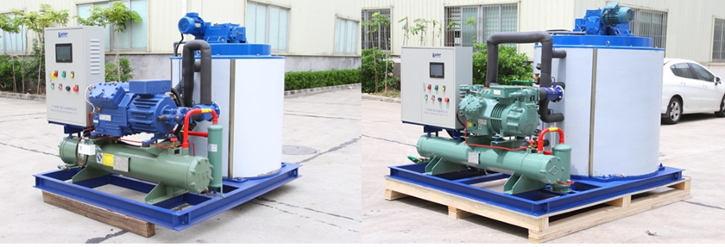
10 tons flake ice machine with Germany Bitzer compressor

Waiting for your kindness reply
Thanks

Best Regards,

