Dear Emiliano Delgado

Good day!

1. Our current maximum capacity of tube ice machine is 20 tons per day.
We will adopt 40 horsepower Germany Bock compressor (HGX7/1860-4) for the 10 tons tube ice machine, and 2 sets 40 horsepower Germany Bock compressor HGX7/1860-4 for 20 tons tube ice machine.

2. Quotation
Fresh water flake ice machine | Compressor | Cooling system | Refrigerant gas | Electric power | Unit price
1 ton | Germany Bitzer | Air cooling | Environmental R404a | 220V, 60 Hz, 3 phases | $ 7,200 USD
2 ton |  |  |  |  | $ 9,900 USD
3 ton |  |  |  |  | $ 11,700 USD

3. Reference pictures:
Here is a video about how to install and operate our block ice machine on Youtube: https://www.youtube.com/watch?v=CusQFuZDJFw
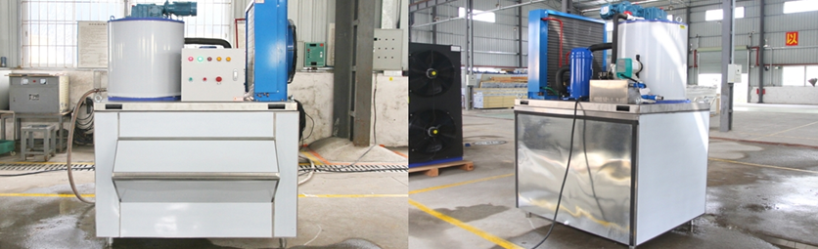
1 ton flake ice machine KP10
*Mr Delgado, what do you think of the machine?

Waiting for your kindness reply
Thanks

Best Regards,
Jamko Ye (Sales Manager)

