Dear Mr. Kurt Donoso

Good morning!

1. This is Jamko writing from sales department of Koller ice machine manufacturer. Thanks for your inquiry of our cube ice machine on Alibaba.
We manufacture and export 1 ~ 25 tons capacity cube / tube / block ice machine for human consumption in restaurant, hotel, drinks shop, night club etc...

2. As for our 2,000 Kg cube ice machine CV2000, it can produce 2,000 Kg cube ice per 24 hours, 84 Kg per hour, 28 Kg per shift (20 minutes).(capacity 100% guaranteed)
Our FOB price of 2 tons cube ice machine CV2000 is $ 13,900 USD. (including all accessories and spare parts)

As for our 4,000 Kg cube ice machine CV4000, it can produce 4,000 Kg cube ice per 24 hours, 168 Kg per hour, 56 Kg per shift (20 minutes).(capacity 100% guaranteed)
Our FOB price of 4 tons cube ice machine CV4000 is $ 22,800 USD. (including all accessories and spare parts)

3. Reference pictures:
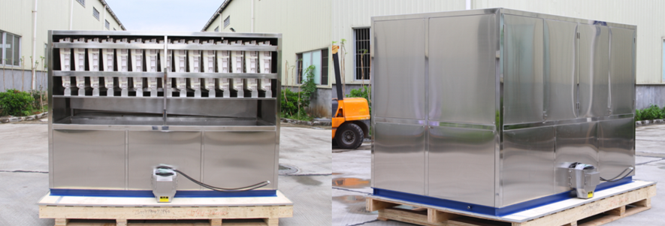
4 tons cube ice machine CV4000 - completely food grade stainless steel 304 framework
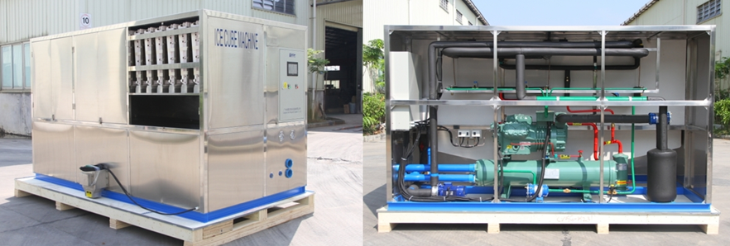
5 tons cube ice machine CV5000- adopt with Germany brand compressor from Bock / Bitzer)
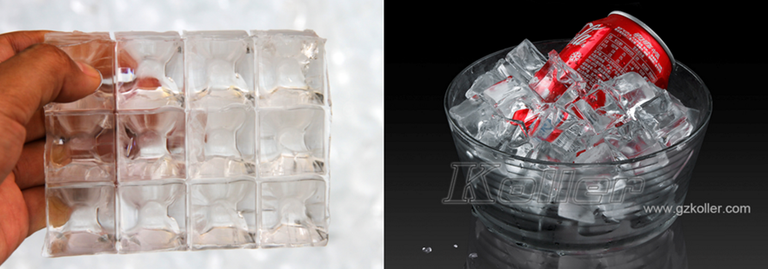
food grade cube ice from machine
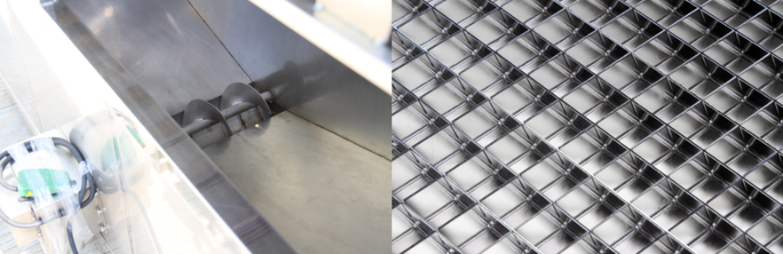
big ice collecting bin with dispenser for ice packing ice grids are made of brass plated with edible nickel

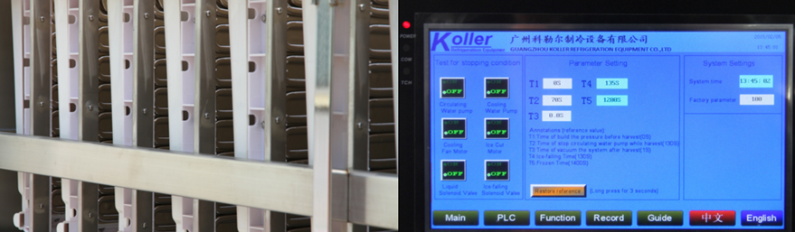
cube ice evaporators touch screen with running condition and fault report

4. *Mr Donoso, does our 2 tons and 4 tons daily capacity cube ice machine meet your demand or not?
According to our experience, the industrial electric power in Chile is 440V, 60 Hz, 3 phases, is it?
Please reply us by email so that we can provide more information about how to establish your cube ice plant.

Waiting for your kindness reply
Thanks

Best Regards,
Jamko Ye (Sales Manager)

