
CHINA JIANGSU INTERNATIONAL ECONOMIC-TECHNICAL COOPERATION
GROUP LTD. (ZJMECH TECHNOLOGY CO LTD.)
Add: Haian Development Zone, Jiangsu, China
Http: www.zjmec.com Attn: Mr Song

Facture Pro-forma
Date: le décembre 30, 2015
N°: 14ALG32ZJ55A1004
A: M/S S.A.R.L OUEST Equipment
Email: Ouestequipement@ymail.com
Kind Atten: Mr Mezouar Mohammed; Mr Bouchakour Ali Amar Nasreedine

Nous sommes ravis de offrir les marchandises suivantes au sujet des conditions et les modalités ci-dessous.
Emballage  Prix  Expédition  Valitité  Alimentation | : Emballage d’exportation standard  : FOB Shanghai, Chine  : Sous les 90 jours  : Sous les 21 jours  : 380V/50HZ/3PH

I : Liste de détails
 | Article | Modèle | U/prix  FOB China | Qté | TTL  (USD)
1 | Presse à ailettes type C ∮12.7mm | ZCPC-65 | USD30100 | 2 | 60200
2 | Moule d’ailettes (1): ∮9.52mm*25*21.65*12Rows*2P |  | USD20000 | 1 | 20000
2 | Pièces de rechange pour∮9.52mm |  | USD3260 | 1 | 3260
2 | Moude d’ailettes (2) ∮12.7mm*41*35*8Rows*1P |  | USD20000 | 1 | 20000
2 | Pèces de rechange pour ∮9.52mm |  | USD3260 | 1 | 3260
3 | Cintreuse d’épingles semi-automatique | ZJBU-9.52*4 /1600mm | USD18000 | 1 | 18000
3 | Cintreuse d’épingles semi-automatique | ZJBU-12.7*4 /2500mm | USD24000 | 1 | 24000
4 | Découpeuse de coiled tube automatique | ZJQX-9.52*2 + 12.7*2 | USD19000 | 1 | 19000
5 | Pistolet pneumatique | M6, M8, M10 | USD220 | 3 | 660
6 | Expandeur portable | ZSZ -12.7/2500 | USD7500 | 2 | 15000
7 | Exbandeur de tube vertical | Model: AFPZ-1500 | USD51000 | 1 | 51000
8 | Cintreuse de coude U | Model: ZXU-9.52 | USD20000 | 1 | 20000
8 | Cintreuse de coude U | Moule: 12.7 | USD8000 | 1 | 8000
9 | Machine d’insertion de bague | ZTH9.52 | USD22000 | 1 | 22000
10 | Machine de soudage automatique | ZSH-1500 | USD52000 | 1 | 52000
11 | Machine de nettoyage pour coude U | ZXU | USD29000 | 1 | 29000
12 | Cintreuse de tube manuelle | 5/8”, 3/4”, 7/8” | USD1500 | 3 | 4500
13 | Poinçonneuse CNC à tourelle | HPM-300 (8station) | USD62800 | 1 | 62800
13 | Moule de poinçonnage de trou |  | free | 8 | 0.00
13 | Alésoir |  | USD250.00 | 6 | 1500
14 | Presse plieuse CNC avec CNC Delem DA-41, vis à billes, onduleur, verrouillage rapide | PB-100/3200 | USD16570 | 1 | 16570
14 |  | 121# (30 degree) | USD480.00 | 1 | 480.00
14 |  | 141# | USD550.00 | 1 | 550.00
14 |  | 132# (R12) | USD590.00 | 1 | 590.00
14 |  | PB-80/2500 | USD16000 | 1 | 16000
14 |  | 121# (30 degree) | USD380.00 | 1 | 380.00
14 |  | PB-40/1500 | USD11940 | 1 | 16000
14 |  | 121# (30 degree) | USD380.00 | 1 | 380.00
15 | Cisaille-guillotine avec NC E21, vis à billes, onduleur, lame 6CrW2Si | SBSH-4*3200 | USD10300 | 1 | 10300
15 |  | SBSH-4*2500 | USD9100 | 1 | 9100
16 | Encocheuse hydraulique avec angle ajustable | HN4/200 | USD6200 | 1 | 6200
17 | Presse hydraulique ( simple action 200-Ton, w/ operation à bouton classique) | YAN32-200 (table de travail 1500 L-R x 1200 F-B) | USD26000 | 1 | 26000
17 | Moule combiné poinçonnage + alésage 15mm (5 tailles, 1.2mm) (220, 265, 320, 365, 420mm) | Cadre moulé | USD9600 | 1 | 960  0
17 |  | 5 tailles | USD8460 | 5 | 42300
18 | Compresseur à air à vis | SMAC-22KW | USD4890 | 2 | 9780
18 | Réservoir d’air | 2m3, 1MPa | USD1500 | 2 | 3000
18 | Sécheur à air | SMLG-5GF | USD1000 | 2 | 2000
18 | D’autres accessoires | Comme notre liste | USD3025 | 2 | 6050
19 | Cisaille manuelle | GS1000 | USD1500 | 1 | 0.00
 |  |  | Réduction |  | -30750
 | Total FOB Shanghai USD |  |  |  | 578710.00
C’est-à-dire, cinq-cent-quatre-vingt-un-milles deux-cent-dix dollars américains au total.

D’autres:
Délai de livraison: 90 jours après la réception de l’acompte.
Modalité de paiement: 15% T/T à l’avance, 85% avant l’expédition après l’inspection dans l’usine du vendeur.
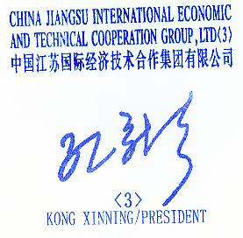
Garantie : 14 mois à compter de la date de B/L ou 12 mois à compter de la mise en service.
Installation: Excluant . Formation gratuite.
Validité de devis: 30 jours
Informations Bancaires:
BÉNÉFICIAIRE: CHINA JIANGSU INTERNATIONAL ECONOMIC-
TECHNICAL COOPERATION GROUP LTD
Banque de notification: BANK OF CHINA, JIANGSU BRANCH
Adresse : 148 ZHONGSHAN NANLU, NANJING, 210005, P.R.CHINA
SWIFT: BKCHCNBJ940; A/C NO.: 532658191164

Vendeur: CHINA JIANGSU INTERNATIONAL ECONOMIC-
TECHNICAL COOPERATION GROUP LTD

-----------------------------------------------------------------

II Details quotation
- FIN PRESS ZCPC-65
RE: C type FIN PRESS Stroke: 120~200spm
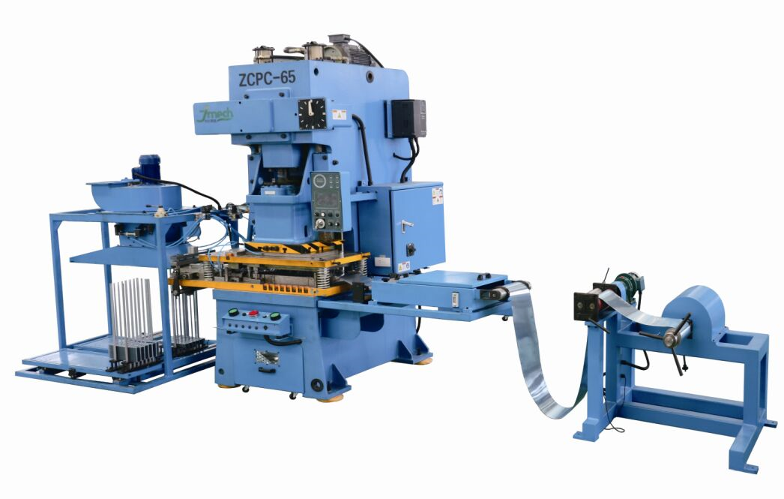
Main performance features of ZCPC series:
● Composition: Aluminum foil uncoiled mechanism, oil tank, initial feeding equipment (option), closed high- speed precision
press, sucker collector, electric control system, pneumatic control system, hydraulic control,quick change die device, High and
reliable technology with Patent 1P/2P changing system;
● The slide has hydro-lifting function which will be convenient for dies installation/commissioning;
● Power press speed & vacuum sucker is controlled by inverter;
● Collector has protecting system for fault operation, material shortage warming, oil shortage warming;
● Hydraulic overload protection for main machine;
● Equipped with hydraulic rapid-dies changing device, making dies change more quickly and convenient;
● Touch screen and PLC electrical control system ensuring the reliable operation of the automatic stamping .

Main characters & function:
Technical Specs: | ZCPC-65
Capacity | 650KN
Nominal pressure stroke | 1.5mm
Slide-strokes | 40mm/ dia 9.52 fin die; 50mm/dia 12.7mm Fin die
Stroke per minute | 120~200spm; 120~180spm
Die height | Max 290mm
Die height adjustment | 75mm
Table size | 850*580*80mm
Bottom size of slide | 500×360mm
Width of material | 270mm / dia 9.52mm; 290mm / dia 12.7mm
Stack length | Max 1000mm
Collecting height of material | 600~800mm
Coil ID x Coil OD | Φ75mm/150mm×Φ850mm
Main motor | 5.5KW
Weight | 6000kgs
Overall size | 7200X2580X2950mm

Part chose:
  - Air valve—TACO (Japan)
  - PLC --- OMRON Japan
  - Converter: TECO Taiwan or DELTA Taiwan
  - Pneumatic Solenoid valves: Airtec ( Taiwan)
  - Electric components: TE (France) or LG ( Korea)
  - Pneumatic cylinder: Allgreat or SMC (Japan)
  - Induction switch & sensors & inductor: Autonics (Korea)

Optional : USD5500 included
Industrial Touch-Screen controller
Photo-electric protecting device (not included)
Hydraulic overloading system:

- Re:Fin Die
2.1 FIN Die (1) : Conical collar base, Wave flat surface, Rippled fin edge
- Drawing to be issued for your confirmation
- SPECIFICATIONS:
(1) fins: ∮9.52mm*25*21.65*12R*2P
Tube diameter: ∮9.52
Fin hole: ∮9.83mm+/-0.03mm (ID)
Row Distance:21.65mm
Hole distance: 25mm
Collar height: 3~6 mm (according to fin drawings confirmed)
Fin thickness:0.15 to 0.20mm
FPI: 3 to 6
Fin Surface: plain flat surface
Fin edge: ripple fin edge
Numbers of rows: 12
Progress: 2P
With heating hole (no flaring)
- Die consists of draws, pierce extrudes, reflare, Edge trim, pilot, slit, feed and cut-off station

2.2 FIN Die (2) : Conical collar base, Wave flat surface, Rippled fin edge
- Drawing to be issued for your confirmation
- SPECIFICATIONS:
(2) fins: ∮12.7mm*41*35*8R*1P
Tube diameter: ∮12.7
Fin hole: ∮13.00mm+/-0.03mm (ID)
Row Distance:35mm
Hole distance: 41mm
Collar height: 6~9mm(according to fin drawings confirmed)

Fin thickness:0.32mm
FPI: 2 to 3
Fin Surface: plain flat surface
Fin edge: ripple fin edge
Numbers of rows: 8
Progress: 1P

- Spare tooling recommended as optional order (not covered in price)
 | Items | U/price  (USD) | Q’ty | TTL amount  (USD)
1 | Pierce punch and die | 65.00 | 12 | 780.00
2 | Slitting blade | 100.00 | 4 | 400.00
3 | Edge-trim blade | 340.00 | 2 | 680.00
4 | Cut-off blade | 1100.00 | 1 | 1100.00
5 | Spring | 25.00 | 12 | 300.00
 |  | TTL Amount USD USD |  | 3260.00
- Die consists of draws, pierce extrudes, reflare, Edge trim, pilot, slit, feed and cut-off station

- Re: Semi-Automatic Hairpin Bender
3.1 Model: ZJ-BU-9.52*4/1600
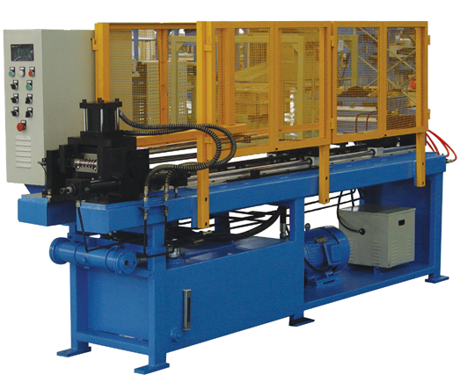
Main specs:
- It is suitable for T2M or TP2M Copper tube (straight)
- Tube specs: 9.52*4pcs tube thickness: each 0.35mm
- Center distance of tube: ∮9.52mm*25mm
- It is max 04 pcs one specs (number of tubes at a time: 4nos)
- Bending length: L200~1600 (stepless adjustable) After bending size
- Bending angle = 180°
- Accuracy:
6.1 Bending ellipse degree: <0.5mm
6.2 Bending length accuracy in two end: 1mm
6.3 Bending area is without obvious deform, crack, wrinkles etc defects
6.4 Tube mouth should be even，max length error ≤ 1mm，cut tube is smooth, flat and without crack
- Bending speed: L=1000mm, 20s/cycle
- Power: 380V/50HZ/3PH
- Hydraulic pressure: 0-6Mpa
- Hydraulic oil: YA-46#, 150L
- Air pressure: >0.5Mpa, 1m3/h
- Oil pump: PV2R2-33-F-EAL,
- Oil pump motor: 3KW
- Water cooling system equipped
Main components:
- Hydraulic system: YUKEN (Japan)
- Pneumatic components: SMC
- PLC: mustubish (Japan)
- Electric components: Fuji or Schneider
Standard accessories:
 | Name | Unit | Qty | Note
1 | Fixing mandrel | pc | 20
2 | Swivel ball mandrel | pc | 20
3 | Stripper tube | pc | 15
4 | Special tools | pc | 1
5 | Wrench | pc | 1
Optional accessories :
 | Name | Unit | Qty | U/price | T/Price
1 | Swivel ball mandrel | pc | 20 | 35 | 700.00
2 | Stripper tube | pc | 15 | 18 | 270.00
3 | E_Magnitic vlave | unit | 2 | 40.00 | 80.00
 | Total FOB Shanghai USD |  |  |  | 1050.00

3.2 Model: ZJ-BU-12.7*4/2500
Main specs:
- It is suitable for T2M or TP2M Copper tube (straight)
- Tube specs: 12.7*4pcs tube thickness: each 0.40mm
- Center distance of tube: ∮12.7mm*41
- It is max 04 pcs one specs (number of tubes at a time: 4nos)
- Bending length: L200~2500 (stepless adjustable) After bending size
- Bending angle = 180°
- Accuracy:
6.1 Bending ellipse degree: <0.5mm
6.2 Bending length accuracy in two end: 1mm
6.3 Bending area is without obvious deform, crack, wrinkles etc defects
6.4 Tube mouth should be even，max length error ≤ 1mm，cut tube is smooth, flat and without crack
- Bending speed: L=1000mm, 20s/cycle
- Power: 380V/50HZ/3PH
- Hydraulic pressure: 0-6Mpa
- Hydraulic oil: YA-46#, 150L
- Air pressure: >0.5Mpa, 1m3/h
- Oil pump: PV2R2-33-F-EAL,
- Oil pump motor: 3KW
- Water cooling system equipped
Main components:
- Hydraulic system: YUKEN (Japan)
- Pneumatic components: SMC
- PLC: mustubish (Japan)
- Electric components: Fuji or Schneider
Standard accessories:
 | Name | Unit | Qty | Note
1 | Fixing mandrel | pc | 20
2 | Swivel ball mandrel | pc | 20
3 | Stripper tube | pc | 15
4 | Special tools | pc | 1
5 | Wrench | pc | 1
Optional accessories :
 | Name | Unit | Qty | U/price | T/Price
1 | Swivel ball mandrel | pc | 20 | 35 | 700.00
2 | Stripper tube | pc | 15 | 18 | 270.00
3 | E_Magnitic vlave | unit | 2 | 40.00 | 80.00
 | Total FOB Shanghai USD |  |  |  | 1050.00

- Re: Automatic Coiled Tube Cutting Machine
Model: ZJ-QX-9.52*2 + 12.7*2
Copper size: 9.52mm*2pcs+ 12.7*2pcs
Tube length cut: 30mm, length: 3000mm
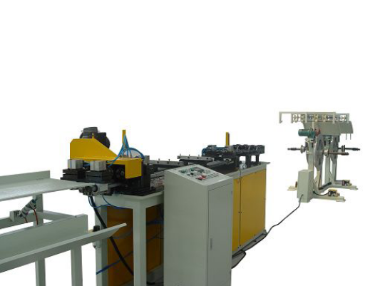
Hydraulic feeding with water cooling system
Feeding size: 1000mm max
Cutting method: Free scrap cutting
Servo motor feeding + ballscrew feeding
Adjustable manual-decoiler, ID: 134mm
4~5pcs/min (1000mm length)
Main motor: 5.5KW
Cutting motor: 1.5kw
PLC control: Mitsubishi
Accuracy: cutting ≤+/-0.5mm (1000mm length)
Straightening: ≤+/-3mm (1000mm length)
Manual adjustment of straightening wheels, 8pcs/set
Cutting blades: 12pcs + tool box + english manuals
1. This is burr free type, cutting blade size: 31x8x12mm
2. Spares: Blade – USD15.00/pc

- Portable Expander Model:ZSZ-9.52
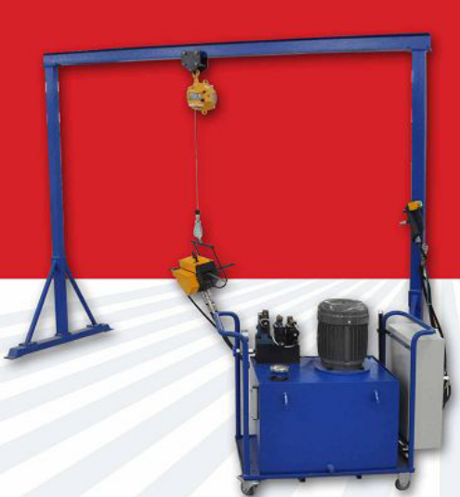 | Maunal Expander:  1. Expanding specifications of copper tube: 12.7mm  2. Length of copper tube: 3000mm. (Tube after bending l ength:1500mm)  3. Center distance: 41mm * 0.32mm thickness  4. Max q’ty one time expander:02 pcs  5. Expanding method: 1 time expanding  6. Manual operation/adjustment  1. Pressure of hydraulic system: 70kgf/cm2  2. Motor: 3KW  3. Oil tank: about 45L  4. Emergancy stop  5. Overall size: 550x200x300  6. Expanding head: 4pcs,  7. Including 1set hydraulic station, 1 set frame, 1 set trolley, 2sets balancer, 2 sets expanding gear and flaring devices
Extra head for dia 9.52* 25mm * 0.35mm

- Vertical Tube Expander Model: AFPZ-1500
Main specs
Valid stroke of expanding pipe: 200-1500mm
Capacity: 42 holes/rows X 6 rows, Number: 252 holes ( to be cnfirmed by customer)
Smooth tube size:φ9.52mm x 0.35mm WT flat
Control way:manual-automatic shift
Speed of expanding pipe:5M/min(fast speed)or less
Motor power:15KW, 380V, 50Hz
Work pressure of hydraulic station:5-10MPa
Cooling water for hydraulic oil-pressure:0.2MPa
PLC control: Control: Mitsubishi
Emergency stop button
EL setting: small motor driving & micro-adjustment
2,3 time expanding mouth adjusting: small motor driving & micro-adjustment
1,2,3 time expanding: at same time
Max expand force: about 35 tons
Mechanic cycle time: about 25 sec
Overall size: about 2200x2200x4800mm
Expanding Way: 3 steps
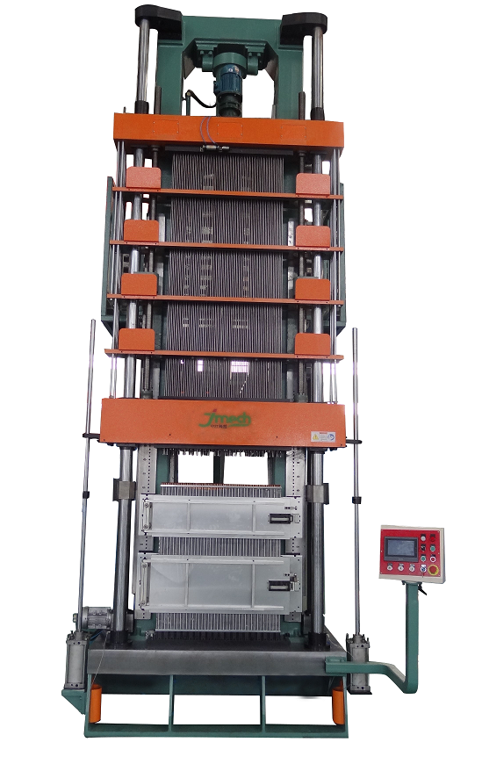 | Standard Accessories:  - Mandrel commissioning/releasing device  - Middle base plate & accessories  - Expanding accessories  - Pattern drawing plate accessories  - Base plate to Hair-pin receiver  - Expanding adjusting device

Stand tools including:
 |  | Q’ty
1 | Expand rod | 144
2 | Expand head ( called bullet also) | 144
3 | Expand sleeve | 144
4 | Flaring sleeve receiving rod | 144
5 | Knock-out sleeve | 48
6 | Level insert acceptor | 72
7 | Slanting insert | 24

- RE: SHORT-U-BENDER MACHINE Model: ZXU-9.52 (to make Elbow)
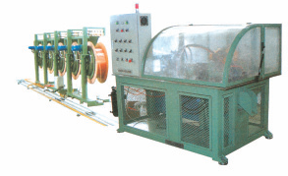
Main specs:
- Oval tube size: 9.52 * 25mm*3pcS, wall thickness: 0.32mm
12.7*41mm*3pcs, wall thickness 0.45mm
- Bending 3pieces at the same time.
- Speed :15s/time.
- PLC Controller
- Oil pressure: 60kgs/cm2 (for oil cooler)
- Air pressure: 4.5~6bar/cm2
- Mechanic/automatic operation,
- Tube-shortage showing
Two die: 1 die 9.52 * 25mm, wall thickness: 0.35mm
1 die 12.7*41mm, wall thickness 0.40mm

- RE: RING INSERTING MACHINE FOR WELDING MODEL: ZTH9.52
This machine is unfit to change die.

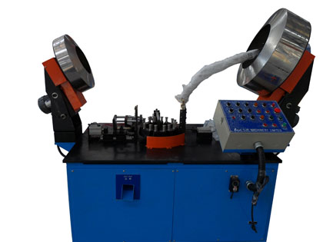
The machine is specially designed to insert the small ring to the small elbow, the welding ring and elbow were feeder separately by feeding and guider to the set position
Main specs:
Diameter of elbow: 9.52mm
Inserting position: 5mm or more from the end of elbow
Capacity: about 3000~3600pc/hour
Cycle time for inserting: 1s
Power: 380V/50HZ/3PH, Control power: DC 24V
Accuracy: 0.25mm
Pressure used: 5kg/cm2, 50NL/m
Environment temperature: 0—40 C degree, Humidity: 20—95%, Dust: little
Overall size: 1400x700x1200mm

- Re:Automatic welding machine Model:ZSH-1500
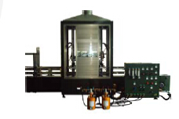
Main specs:
- Max coil height: max 1500mm ~ min 300mm
- Transmission belt: 26meter Length X 190mm Width
- Transmission speed: 0-3m/min
- Blow air pressure: 4kg/cm2
- Oil content rate inside furnace: <= 300PIM
- Air input pressure: 6-10kg/cm2
- Cold air blow pressure: 4kgs/cm3, 300m3/h
- Air working pressure: <=15kgs/cm2
- LPG gas: 7kg/cm2
- LPG working Capacity: 15m3/h, 0.5-1kg/cm2
- N2: 4-16L/min
- Motor: 3.5KW
- Max, height of solder: 1500mm machines type can be selected.
- The burners of special design: 4~6 pieces. Per burner carry angles: 20
- Special gas control cabinet, flow adjustable and with auto fire extinguishing. Strong fire and feeble fire can be changed.
- The angle of welder muzzle can be adjusted, as you like.
- Welding gas: Liquefied petroleum gas and Compress air
- It employs converter, welding speed is adjustable from 300 to 3000mm/min.
- Equipped with the independent welding protective system of Nitrogen with flux, and the independent system of Air cool fines.
- Suggestion:above 2000mm,pls welding by man-made, workpiece is too big,improve station may be more difficult

- Re: Chip-cleaning machine for Small U
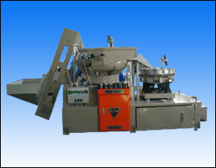 | This machine is used to deal with kinds of small elbows at φ9.52 in heat exchanger. It can remove burring of massive elbows and clean them and make them dry at one time.  1. Feeder, which can convey the small elbows from storage hopper to vibrating grinding machine. The time and frequency can be set.  2. Cleaner, in which both elbows and grinding steel balls vibrate and they rub each other. In the meantime, cleaning agent (about 20min washing) at a certain dilution ratio is added continuously to wash the elbows and the wastewater is discharged. Thus the burring is removed.  3. Dryer, in which elbows automatically is aligned with openings downwards, so as to completely empty the grinding balls in the elbows and to dry them up by electrical heat-blower
II Main technical parameters
Power supply | elbow Size  * height  (mm) | Water  consuming | Center  Distance  (mm) | Air  Pressure  (Mpa) | Quantity of elbows for one clean | Clean  speed  (pc/min) | Dimensions  (cm) | Weight
7.5kW | Dia 9.52 mm | 0.3Mpa, 80L/h | 1~30mm | 0.5~0.7 | 1800 about | 70 | 382*122*192 | 1500kg

Stainless steel ball: 1Cr18Ni9Ti required
PLC control: Omran (Japan)
Pnematic parts: SMC (Japan)
Main electric parts: Chneider, Omron, fuji etc

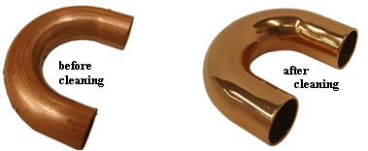

- Re: Manual Hairpin Bender Model: ZJMB- 5/8”, 3/4”, 7/8”
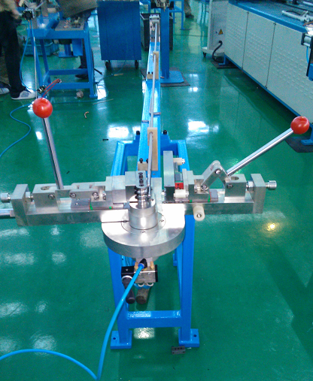 | Main specs:  - It is suitable for T2M or TP2M Copper tube (straight)  - Tube specs:5/8”, 3/4”, 7/8”  - Air cylinder feeding  - It is max 01 pcs one specs  - Bending length: L100~1000  - Bending angle = 180°

CNC Punching Machine from Qingdao AMADA
Press brake, shear from Nantong New Atlantic
Air compressors as per separate File

More specs:

Fin: H22, 8011
Tube: TP2M, Soft

- FIN DIE ONE Φ12.7x41+35x8Rx1P
FIN =0.32mm
Collar height=6~9mm
Width of coil=290mm, ID of coil=Φ75mm
Stroke of press=50mm
- Long U tube Φ12.7x0.4mm thickness
Φ9.52x0.35mm thickness
- Small U Φ12.7x0.65mm
Φ9.52*0.5mm
- Other tube
Φ5/8”x0.6mm
Φ3/4”x1mm
Φ7/8”x1mm
5. Fin die two Φ9.52x25x21.65x12Rx2P
Fin =0.15-0.2mm
Collar height=3~6mm
Width of coil=270mm, ID of coil=Φ75mm
Stroke of press=40mm
With heating hole (no flaring)
- Vertical expander
4Rx14 hole x 2pcs/expanding
>14 hole x 1pcs/expanding

Fin die Φ9.52; fin thickness: 0.13~0.20mm
Fin thickness (mm) | Collar height (mm) | FPI
~0.13 | 3 | 8
~0.15 | 4 | 6
~0.2 | 8 | 3
~0.18 | 6 | 4
Rules of fin
Collar height=25.4/number of FPE - FIN thickness

Fin die Φ12.7; fin thickess: 0.32mm
Fin thickness | Collar height | FPI
0.32 | 6~9mm | 3~4
0.25

------- the end -------------

