Dear Mr. Julio Cesar Ureña

Good morning!

1. This is Mr Jamko writing from Koller ice crusher machine manufacturer. Thanks for your inquiry of our ice crusher machine.
If you want to buy this machine, you have to import it to your country, we can take care the shipping for you. And you would receive the machine when it arrives at your port.

2. Currently we manufacture 4 kinds ice crusher machine for crushing block, cube, tube ice to powder or granular ice size.

*Mr Ureña, what kind of ice are you going to crush?
Do you prefer crushing into granular ice size or powder ice size?

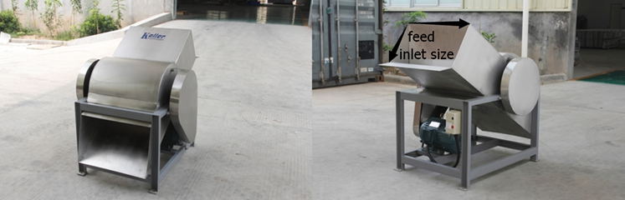
Ice crusher machines made of stainless steel 304 material against corrosion and rust

Looking forward to your reply
Thanks

Best Regards,
Jamko Ye (Sales Manager)

