Dear Mr. Mbany

Good morning!

1. Thanks for your inquiry of our cube ice machine on Made in China.
We manufacture and export 1 ~ 25 tons capacity cube / tube / block ice machine for human consumption in restaurant, hotel, drinks shop, night club etc...

2. Our 3 tons cube ice machine CV3000 can produce 3,000 Kg cube ice per 24 hours, 125 Kg per hour, 42 Kg per shift (20 minutes).(capacity 100% guaranteed)
Our FOB price of 3 tons cube ice machine CV3000 is $ 15,600 USD. (including complete set of machine and spare parts)
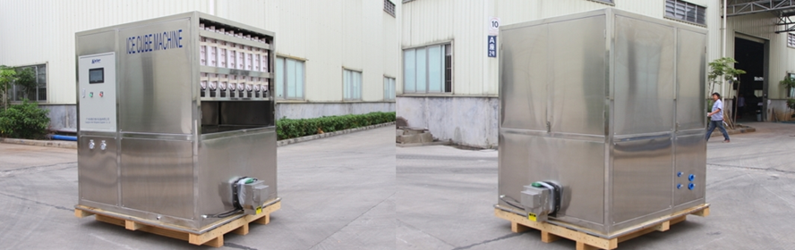
2 tons cube ice machine CV2000 (complete stainless steel 304 body and framework)
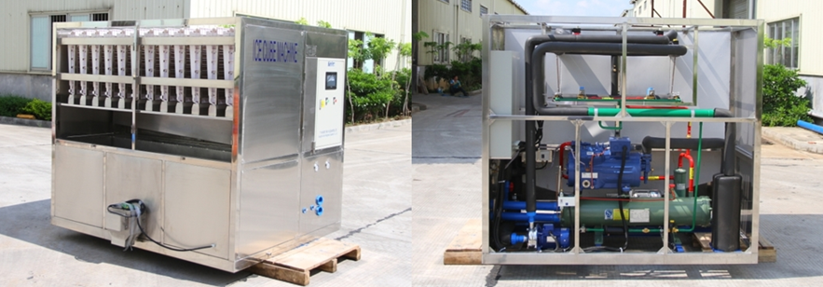
3 tons cube ice machine CV3000 (equip with Germany brand compressor from Bock / Bitzer)

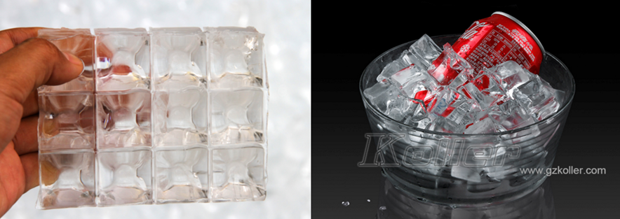
cube ice from machine
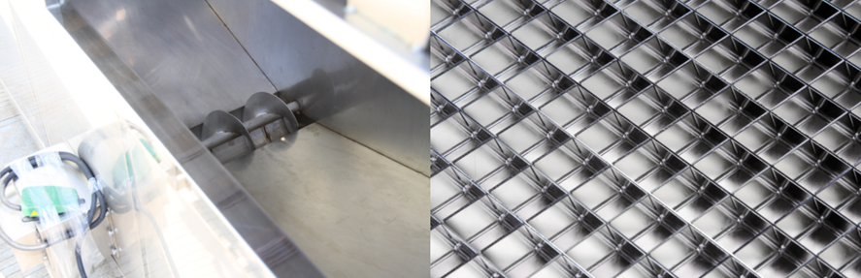
big ice collecting bin with dispenser for packing
ice grids are made of brass plated with edible nickel
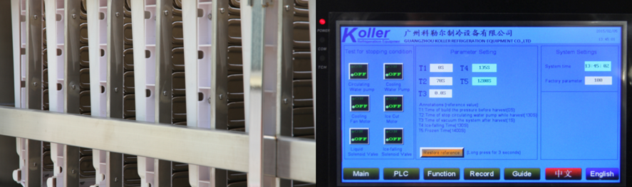
cube ice evaporators touch screen with running condition and fault report

3. The complete set of machine mainly consists of 1 cube ice machine, 1 cooling tower and 1 cooling water pump.
Here we share a Youtube video link about how to install and operate the machine when you receive it : https://www.youtube.com/watch?v=pBazAcw7SmE

*Mr. Mbany, does our 3 tons cube ice machine CV3000 meet your demand or not?

Waiting for your kindness reply
Thanks

Best Regards,
Jamko Ye (Sales Manager)

