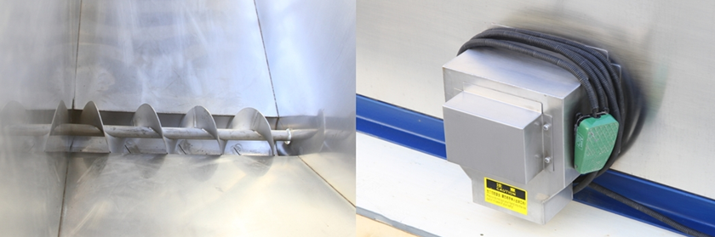
Dispenser & ice collecting bin made of complete food grade stainless steel 304 ice outlet

In that way, you can pack up 3kg, 5 kg, 10 kg or whatever standard of bags ice for the market selling.
Moreover, the bin, the dispenser, ice collecting bin and the machine framework are all made of stainless steel 304 to guarantee food grade standard and sanitary.
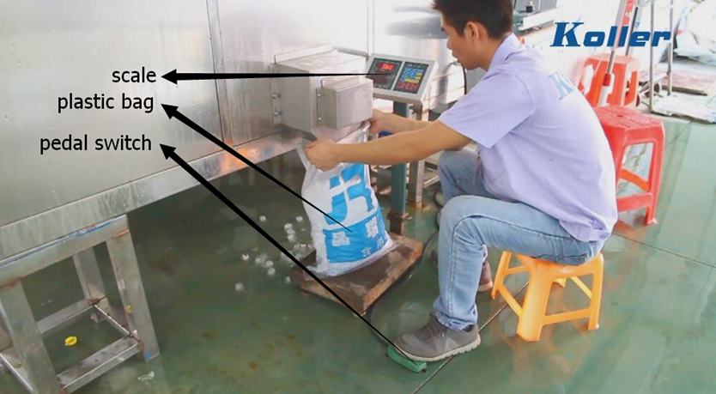
packing and weighting at the same time
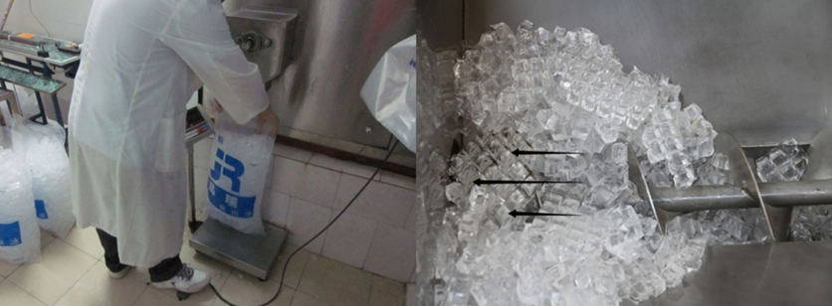
Cube ice packing dispenser conveying ice out from ice collecting bin
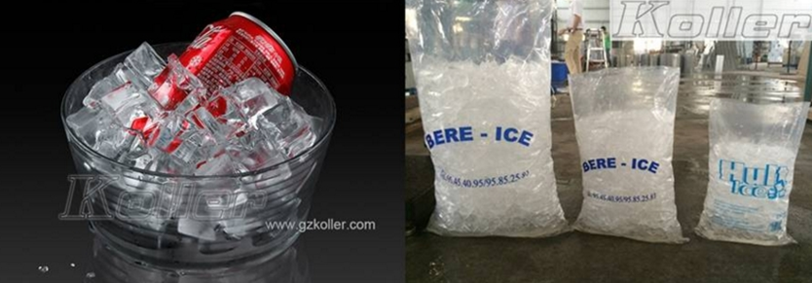
Bags of cube ice

* Mr. Mbany, what do you think of our machine packing function?

Waiting for your kindness reply
Thanks

Best Regards,
Jamko Ye (Sales Manager)

