Dear Mr. Nelso N

Good morning!

1. This is Jamko from sales department of Koller ice machine manufacturer. Thanks for your inquiry of our cube ice machine on Made in China.
We manufacture and export 1 ~ 25 tons capacity cube / tube / block ice machine for human consumption in restaurant, hotel, drinks shop, night club etc...

2. As for our 5 tons per day cube ice machine CV5000, it can produce 5,000 Kg cube ice every 24 hours, 210 Kg every hour, 70 Kg every shift (20 minutes).(capacity 100% guaranteed)
Our FOB price of 5 tons cube ice machine CV5000 is $ 26,200 USD. (including all accessories and spare parts)
The price base on machine works under 220V, 60 Hz, 3 phases electric power in Venezuela.
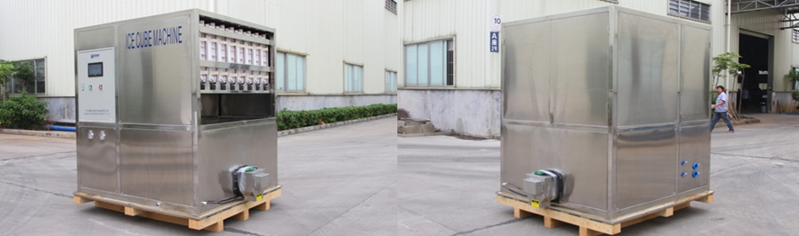
2 tons cube ice machine CV2000 (adopt with Germany brand compressor from Bock / Bitzer)
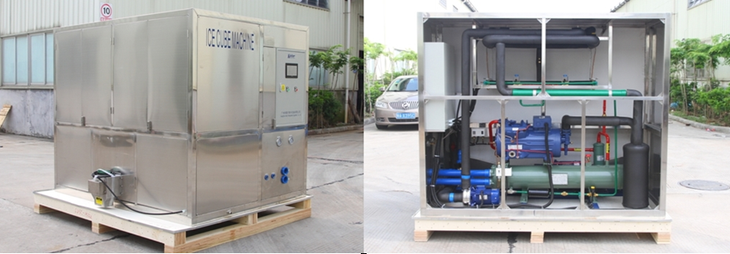
3 tons cube ice machine CV3000
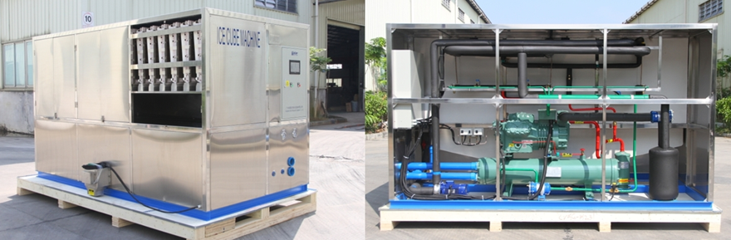
5 tons cube ice machine CV5000
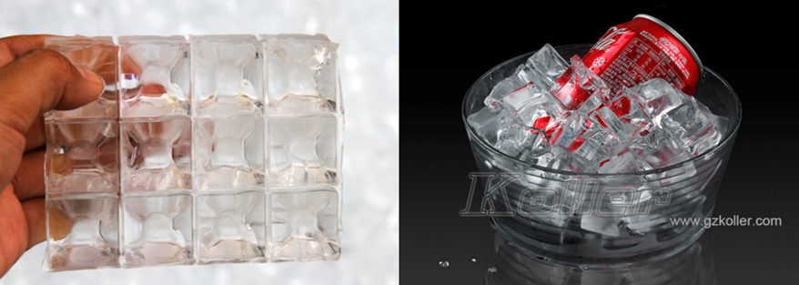
cube ice from machine
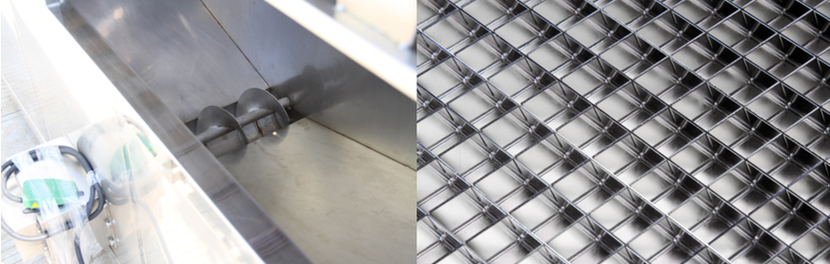
big ice collecting bin with dispenser for packing
ice maker grids are made of brass plated with edible nickel
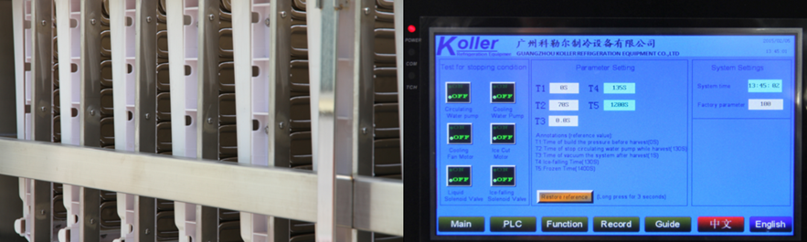
cube ice evaporators touch screen with running condition and fault report

3. The complete set of machine mainly consists of 1 cube ice machine, 1 cooling water pump and 1 cooling tower.
Here we share a Youtube video link about how to install and operate the machine when you receive it, hope you would enjoy it: https://www.youtube.com/watch?v=aH-bLsxmX_s

4. *Mr. Nelso, do you have any idea about the machine?
Does 5 tons daily capacity meet your demand or not?

Waiting for your kindness reply
Thanks

Best Regards,
Jamko Ye (Sales Manager)

