Our engine and generator set for power supply
Our engine and gen-set has been widely used in hospitals, schools, shopping malls, nuclear power plants and other places for power supply and emergency power supply.

2 sets of 850KVA gen-sets in parallel operation in Medicine Hospital
The gen-set with UPS system in red container on the roof of the hospital will switch on when a sudden public power shutdown happens. It will help supply lighting and the operation of medical devices in the hospital to reduce hurt on patients in therapeutic process and damage on expensive medical devices. They have advantages of space saving and low noise.

550KVA gen-set in Goztepe Dental Health Center in Turkey
A gen-set is enough for the temporary power supply for the lighting and dental devices for a dental health center. The gen-sets with UPS system also apply to shopping malls and other public facilities.

2 sets of 700KVA gen-sets in parallel operation in Reis Inn Hotel
The gen-sets could be placed in basement or on the roof of the hotel. It won’t take much space or influence the routines of the hotel.

1250KVA gen-set in Matupo cement plant in Mozambique
The emergency power supply will help prevent accident from sudden shutdown of machinery in the plant and reduce the loss of suspension period and the restart of machinery.
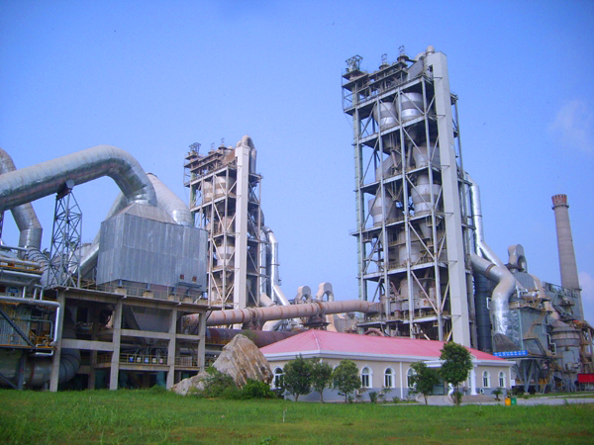

1250KVA gen-set in Letpadaung cooper mine in Myanmar (the largest cooper mine in Asia)

The large power gen-set is used as prime power supply in cooper mine, coal mine and other construction site where there is no stable power supply.
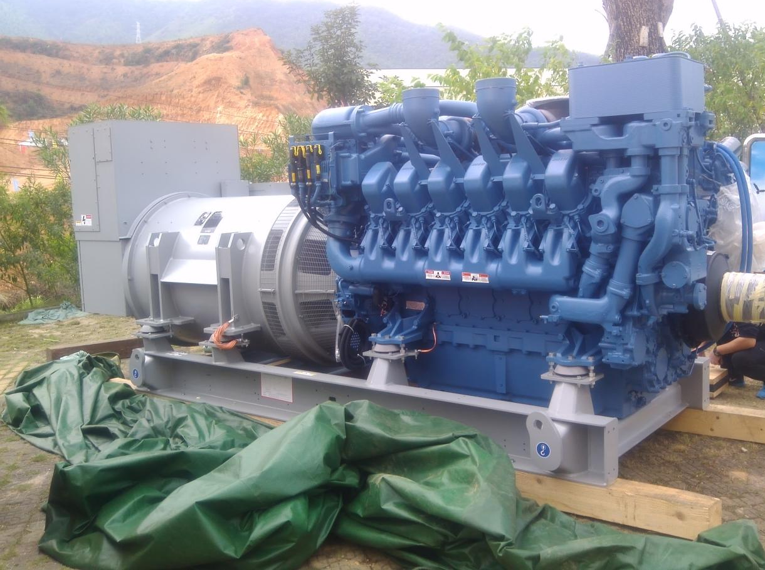

Our engine in power cars (Specially designed for customer)
Applied with the generator set, the car becomes a mobile power plant. The power car will immediately switch into power supply when a sudden natural disaster or accident happens. As a car, it is easy to move for a long distance to the area needs electricity. It has the advantage of low noise and water-proof. The power cars are widely used in coal mine and other remote areas where there is no stable power supply. 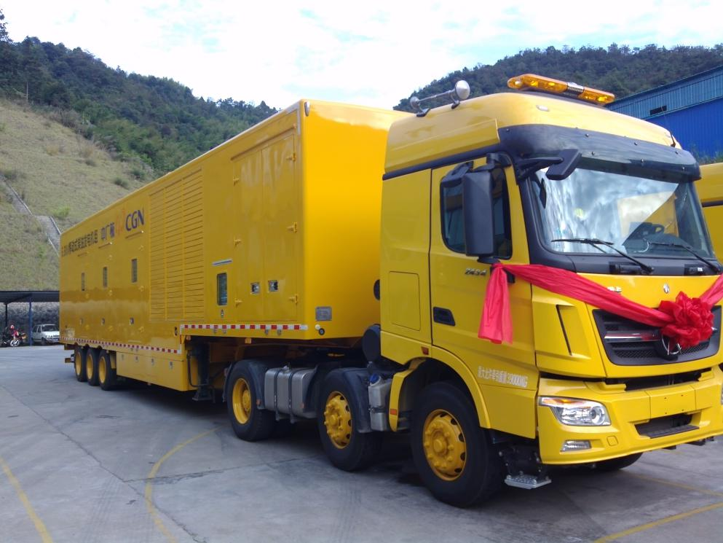

Our engine in mixing plant
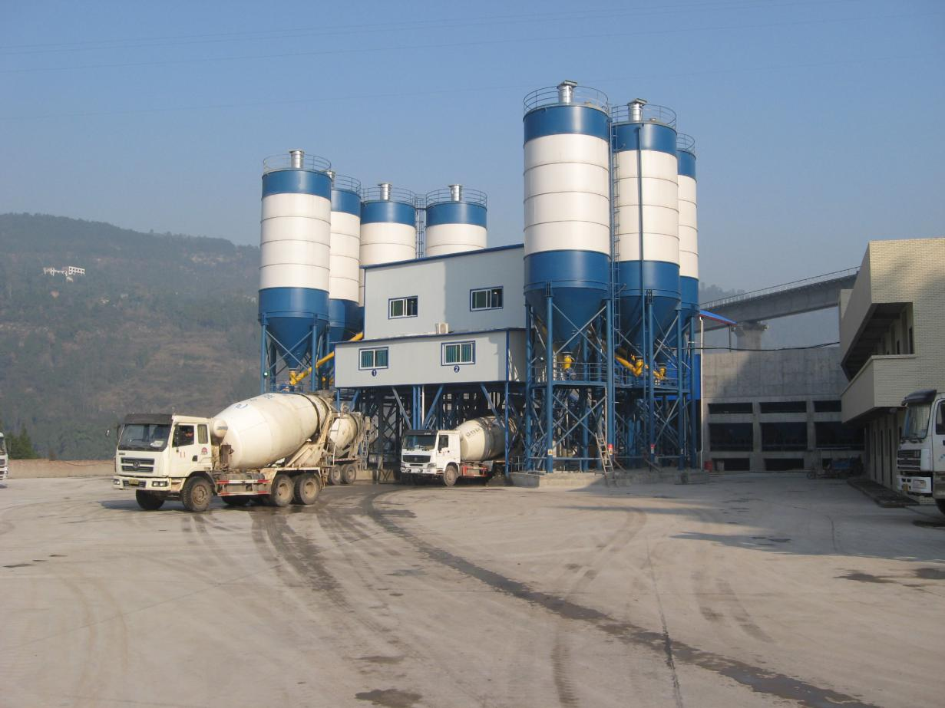

Our gen-set in Yangjiang nuclear power plant
The emergency power supply will help prevent accident from sudden shutdown of machinery in the nuclear plant and reduce the damage of possible pollution and disaster.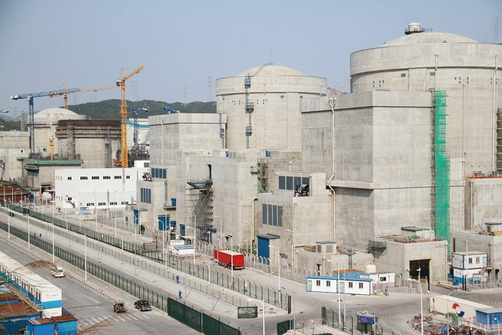

Our engine and gen-set could work smoothly in severe cold, plateau and other extreme conditions.

456KVA gen-set on Pamirs
The gen-set works as prime power supply on the Pamirs Plateau. It works smoothly in severe cold and low atmospheric pressure.
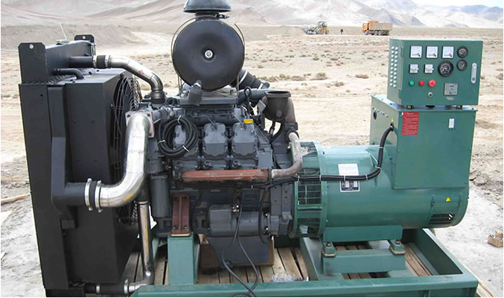

Our gen-set in the 29th Antarctic Station Construction
Most scientific research stations adopt diesel gen-set allowing for its stability. Several gen-sets working by turn is able to guarantee the power supply for the station for 24 hours each day for the whole year without interruption. Our diesel engine works well in the severe cold with its excellent cold starting performance and makes great contribution to the station construction.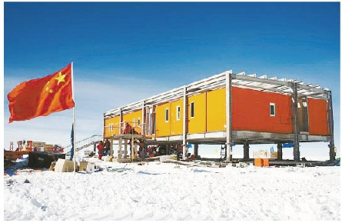

Our engine for construction machinery
Our engine has a wide application in railway construction, public facility construction, agriculture and other fields.

Our engine applied in cotton pickers
The diesel engine could be applied to cotton pickers, tractors and other agricultural machines. Low fuel consumption and strong power makes them good friends to farmers.

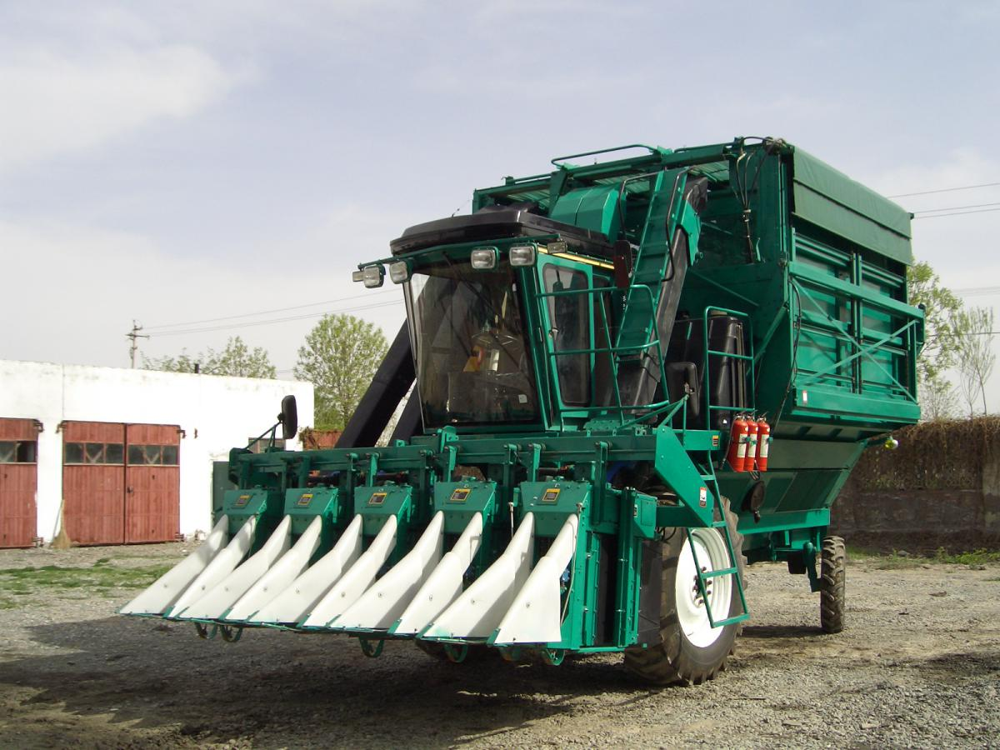

The cotton picker in farmland

With the features of easy maintenance, high power density, and large torque, the construction machines could have good performance in railway, bridge, road construction.

Our engine in girder vehicle
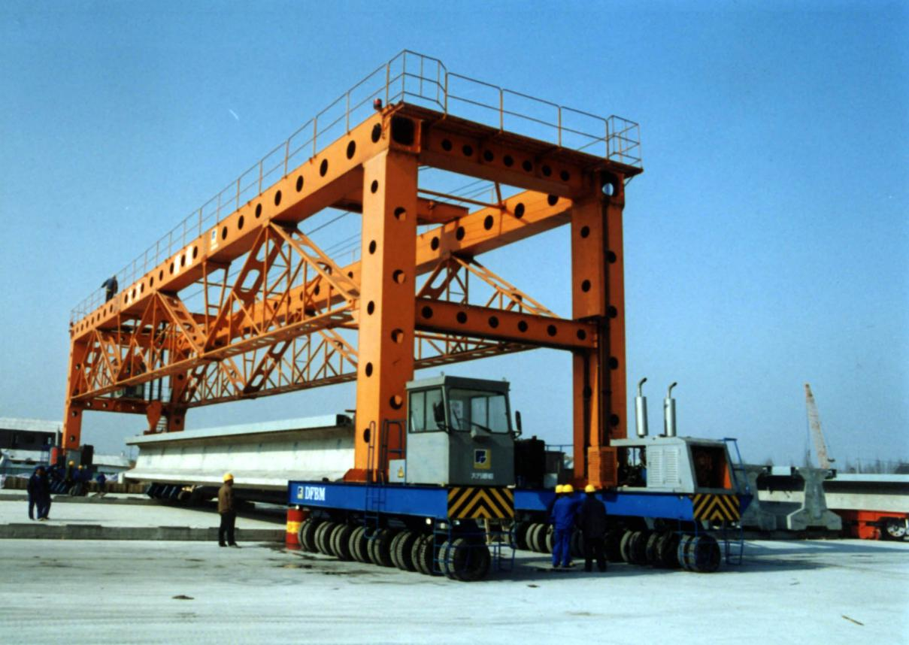

Our engine in bridge erecting machine

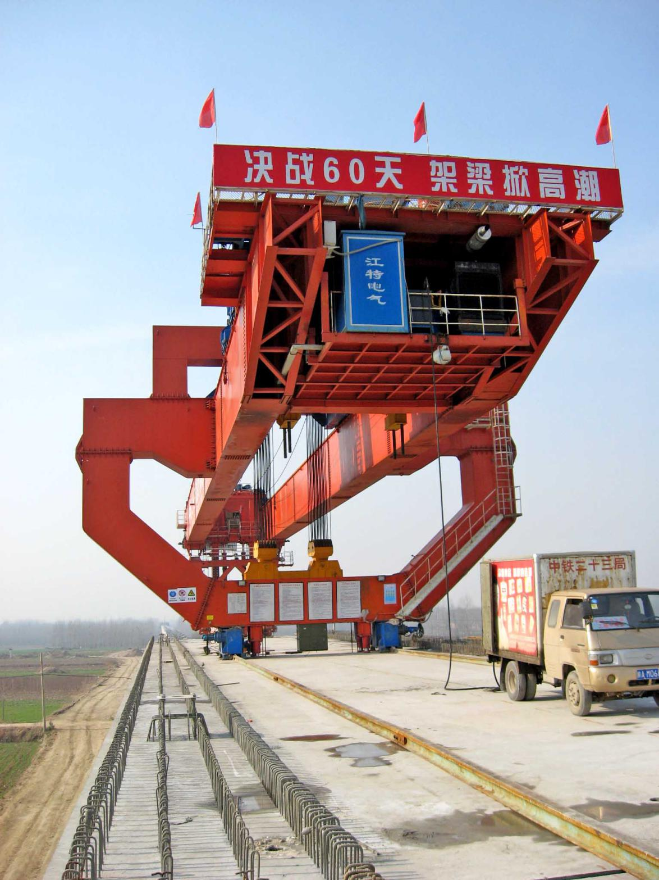

Our engine in girder gantry crane
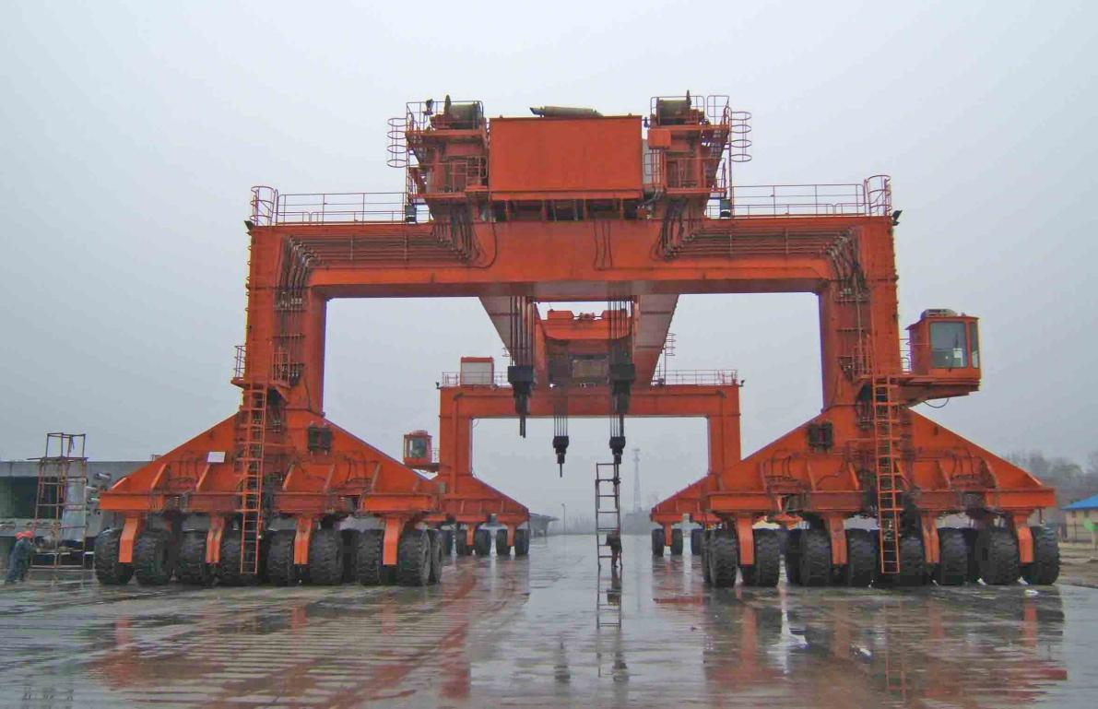

Our engine in railway construction
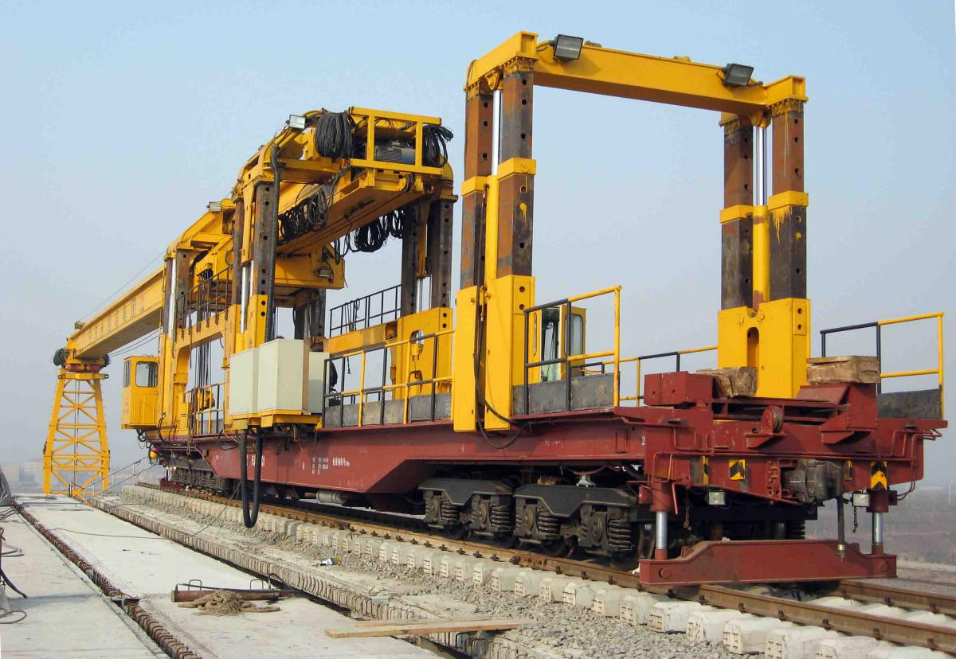

Our engine for vehicles
Our engine has been widely used in domestic vehicles like dump truck, mining truck and tractor truck. The engine is the core of the vehicle. Huachai engine is a good choice for heavy trucks.

Our engine in dump truck
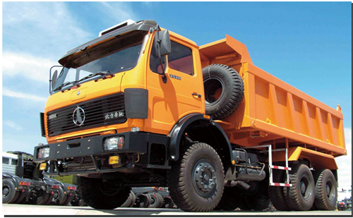

Our engine in mining truck
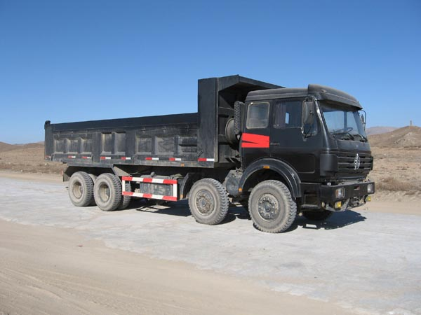

Our engine in tractor truck
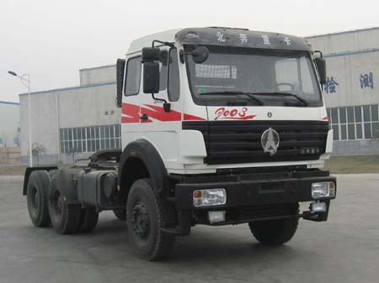

Our marine engine
Our marine diesel engine has become prime power supply for fishing boats and cruises and gained C.C.S certificate.

Our marine engine on inland waterway vessels
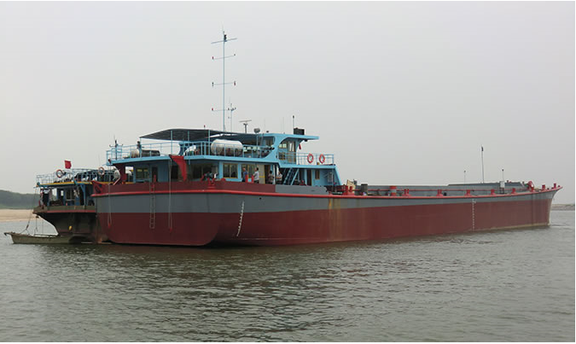

Our marine engine on fishing boat
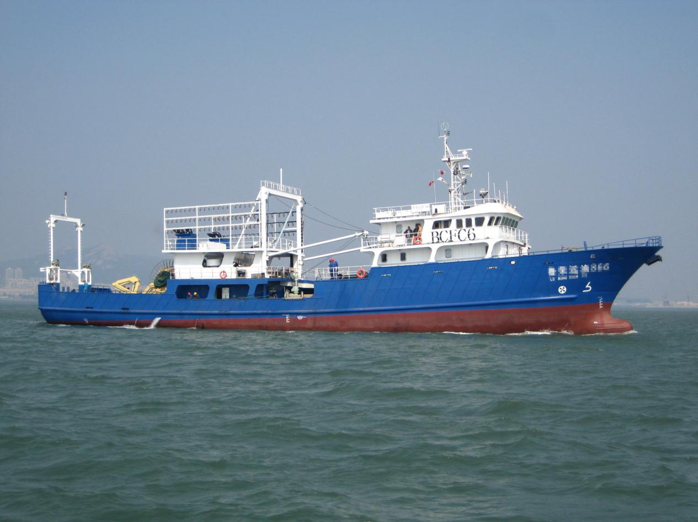

Our marine engine on cruise
