Dear Ismael Alen Augustin Ouedraogo

Thanks for your reply.

1. For your preliminary reference, here we quote you 1 ton block ice machine as follow:

Our FOB price of complete set of 1 ton block ice machine MB10 is $ 5,780 USD. (including all accessories and spared part)

It has 40 pieces ice portable cans, which can produce 40 pieces 5 kg block ice every 4.8 hours, 200 pieces 5 kg block ice every 24 hours.

Adopt with air cooling system, the installation and operation is very simple, which only involves with power and water supply connection.

Here is a video on how to install and operate our 1 ton block ice machine on Youtube: https://www.youtube.com/watch?v=Lg1PdiwwJR0
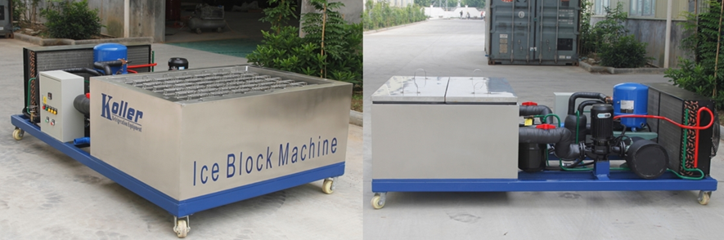
MB10 block ice machine adopts with France brand Maneurop compressor
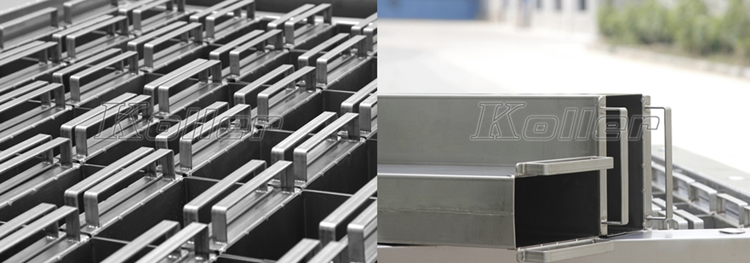
protect from the corrosion of salt water, ice cans are made of complete stainless steel 304 materical
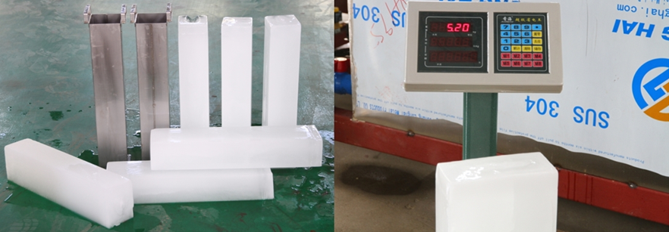
hard and solid block ice - capacity is 100% guaranteed

2. *Ismael, does our 1 ton daily capacity block ice machine meet your demand or not?

For the electricity power issue, you can equip with a diesel generator to run the machine, just as many of our clients from Africa do.

Waiting for your kindness reply
Thanks

Best Regards,
Jamko Ye (Sales Manager)

