Main Parameter |  | FT140 | FTY165-2 | FTY230-3
 |  | 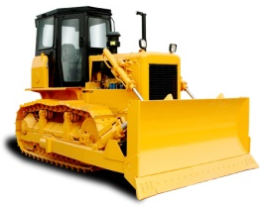 | 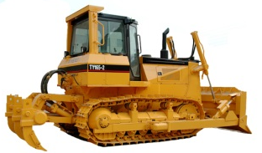 | 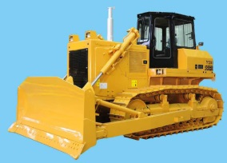
OVERALL DIMENSIONS | mm | 5336×3297×2842 | 5416×3297×3160 | 5733×3666×3380
OPERATION WEIGHT | kg | 16500 | 17200 | 24840
ENGINE |  | Weichai  WD10G156E26 | Weichai  WD10G178E25 | CUMMINS NTA855-C280-S10
FLYWHEEL POWER | kw | 104/1800 | 121/1850 | 169/2000
GRADIENT | ° | 30/25 | 30/25 | 30/25
BLADE TYPE | mm | straight blades | straight blades | straight blades
BLADE CAPACITY | m³ | 4.5 | 5 | 7.8
MAXIMUM DIGGING DEPTH | mm | 400 | 420 | 540
Rippers type |  | unidentate ripper | unidentate ripper | unidentate ripper
MINIMUM GROUND CLEARANCE | mm | 400 | 352.5 | 405
WIDTH OF TRACK SHOE | mm | 500 | 500 | 560
TRACK CENTER DISTANCE | mm | 1880 | 1880 | 2000
EXW Qingdao |  | 53000$ | 60000$ | $105000
Ripper |  | 4700$ | 4700$ | $11000
Delivery time |  | 35 days
Warranty |  | 12 months or 2000 hours
Payment: |  | 30%TT down payment +70% TT paid before shipment

Contact:

Ms. Kelly
Lovol Heavy Industry Co.Ltd
Add: No.192 Beihai Road, Fangzi District,Weifang City ,
Shandong Province, China
Tel: +86 05367512280 Fax: +86 05362288909
Mail: zhangyang@lovol.com Web: www.lovol.com

