Dear Mr Flavio Vasconcelos

Good day!

I know it might be hard for you to choose what daily output capacity ice machine you really need. Here for your reference, we quote you our 1 ton and 2 tons cube ice machine.

1. Our 1 ton cube ice machine CV1000 can produce 1,000 Kg cube ice per 24 hours, 42 kg per hour, 14 kg per shift (20 minutes).(capacity 100% guaranteed)
Our FOB price of 1 ton cube ice machine CV1000 is $ 10,200 USD. (including all accessories and spare parts)

Our 2 tons cube ice machine CV2000 can produce 2,000 Kg cube ice per 24 hours, 84 kg per hour, 28 kg per shift (20 minutes).(capacity 100% guaranteed)
Our FOB price of 2 tons cube ice machine CV2000 is $ 14,200 USD. (including all accessories and spare parts)

Please notice that the machine must works under 220V, 60Hz, 3 phases electric power in Brasil.

2. Reference pictures
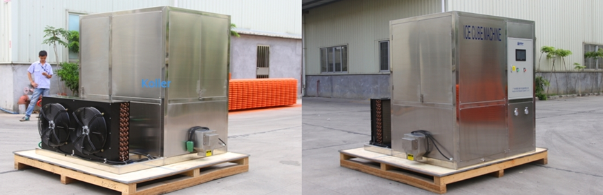
2 tons cube ice machine CV2000
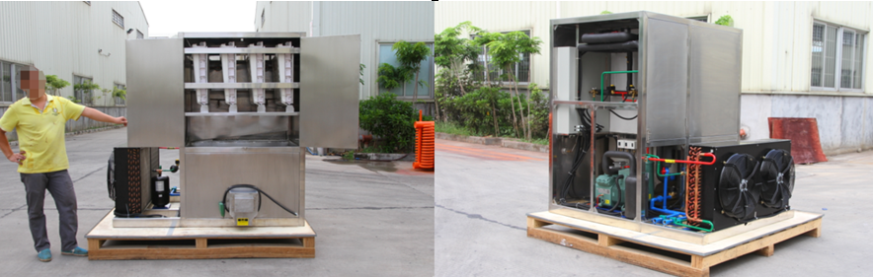
complete stainless steel 304 framework equip with Germany brand Bitzer compressor
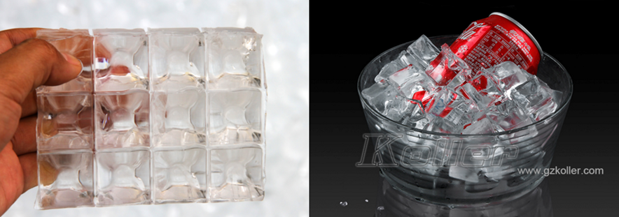
cube ice from machine
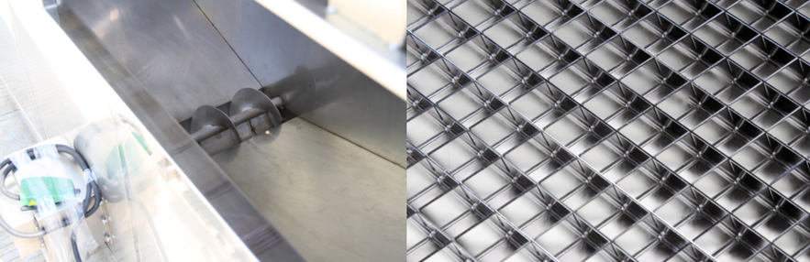
big ice collecting bin with dispenser for packing ice grids - brass plated with edible nickel
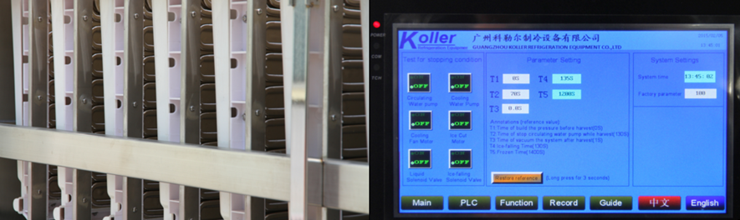
cube ice evaporators touch screen with running condition and fault report

2. Here we share a Youtube video link about how to install and operate the machine when you receive it : https://www.youtube.com/watch?v=GBjl4h5nc0c

*Mr Flavio Vasconcelos, weather our 1 ton and 2 tons daily capacity meet your demand? Or you want larger capacity?

Waiting for your kindness reply
Thanks

Best Regards,
Jamko Ye (Sales Manager)

