Dear Flaviano Vasconcelos

Good day!

Basically, the same output capacity cube ice and tube ice machine prices are so closed.

Our 1 ton tube ice machine is our model TV10, it can produce 14 kg tube ice per shift (20 minutes), 42 kg per hour, 1 ton per 24 hours.

Our FOB price of complete set 1 ton tube ice machine TV10 with air cooling system is $ 10,400 USD.
Our FOB price of complete set 1 ton cube ice machine CV1000 with air cooling system is $ 10,200 USD.
As you see, it not a significant difference, only a few hundreds dollars.
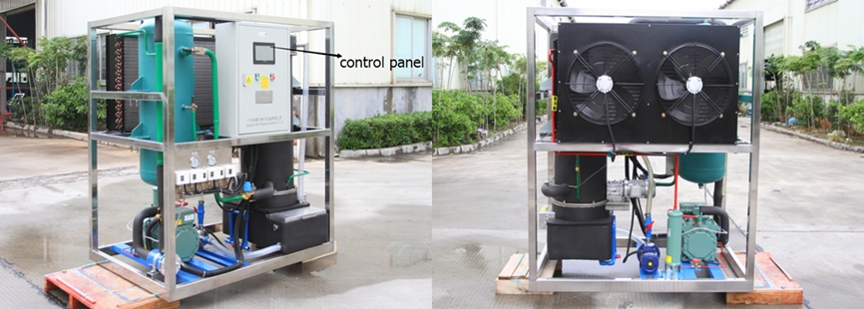
1 ton tube ice machine with Germany Bitzer compressor
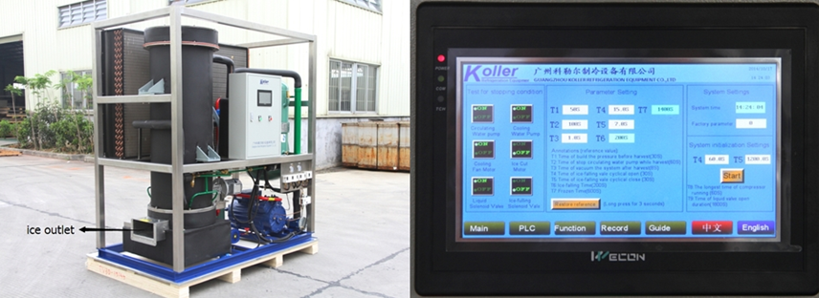
1 ton tube ice machine with Germany Bock compressor
control panel displaying working condition and fault report if occurred

*Mr Vasconcelos, do you prefer cube ice or tube ice?
*Do you want to set up an ice plant to sell ice to the market?

Waiting for your kindness reply
Thanks

Best Regards,
Jamko Ye (Sales Manager)

