Dear Miss Paola Racchi Salvado

Good day!

This is Jamko from Koller cube ice machine manufacturer. Thanks for your inquiry of our products on Made in China.
We manufacture and export 1 ~ 25 tons capacity cube / tube / block ice machine for human consumption in restaurant, hotel, drinks shop, night club etc...

1. As for our 3 tons cube ice machine CV3000, it can produce 3,000 Kg cube ice per 24 hours, 125 Kg per hour, 42 Kg per shift (20 minutes). (capacity 100% guaranteed) The machine works with 380V, 50 Hz, 3 phases electric power in Paraguay.
Our FOB price of 3 tons cube ice machine CV3000 is $ 16,000 USD. (including all accessories and spare parts)

Here we share a Youtube video link about how to install and operate the machine when you receive it : https://www.youtube.com/watch?v=pBazAcw7SmE

2. Reference pictures
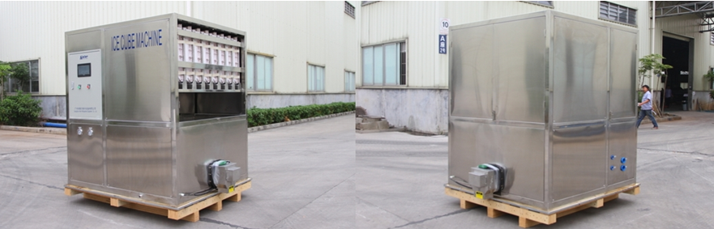
2 tons cube ice machine CV2000
(complete stainless steel 304 body and framework)
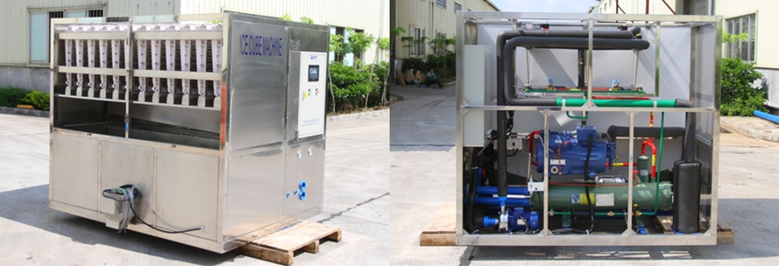
3 tons cube ice machine CV3000
(equip with Germany brand compressor from Bock / Bitzer)
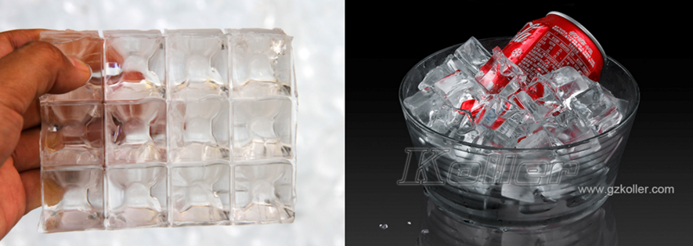
cube ice from machine
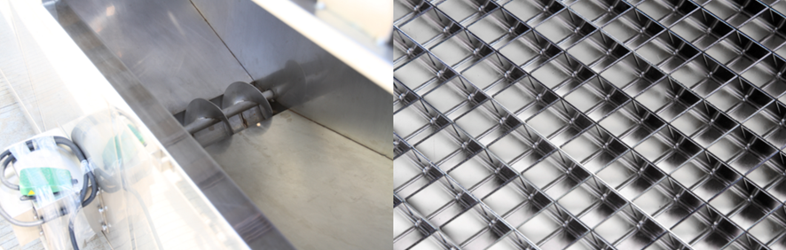
big ice collecting bin with dispenser for packing
ice maker grids - brass plated with edible nickel
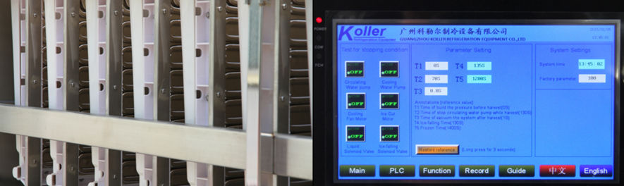
cube ice evaporators
touch screen with running condition and fault report

* Miss Paola Racchi Salvado, does our 3 tons daily capacity cube ice machine meet your demand or not?
Waiting for your kindness reply
Thanks

Best Regards,
Jamko Ye (Sales Manager)

