Dear Mr. Vicente Serrano

This is Mr Jamko writing from Koller ice machine manufacturer.
Thanks for your inquiry of our tube ice machine on Alibaba.
We manufacture 1~20 tons daily capacity tube / cube / block ice machine for human consumption in restaurant, community, hotel, drinks shop, night club etc...

1. Quotation and specification
As for our 1 ton daily capacity tube ice machine is our model TV10, it can produce 14 kg tube ice every shift (20 minutes), 42 kg every hour, 1 ton every 24 hours.

Our FOB price of complete set 1 ton tube ice machine TV10 with air cooling condenser is $ 10,550 USD. (including complete set of machine and spare parts)
The machine works with 380V, 50 Hz, 3 phases electric power in Spanish.
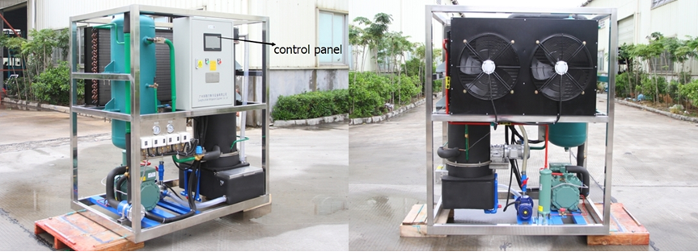
1 ton tube ice machine with Germany Bitzer compressor
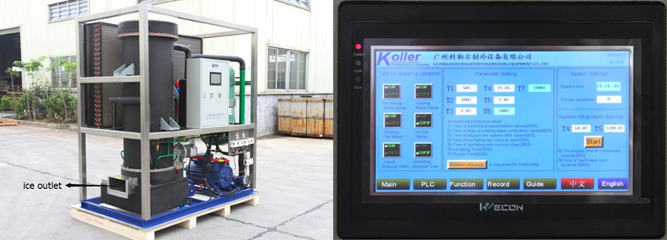
1 ton tube ice machine with Germany Bock compressor
control panel displaying working condition and fault report if occurred

2. Components and installation
The tube ice machine adopts with air cooling system, so the complete set of machine only consists of 1 part, so the installation only involves with simple power and water connection.

Here is a Youtube video teach you how to install and operate the machine when you receive it: https://www.youtube.com/watch?v=KA_vSb5iONg
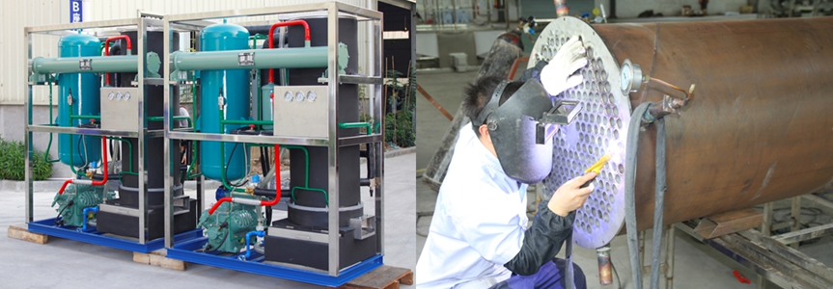
5 tons tube ice machine TV50 tube ice evaporator
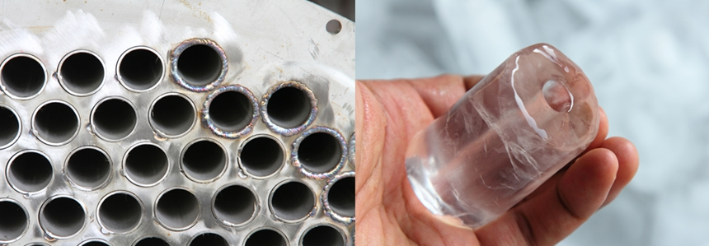
tube ice evaporator tube ice evaporator

3. Available tube ice size
The tube ice external diameter is available with 20, 28, 34, 40 mm, tube ice length is available with 30, 35, 40, 45, 50 mm. One tube ice machine can only produce 1 size tube ice. Which outer diameter and length do you want to choose?
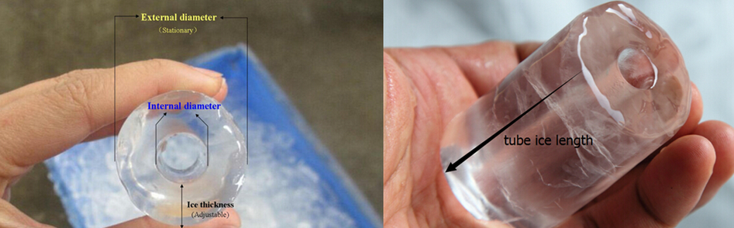

* Mr. Vicente Serrano, does our 1 ton tube ice machine TV10 meet your demand or not?

Waiting for your kindness reply
Thanks

Best Regards,
Jamko Ye (Sales Manager)

