Dear Miss Paola Racchi Salvado

Good day!

Here we briefly introduce our cube ice machine with ice packing function, which is especially design for ice selling man.
Considering ice packing is very labor intensive, the cube ice machine already equips with an ice collecting bin and packing function. (semi-automatic packing)

There is a dispenser on the bottom of ice collecting bin. Controlled by the pedal switch, it can convey ice directly from machine into plastic bags .
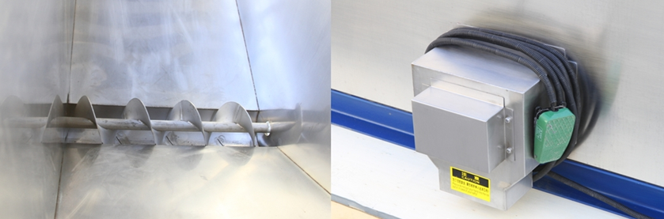
dispenser made of complete food grade stainless steel 304
ice outlet

In that way, you can pack up 3kg, 5 kg, 10 kg or whatever standard of bags ice for the market selling.
Moreover, the bin, the dispenser and the machine framework are all made of stainless steel 304 to guarantee food grade standard and sanitary.
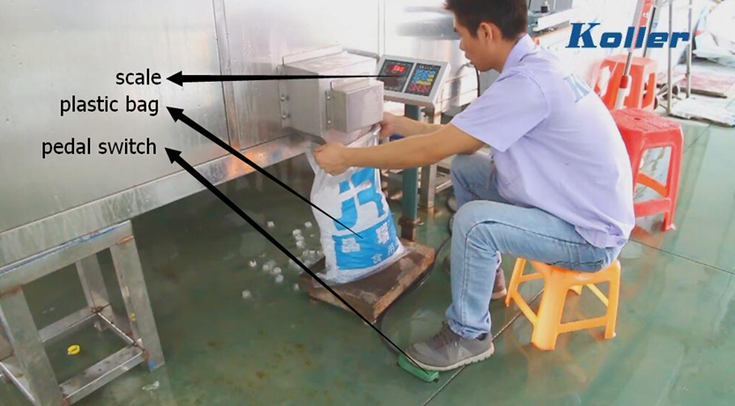
packing and weighting at the same time
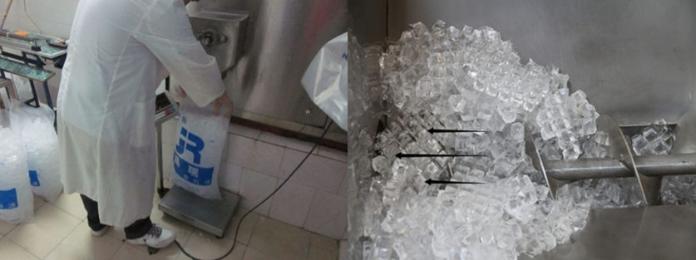

*Do you want to pack the ice and sell them to the market?
Or you will use the ice on your own?

Waiting for your kindness reply
Thanks

Best Regards,
Jamko Ye (Sales Manager)

