英语翻译成西班牙语 (烦请将翻译附在每个条目旁边/下方，并一一对应，方便我方查看，谢谢！！)

Hook Load Beaning 3000Kg
By Owner

Machine Room Height

Control Panel

Overhead Height (OH)

Interval 2000mm Steel Plate Bearing Reservation (By Owner)

Interval 6000mm Hoistway Linghting (By Owner)

Hoistway Height (HH)

Travel Height (TH)

Min Floor Distance

Structure Door Opening

Entrance Net Height

Pit Depth (PD)

Pit Ladder (by owner)

Concreting Plinth
By owner

Ventilating Fan
By owner

Speed Control
By Owner

Ventilating Window

Main Power Box

Switch of Elevator

Dual Control Switch of Shaft Lighting

Socket

Plan on Machine Room

Plan on Hoistway

Confirmed by Buyer:
We agree to do civil construction base on above elevator layout

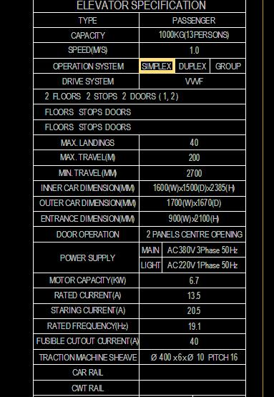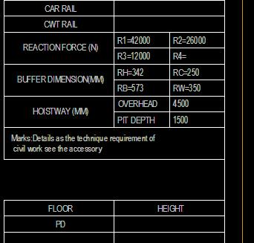

Slab Hole on Machine Room

Concreting Beaming
By Owner

Structural Opening of Landing Door

Main Landing Floor Only

Section （截面图）

Concreting Plinth
By Owner

Hoistway Linghting
By Owner

Hoistway Linghting Switch
By Owner

Plan on hoistway pit

Door Opening

Entrance Finished

Reservation Hole for backfill grounting after installation
By Owner

Machine Room Floor

Concreting Plinth
By Owner

