Good afternoon from China, Maunel,

I am sure that you are familiar with industrial machinery field. We are known that in this field, prices differ a lot because of different quality and different after-sale service. We know well about the market, based on the quality and service of our products, we can guarantee that our price is the most competitive. Following are the details. Hope it will be helpful for you to make a decision.

1. Easy to operate: all the ice making processes, including water supply, ice freezing and ice falling all automatic. And you just need to operate the ice machine via the touching screen, to see all the running conditions, or to set the parameters by yourself. Please download the attached operation manual book of touching screen, and figure out how intelligent and convenient it is.

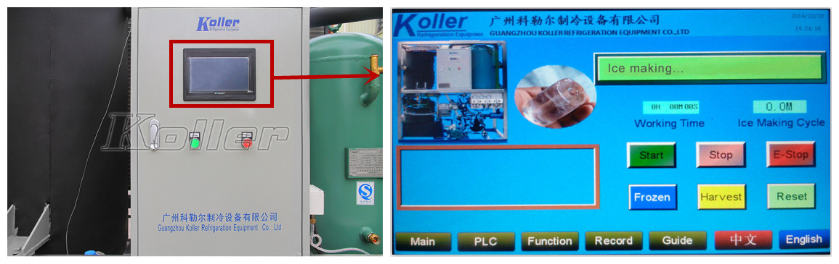

2. High Quality Ice: my friend, it is hard to produce high quality ice because of its special design. Tube ice becomes fragments easily and the middle cylinder hole is too large. For our tube ice machine, you can make complete, transparent and thick ice. And the diameter of tube ice can be adjusted according to your needs.

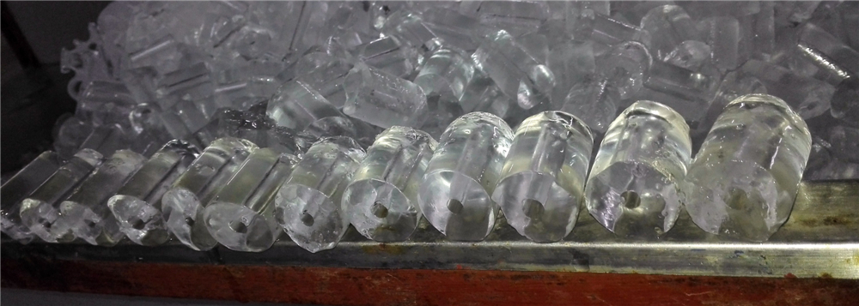

3. Protection Program: for the traditional tube ice machine, it is controlled by relay. For our machine, it is controlled by program in the Siemens PLC controller. It means that the machine will work more stable and efficient. If there is anything wrong with the machine, the protection program will start by itself and stop machine, display the problems (high/low pressure) on the touching screen, much safer.

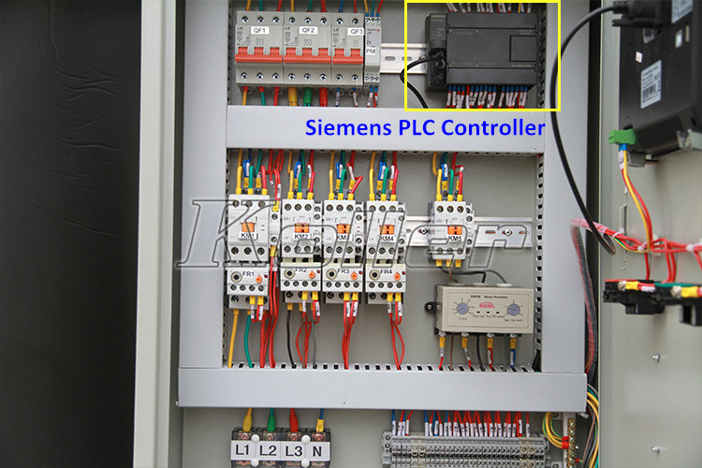

4. Excellent components
For the most important components, we adopt Germany brand-Bitzer, one of the best brands for compressor.
For the evaporator, we use the best material, stainless steel SUS304, also sanitary. It can be used for more than 10 years. It seems that your customer has some problems with the evaporator, you can ask him what material it use and make a compare with our evaporator.
Controller PLC from Germany Siemens, Valves from Denmark Danfoss etc.

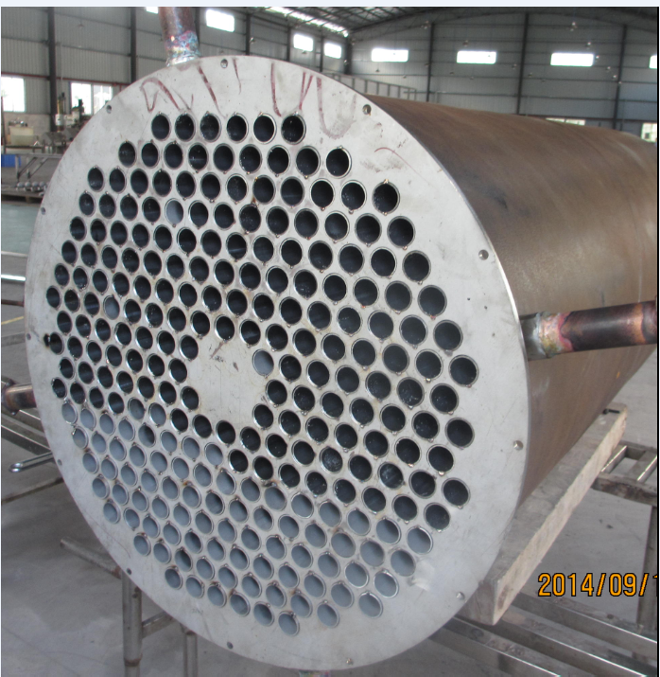

5. After-sale Service: why after-sale service is so important for industrial machine field? Because the product is quite complex and once it breaks, it will be hard for the user to repair it. And sometimes you need to replace the components. You will use the machine for many years and it is unavoidable it will break some day.
We definitely know the importance of after-sale service and we are trying to offer the best service for our customers.

--Testing: all the Koller ice machines will be tested for 72 hours before shipping. We must make sure when the customers receive the machines, they are in the best permanence.

--Warranty: all the Koller ice machines enjoy 12 months of warranty free of charge. If anything wrong with the machine, you can send us pictures or video about the fault, we will mail you the solution to solve problems within 24 hours.

--Installation: after you place the order, we will send you the operation manual and installation videos with the machine. After you receive the machine, we can have the video call to guide your installation. Or, we can send you the engineer to your country. (The operation manual can be in Spanish)

My friend, sincerely hope we can reach the win-win business with you. I am trying my best to offer any useful information. If it just the matter of price, of course there are still room for compromise. But we need to know your bottom price and I will apply to my boss for a discount.

Good day and looking forward to your feedback.

