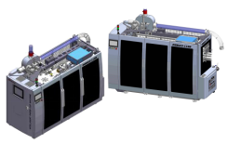
- Machine out-looking
The machine is design into cases.

One side: Opening type 3 Plexiglass doors.
Our door can be folding opened for machine easy control and maintain.
The other side: Stainless steel safety door.
High Efficient paper cup machine in your workshop make your work more intelligent.

- Machine design
Our technical development team is experience in “HORAUF” and “PMC” machine. Depend on it, we think more for users.
* DEBAO-118S Electric wire and Air tube is all designed into machine protect channels, not placed in a mass. More safe and clear.

* Our machine transmission part, we learned from UAS PMC driving system. Designed in longitudinal axis with indexing cam. No chains, machine keep highest precision and work stable.
Machine transmission part is like one man’s heart, if your heart is strong enough, then you can run fast as you want.
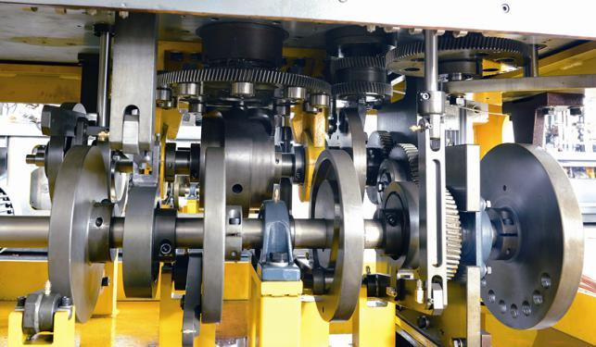

* Machine speed now is 100-120cups/min. We have machine test of speed:
Machine running without mould test speed----------- 200 times/min,
Forming paper cup test speed---------------------150 cups/min.(Video:)
Therefore, under long-term test, we can guarantee machine normal working speed can be 100-120 cups/min.
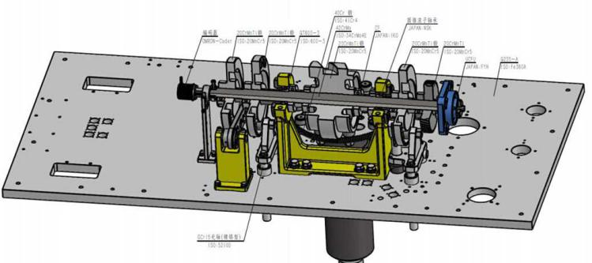

When machine working, there will be many pieces of paper fall into transmission system and get oil polluted. We adopt full sealed on A3 iron board, separate the cup forming part and transmission part. So paper won’t fall into driving system and won’t get oil polluted. There’s no need for you to clean oil & driving system. It can help you save cost on oil change and time to clean the machine every week.

- Electrical part/Bearing part:
We adopt Germany Schneider as the main electrical part for DEBAO-118S. And Japan-IKO/NSK Korea-SAMICK as bearing part. Best electrical part and bearing build machine running fast and stable.

- Machine Intelligent work
Our goal is always make our machine stable, intelligent work...
Regarding the intelligent part, there’s many details:
* Our machine, we adopt Switzerland Lester heater, and machine adopt PID temperature control. You can control heater temperature very precision by PID. Also when you change paper, you can set paper information in computer, they will adjust temperature
* Machine transmission, we adopt encoder to control it. You can control machine running way by computer, not by tools. So machine work will be more easy for technicians.
* Machine running with sensors, all sensors is link with PLC. Once machine have problem, sensor will give signal to PLC, and it will show the problem on the screen and give guidance.
* We support system remote update, Via Ethernet, We can update your machine system to new version.

- After sales service
- We also give 3 years warranty for mechanical parts, and 1 year for electrical part.
- Engineer install & Adjust work in your factory. When the new machine arrived to your factory, we can send engineer to France to adjust machine, and teach your technicians get skilled. The cost need paid by you.
- We have plan: set After sales service place in Turkey/Italy next year for Europe market. And will set more branch in some countries.
- For our 17 years sales&services experience, we have work with many famous package company like Detpak, TMA group, Salman Group..., we have long term work with them. So I believe our team also can do the best for you.

