大小写自己调节
(1)
这里的分类改为RIVET
下面的标签改为
rivet ,blind rivet , drive rivets,hollow rivets,flush rivets,pop rivet,solid rivets,black rivet ,semi tubular rivets,tubular rivets,small rivets, aluminum rivets ,brass rivets,stainless steel rivets ,steel rivets,cooper rivet,snap rivets,round head rivets,countersunk rivets
（2）
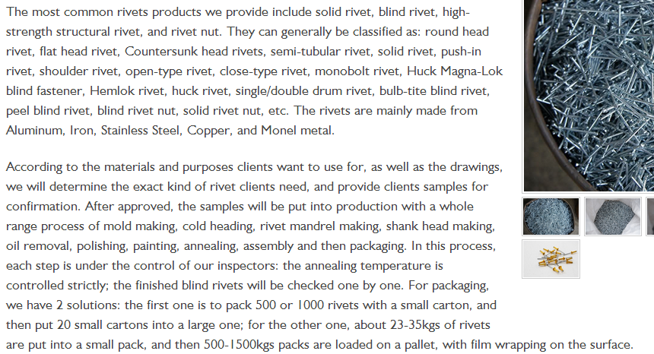
这段话改为
Our rivets can be used everywhere with its special design,which are widely used in construction,automobies,ships,aircraft,machinery,electrical,appliances,furniture and so on.The details of our products is following:
(1)Standard:GB,DIN,IFI,ISO
(2)Kins:Blind Rivet(Many kinds as Open type rivet,Sealed type rivet,Multi-grip type rivet,Peel type rivet,Grooved Type rivet)
Structural Rivet
Drive Rivet
Semi-tubular rivet ,Tubular rivet
Solid Rivet
Split Rivet
(3)Materials :Aluminium,Brass,Stainless steel,Steel,Copper ,Iron,Monel metal
(4)Head:Round Head,Snap Head,Flat Head,Countersunk Head,Oval Head,Truss Head Domed Head,Pan Head,Large Head ,Universal Head
(5)Surface:no finish,brass,zin,static electronic black,painting black,white nickel ,black nickel and so on
(6)Package:one is to pack 500 or 1000 rivets with a small carton, and then put 20 small cartons into a large one; for the other one, about 23-35kgs of rivets are put into a small pack, and then 500-1500kgs packs are loaded on a pallet, with film wrapping on the surface.
(7)MOQ:10000PCS
According to the materials and application clients want to use for, as well as the drawings, we will determine the exact kind of rivet clients need, and provide clients samples for confirmation. After approved, the samples will be put into production with a whole range process of mold making, cold heading, rivet mandrel making, shank head making, oil removal, polishing, painting, annealing, assembly and then packaging. In this process, each step is under the control of our inspectors: the annealing temperature is controlled strictly; the finished rivets will be checked one by one.
The following is some size according to our molds , Without these ,we have some other molds too ,pls kindly check with me if you need ,and we also can produce any type according to customers' requirements.
保留下面的表格

