(大小写你们改下哦）
(A)
这里需要改为aluminium slug for electric container,aluminium slug for aluminium bottle ,aluminium slug for aerosol cans ,aluminium slugs for cosmetic packaging ,aluminium slug for capacitor shell,aluminium slug for toothpaste tubes,aluminium slug for beverage containers ,aluminium slug for hand cream tube,aluminium slug for pharmaceutical tube,aluminium slugs for auto parts,aluminiumslugs for making pen

(B) 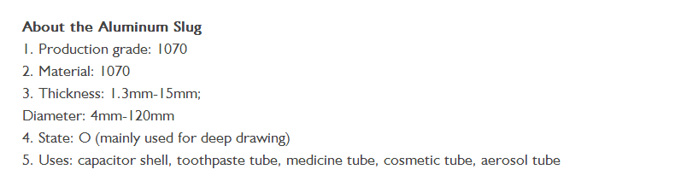
改为
about the aluminum slug
1.
Product name | Alloy | Purity | Hardness | Specifications
 |  |  |  | Thickness | Diameter | Tolerance
Aluminium slug | 1070 | 99.7% | 16-19HB | 1.3-15mm | 4-120mm | +/-0.05mm

2. Chemcial composition of our alloy 1070
Si | Fe | Cu | Mn | Mg | Zn |  | Ti | others | Al
0.2 | 0.25 | 0.04 | 0.03 | 0.03 | 0.04 | 0.05v | 0.03 | 0.03 | 99.7

3.Shapes:flat,domed,conical domed,spherical,round ,column,quadratic,oval,rectangular,preform
4.Surface fnish:smooth,matting
5.Type:Tumbling treatment,Non-tumbling treatment,Shotblasting treatment

(C) 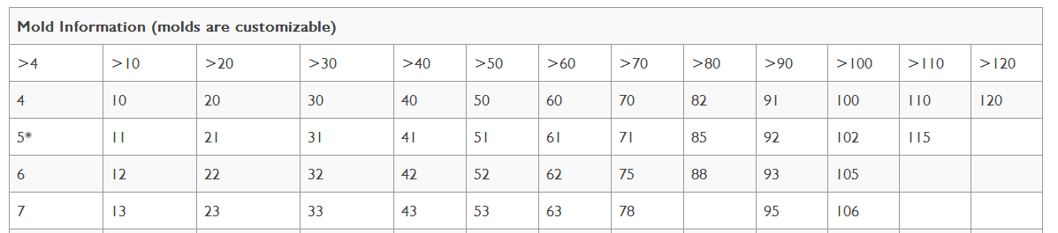这个表格保留

（D）
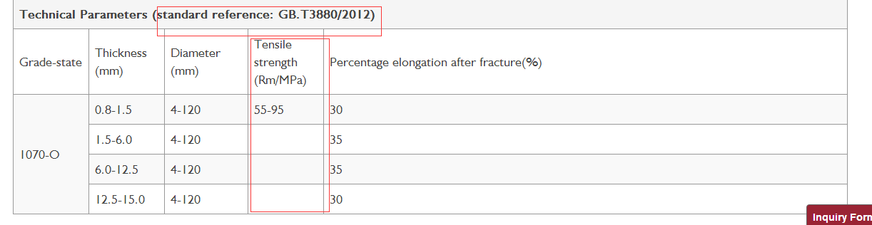

standard reference 改为 GB.T 3880-2012，EN 570/573

下面的Tensile strength 那里合并下

（F）
改为
Application:
collapsible tube ,aerosol cans ,aluminium bottle ,aluminium cover,auto parts ,cigar tube,moss tube,hand cream tube,glue tube,making pens,capacitor shell ,cosmetics packaging,electronics ,medical,food ,toothpaste tube,beverage containers,lipstick tube,pharmaceutical tube and so on.

Package:
(1)corrugated box
(2) 25 kgs carton box or bags ,then 1000kgs will be packed by the fumigation wooden pallets

(G)
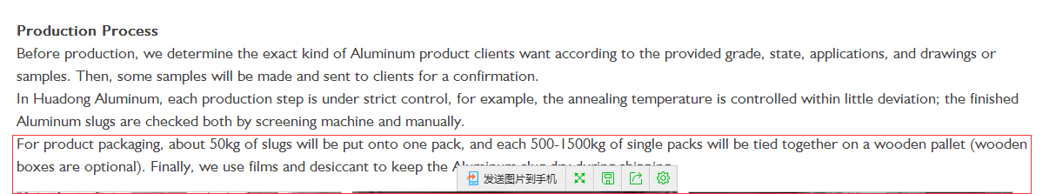
红色部分删除掉

