SUBQ Series Fully Automatic Non Woven Bag Making Machine
Quotation: 85000 USD/SET,FOB NINGBO,CHINA
Video : https://www.youtube.com/watch?v=NVtFy_9G3rA&feature=youtu.be

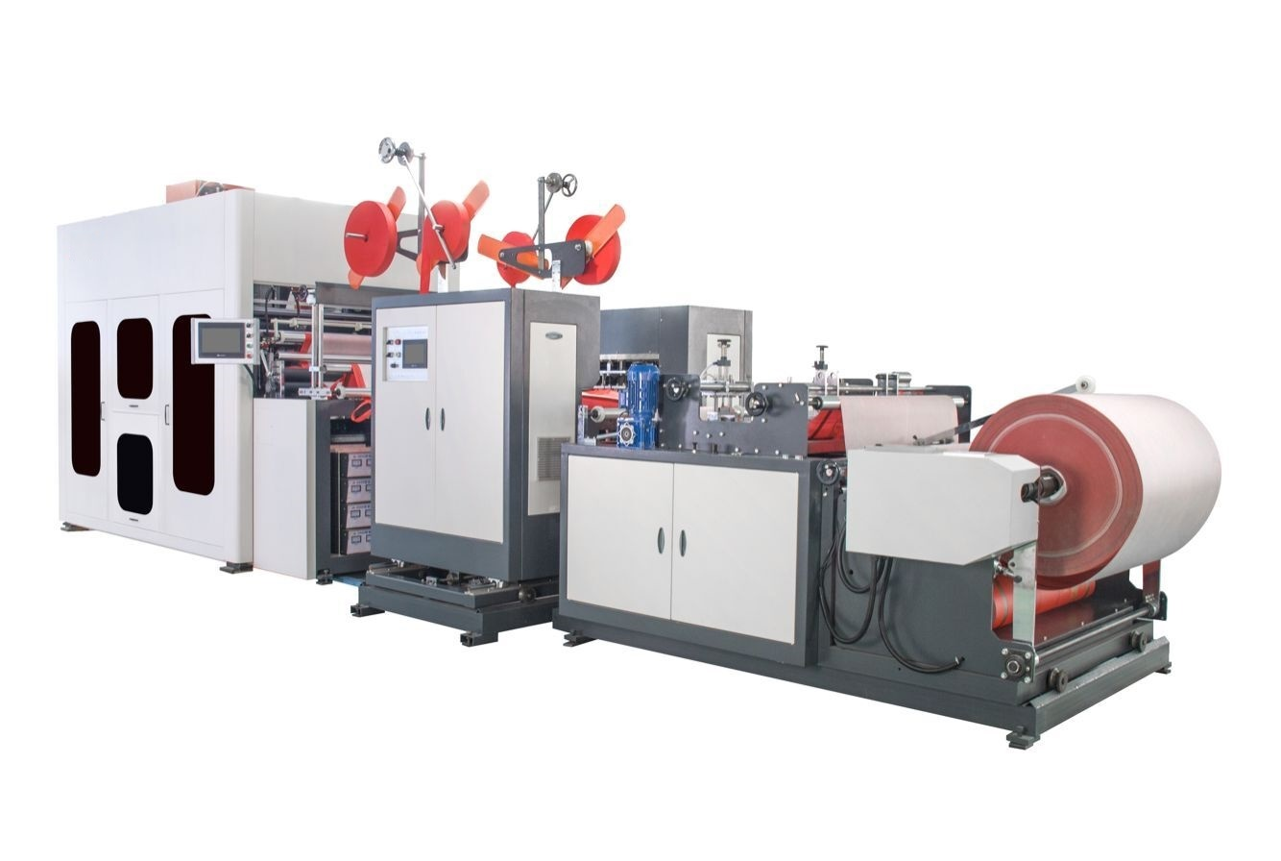
Features：
1.The latest bag making equipment in the world,one-time process for forming bag. Own many patents in china.
2.High intelligent,operation simple and convenient and require small workshop.
3.Only need 2 workers,save lots of labor,ensure delievery on time for big order,enhance competitiveness of the market and reduce cost about20%。
4.Since there is no needle damage on the non woven fabric，the durable were futher enhance pull strength increase from 10kg to 20kg.

Technical Parameters：
Model | SUBQ
Output | 28-38pcs/min
Replace Mould Time | 30-45min
Loop Handle Length | 350-540mm
Bag Size | 80-170mm(Gusset)
Bag Size | 240-450mm(Width)
Bag Size | 220-400mm(Height)
Air Pressure | 1.2m3/min,1.0Mpa
Voltage | 3Phase,380V,50HZ
Total Power | 28kw
Total Weight | 7000kg
Overall Dimension | 7700x2200x2600mm

Detail of spare part：
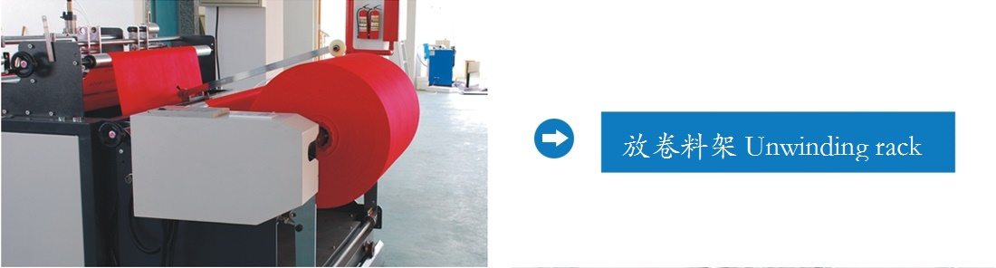

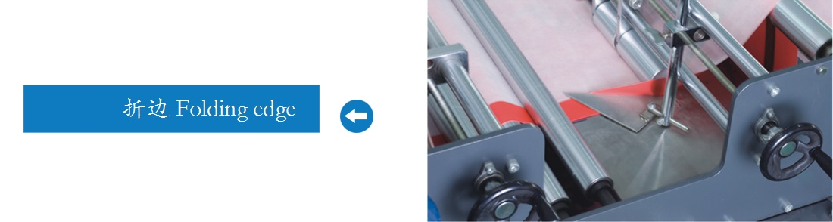

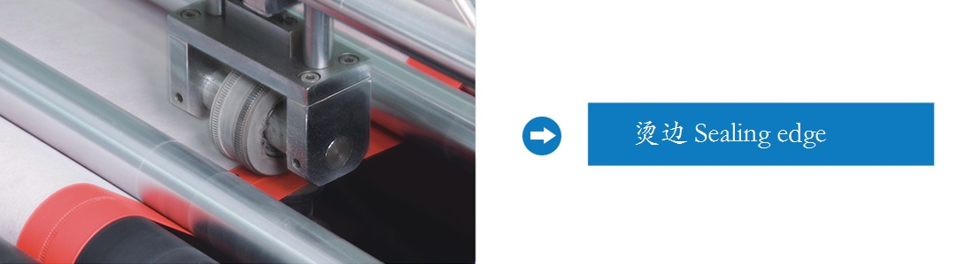
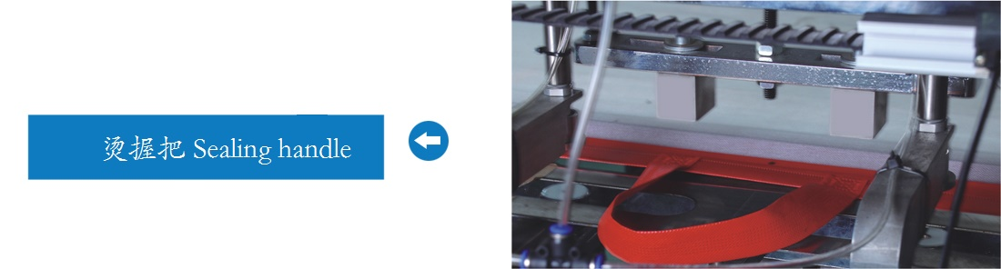

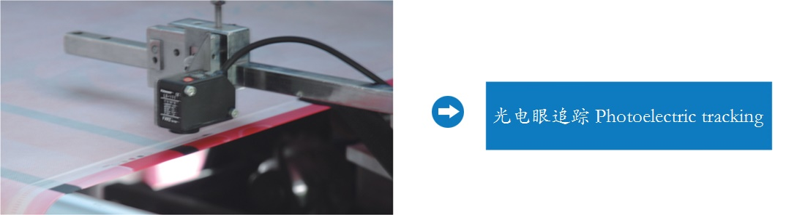

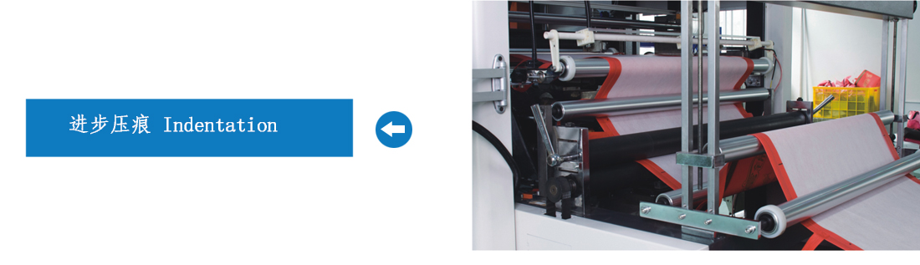

Why shall we prefer non woven bag to paper bag？
- Convenient to carry
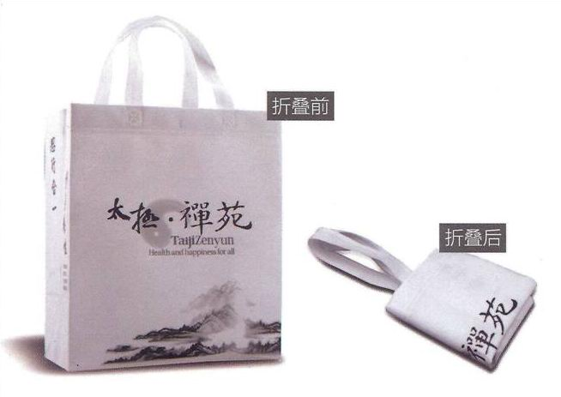

- No hurt the finger and leg
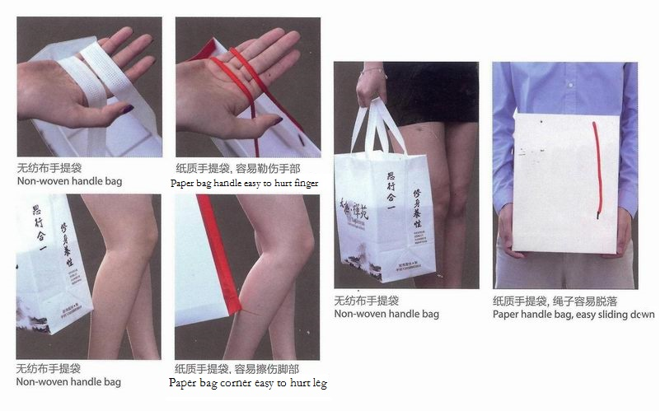
- Bag durable and reusable.
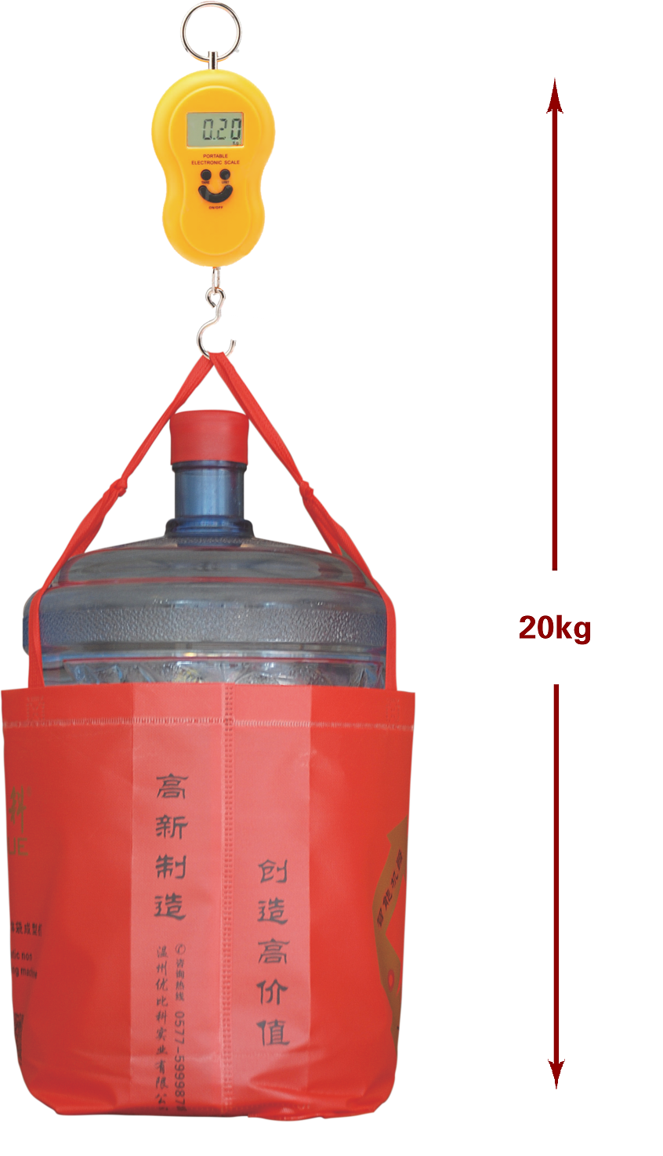
- Greens environmental protection

Why do you choose our non woven bag making mahcine?
1.Return of investment quickly
One piece Non woven bag’s cost is about 0.08-0.15USD(Non wowen fabric cost is about 0.05-0.10 USD,the process cost is about 0.04-0.05 USD),you can sell them at 0.2-0.5 USD. Our machine can produce 1680-2280pcs/hour, How much money do you earn per hour？
- Our machine adopt PLC controll system,easy to operation and maintain.
- Save labor,reduce cost.(only need 1-2 worker）
4.Replace mould conveniently and quickly(Replace time:30-45min)

Non woven bag Sample:
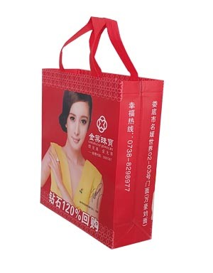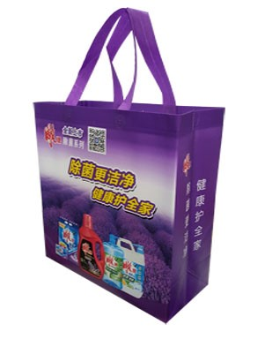
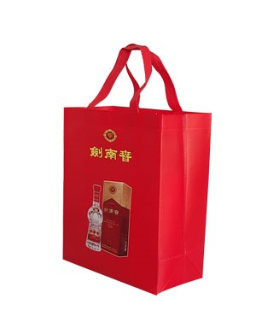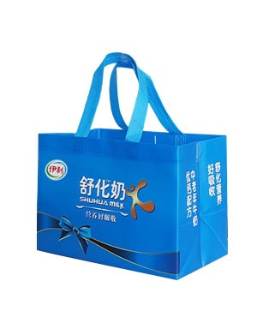
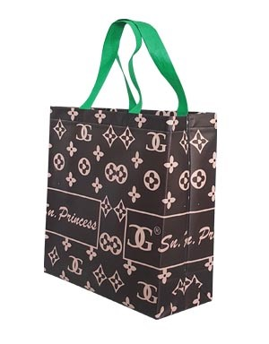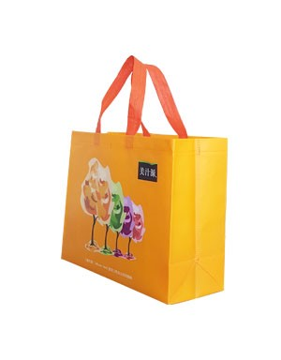
Factory photo：


