QUOTATION

To: Master Box Embalagens Especiais Ltda

Attn: Jose

Date: May 18th, 2017

HM-650A Automatic Gluing Machine
Picture | Specification | Unit/Price FOB SHENZHEN,CHINA | Delivery Date
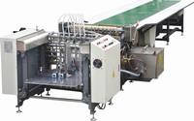 | Paper Width Size:80-600mm | USD7120/ set | 15days
 | Paper Thickness:80-200gsm
 | Speed:7-40pcs/min
 | Voltage:380V
 | Power:6.6KW
 | Net Weight: 1100kg
 | Measurement:6350*1650*1100mm
Function and features:
Automatic gluing machine is suitable for feeding and gluing the paper which is for making book cover, rigid box, set up box, etc.
It has the function of automatic feeding paper and gluing, automatic temperature control and 24-hours timer.
The draft fan under the assembly lines prevents cover paper from curling and bubbling.
Feeder absorption and feed are applied, which contribute to the characteristic of steady and quick paper conveyance.
Hot melt adhesives (animal adhesives) are used for health and environmental protection, and they also save cost because of the recycle system and the adjustable speeds.
Ps:
1, Standard working table is around 5 meters
2. 7m, 9m ,11m working table can be customized per to the customer's need.
3, Remodel for white glue( Optional)
4. Run & Stop Function( Optional)

HM-40 Corner Pasting Machine
Picture | Specification | Unit/Price FOB SHENZHEN,CHINA | Delivery Date
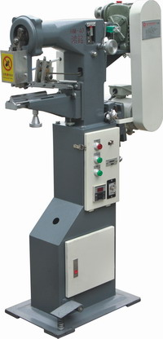 | Box Min,Size:40x40x10mm | USD1330/ set | 10days
 | Max.Size: Not limit
 | Speed: 20-40pcs/min
 | Voltage:220V
 | Power:0.4kw
 | Tape Width:19mm
 | Tape Length(Max.): 30mm
 | Net Weight:170kg
 | Measurement:800x500x1400mm
Function and Features:

HM-40 is a machine with function of pasting the four angles of the inside box(grey board box) of Rigid box manually. Saving supplies with using hot melt tape.
Boxes pasted by it can be with features of stable, smooth & elegant. It is the indispensable equipments for box making.

Raw material related: PVC TAPE
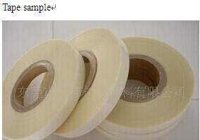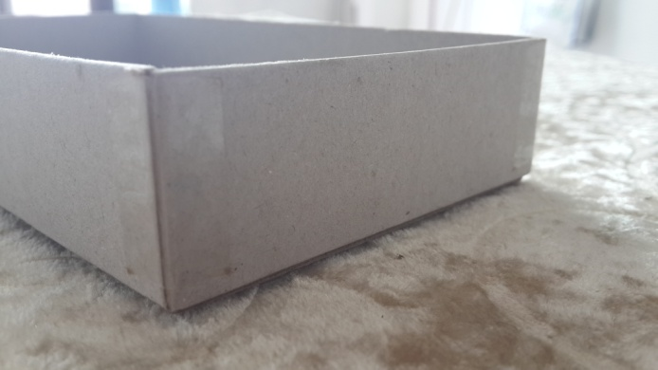
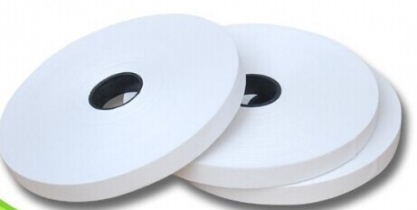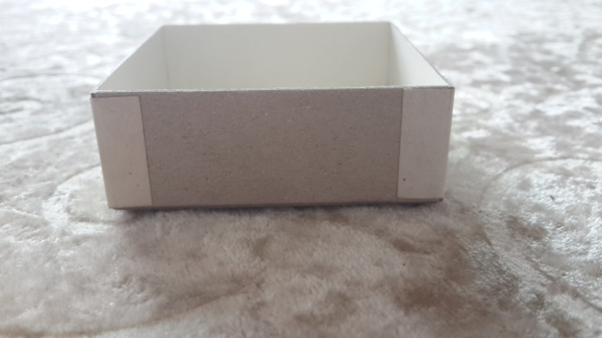

HM-500A Automatic Box Forming Machine
Picture | Specification | Unit/Price FOB SHENZHEN,CHINA | Delivery Date
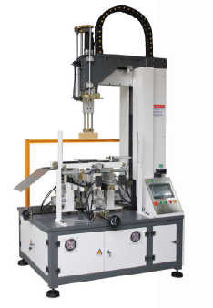 | Box Max size:500x400x120mm | USD13970/ set | 15days
 | Box.Min size:80x60x10mm
 | Paper Folding-in Size: 10-60mm
 | Working Speed: 15-20pcs/min
 | Voltage:AC220V
 | Power:2.2kw
 | Net Weight: 900kg
 | Machine Dimension:900x800x2960mm
Features and functions:

This machine is available in wrapping and folding the paper edge for rigid box, fancy box, and cardboard box, etc.
- It applies servo motor and PLC control.
- The adjusting of the 4 sides is controlled by screw, thus more precise and easier.
- The electric parts apply international brand. Low malfunction and high accuracy.
- With alarm functions display on screen.
- With emergency stop switch.
- When the machine is working, the maximum height could be 2200mm.

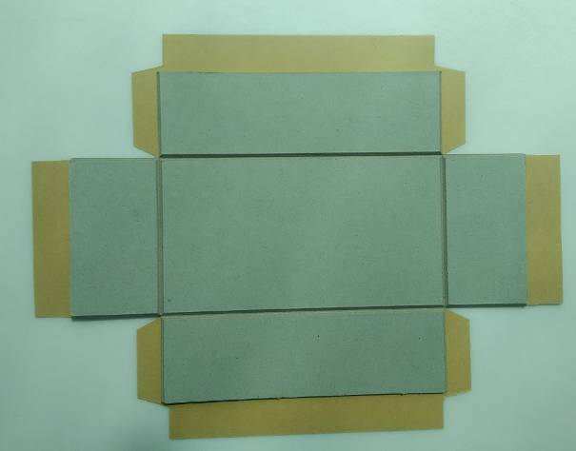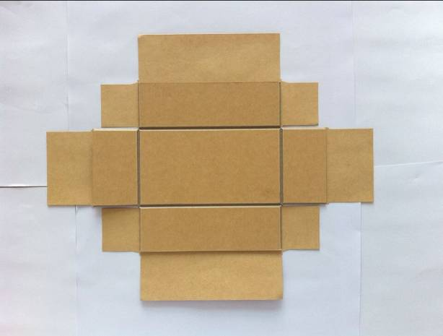

HM-YP300B Box Pressing Machine
Picture | Specification | Unit/Price FOB SHENZHEN,CHINA | Delivery Date
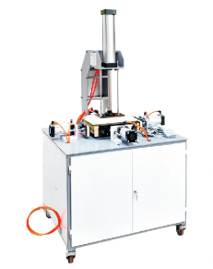 | Box Max size:250x200x80mm | USD1250/set | 10days
 | Box.Min size:50x50x10mm
 | Ideal Box size.(Max):250x150x60mm
 | External Pressure:0.5-0.8Mpa
 | Downward Pressure:160-220kgf
 | Side Pressure: 120-140kgf
 | Upward Pressure: 40-60kgf
 | Voltage: AC220V
 | Power: 20w
 | Net Weight: 85kg
 | Machine Dimension: 800x600x1450mm

Note:
- Above price is valid for 30days, and it doesn’t include the installation charges

- If customer want manufacturer to send technician to install and train the operation. The customer should bear the come and back ticket fee, housing, eating and transporation fee in customer local side.

- Price is only for standard. Other special requirements should discuss further.

- Guarantee: One year

- Package: Vacumm packing + Wooden Case

